Question #1*Topic 1*

You have two Hyper-V hosts named Host1 and Host2. Host1 has an Azure virtual machine named VM1 that was deployed by using a custom Azure Resource  
Manager template.  
You need to move VM1 to Host2.  
What should you do?

* A. From the Update management blade, click Enable.
* B. From the Overview blade, move VM1 to a different subscription.
* C. From the Redeploy blade, click Redeploy. **Most Voted**
* D. From the Profile blade, modify the usage location.

[Hide Solution](https://www.examtopics.com/exams/microsoft/az-204/view/) [Discussion   **16**](https://www.examtopics.com/exams/microsoft/az-204/view/)

**Correct Answer:** *C* [🗳️](https://www.examtopics.com/exams/microsoft/az-204/view/)  
When you redeploy a VM, it moves the VM to a new node within the Azure infrastructure and then powers it back on, retaining all your configuration options and associated resources.  
Reference:  
https://docs.microsoft.com/en-us/azure/virtual-machines/windows/redeploy-to-new-node

*Community vote distribution*

C (100%)

Question #2*Topic 1*

DRAG DROP -  
You have downloaded an Azure Resource Manager template to deploy numerous virtual machines. The template is based on a current virtual machine, but must be adapted to reference an administrative password.  
You need to make sure that the password is not stored in plain text.  
You are preparing to create the necessary components to achieve your goal.  
Which of the following should you create to achieve your goal? Answer by dragging the correct option from the list to the answer area.  
Select and Place:  
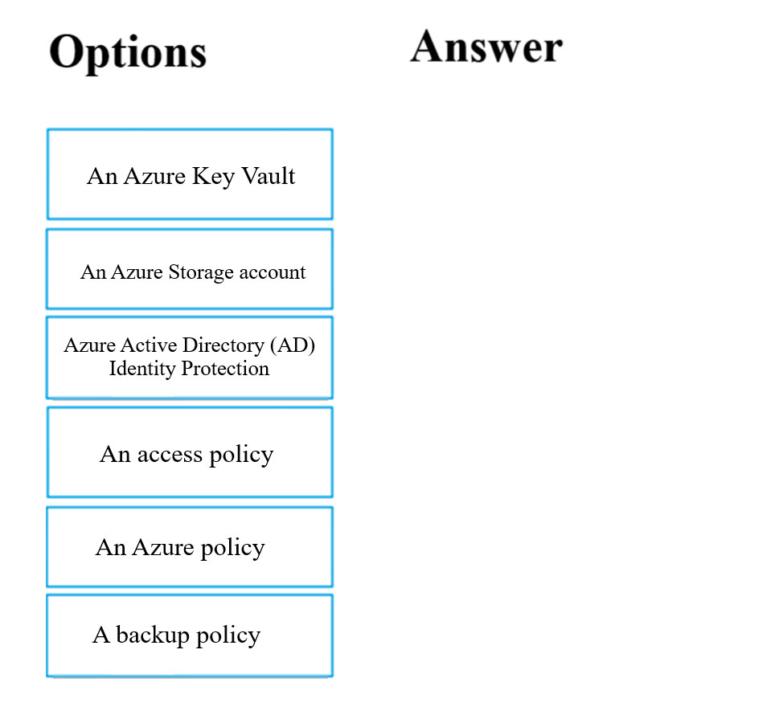

[Hide Solution](https://www.examtopics.com/exams/microsoft/az-204/view/) [Discussion   **6**](https://www.examtopics.com/exams/microsoft/az-204/view/)

**Correct Answer:** 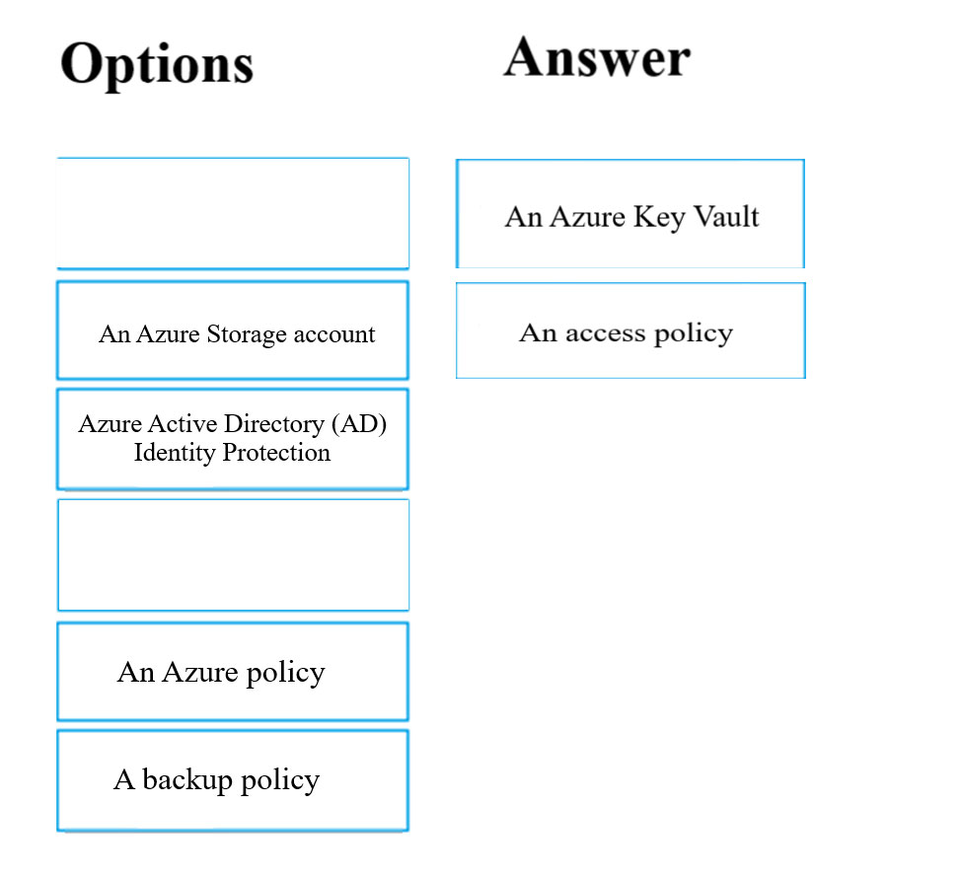

Question #3*Topic 1*

Your company has an Azure Kubernetes Service (AKS) cluster that you manage from an Azure AD-joined device. The cluster is located in a resource group.  
Developers have created an application named MyApp. MyApp was packaged into a container image.  
You need to deploy the YAML manifest file for the application.  
Solution: You install the Azure CLI on the device and run the kubectl apply `"f myapp.yaml command.  
Does this meet the goal?

* A. Yes **Most Voted**
* B. No

[Hide Solution](https://www.examtopics.com/exams/microsoft/az-204/view/) [Discussion   **24**](https://www.examtopics.com/exams/microsoft/az-204/view/)

**Correct Answer:** *A* [🗳️](https://www.examtopics.com/exams/microsoft/az-204/view/)  
kubectl apply -f myapp.yaml applies a configuration change to a resource from a file or stdin.  
Reference:  
https://kubernetes.io/docs/reference/kubectl/overview/  
https://docs.microsoft.com/en-us/cli/azure/aks

*Community vote distribution*

A (67%)

B (33%)

Question #4*Topic 1*

Your company has an Azure Kubernetes Service (AKS) cluster that you manage from an Azure AD-joined device. The cluster is located in a resource group.  
Developers have created an application named MyApp. MyApp was packaged into a container image.  
You need to deploy the YAML manifest file for the application.  
Solution: You install the docker client on the device and run the docker run -it microsoft/azure-cli:0.10.17 command.  
Does this meet the goal?

* A. Yes
* B. No **Most Voted**

[Hide Solution](https://www.examtopics.com/exams/microsoft/az-204/view/) [Discussion   **9**](https://www.examtopics.com/exams/microsoft/az-204/view/)

**Correct Answer:** *B* [🗳️](https://www.examtopics.com/exams/microsoft/az-204/view/)

*Community vote distribution*

B (100%)

Question #5*Topic 1*

Your company has a web app named WebApp1.  
You use the WebJobs SDK to design a triggered App Service background task that automatically invokes a function in the code every time new data is received in a queue.  
You are preparing to configure the service processes a queue data item.  
Which of the following is the service you should use?

* A. Logic Apps
* B. WebJobs **Most Voted**
* C. Flow
* D. Functions

[Hide Solution](https://www.examtopics.com/exams/microsoft/az-204/view/) [Discussion   **36**](https://www.examtopics.com/exams/microsoft/az-204/view/)

**Correct Answer:** *B* [🗳️](https://www.examtopics.com/exams/microsoft/az-204/view/)  
Reference:  
https://docs.microsoft.com/en-us/azure/azure-functions/functions-compare-logic-apps-ms-flow-webjobs

*Community vote distribution*

B (76%)

D (24%)

Question #6*Topic 1*

Your company has an Azure subscription.  
You need to deploy a number of Azure virtual machines to the subscription by using Azure Resource Manager (ARM) templates. The virtual machines will be included in a single availability set.  
You need to ensure that the ARM template allows for as many virtual machines as possible to remain accessible in the event of fabric failure or maintenance.  
Which of the following is the value that you should configure for the platformFaultDomainCount property?

* A. 10
* B. 30
* C. Min Value
* D. Max Value

[Hide Solution](https://www.examtopics.com/exams/microsoft/az-204/view/) [Discussion   **14**](https://www.examtopics.com/exams/microsoft/az-204/view/)

**Correct Answer:** *D* [🗳️](https://www.examtopics.com/exams/microsoft/az-204/view/)  
The number of fault domains for managed availability sets varies by region - either two or three per region.  
Reference:  
https://docs.microsoft.com/en-us/azure/virtual-machines/windows/manage-availability

*Community vote distribution*

D (100%)

Question #7*Topic 1*

Your company has an Azure subscription.  
You need to deploy a number of Azure virtual machines to the subscription by using Azure Resource Manager (ARM) templates. The virtual machines will be included in a single availability set.  
You need to ensure that the ARM template allows for as many virtual machines as possible to remain accessible in the event of fabric failure or maintenance.  
Which of the following is the value that you should configure for the platformUpdateDomainCount property?

* A. 10
* B. 20 **Most Voted**
* C. 30
* D. 40

[Hide Solution](https://www.examtopics.com/exams/microsoft/az-204/view/) [Discussion   **30**](https://www.examtopics.com/exams/microsoft/az-204/view/)

**Correct Answer:** *D* [🗳️](https://www.examtopics.com/exams/microsoft/az-204/view/)  
Each virtual machine in your availability set is assigned an update domain and a fault domain by the underlying Azure platform. For a given availability set, five non-user-configurable update domains are assigned by default (Resource Manager deployments can then be increased to provide up to 20 update domains) to indicate groups of virtual machines and underlying physical hardware that can be rebooted at the same time.  
Reference:  
https://docs.microsoft.com/en-us/azure/virtual-machines/windows/manage-availability

*Community vote distribution*

B (100%)

Question #8*Topic 1*

DRAG DROP -  
You are creating an Azure Cosmos DB account that makes use of the SQL API. Data will be added to the account every day by a web application.  
You need to ensure that an email notification is sent when information is received from IoT devices, and that compute cost is reduced.  
You decide to deploy a function app.  
Which of the following should you configure the function app to use? Answer by dragging the correct options from the list to the answer area.  
Select and Place:  
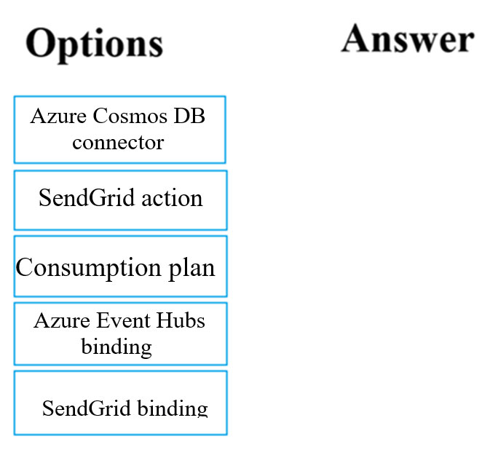

[Hide Solution](https://www.examtopics.com/exams/microsoft/az-204/view/) [Discussion   **16**](https://www.examtopics.com/exams/microsoft/az-204/view/)

**Correct Answer:** 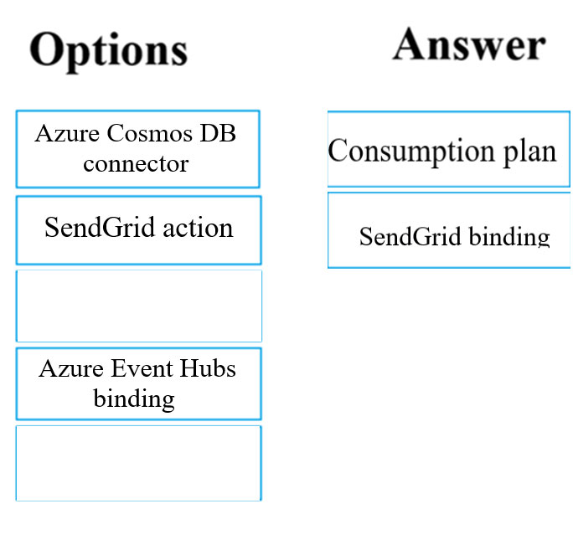

Question #9*Topic 1*

This question requires that you evaluate the underlined text to determine if it is correct.  
You company has an on-premises deployment of MongoDB, and an Azure Cosmos DB account that makes use of the MongoDB API.  
You need to devise a strategy to migrate MongoDB to the Azure Cosmos DB account.  
You include the Data Management Gateway tool in your migration strategy.  
Instructions: Review the underlined text. If it makes the statement correct, select `No change required.` If the statement is incorrect, select the answer choice that makes the statement correct.

* A. No change required
* B. mongorestore **Most Voted**
* C. Azure Storage Explorer
* D. AzCopy

[Hide Solution](https://www.examtopics.com/exams/microsoft/az-204/view/) [Discussion   **36**](https://www.examtopics.com/exams/microsoft/az-204/view/)

**Correct Answer:** *B* [🗳️](https://www.examtopics.com/exams/microsoft/az-204/view/)  
Reference:  
https://docs.microsoft.com/en-us/azure/cosmos-db/mongodb-migrate https://docs.mongodb.com/manual/reference/program/mongorestore/

*Community vote distribution*

B (62%)

A (38%)

Question #10*Topic 1*

You are developing an e-Commerce Web App.  
You want to use Azure Key Vault to ensure that sign-ins to the e-Commerce Web App are secured by using Azure App Service authentication and Azure Active  
Directory (AAD).  
What should you do on the e-Commerce Web App?

* A. Run the az keyvault secret command.
* B. Enable Azure AD Connect.
* C. Enable Managed Service Identity (MSI). **Most Voted**
* D. Create an Azure AD service principal.

[Hide Solution](https://www.examtopics.com/exams/microsoft/az-204/view/) [Discussion   **16**](https://www.examtopics.com/exams/microsoft/az-204/view/)

**Correct Answer:** *C* [🗳️](https://www.examtopics.com/exams/microsoft/az-204/view/)  
A managed identity from Azure Active Directory allows your app to easily access other AAD-protected resources such as Azure Key Vault.  
Reference:  
https://docs.microsoft.com/en-us/azure/app-service/overview-managed-identity https://docs.microsoft.com/en-us/samples/azure-samples/app-service-msi-keyvault-dotnet/keyvault-msi-appservice-sample/

*Community vote distribution*

C (88%)

13%

Question #11*Topic 1*

This question requires that you evaluate the underlined text to determine if it is correct.  
Your Azure Active Directory Azure (Azure AD) tenant has an Azure subscription linked to it.  
Your developer has created a mobile application that obtains Azure AD access tokens using the OAuth 2 implicit grant type.  
The mobile application must be registered in Azure AD.  
You require a redirect URI from the developer for registration purposes.  
Instructions: Review the underlined text. If it makes the statement correct, select `No change is needed.` If the statement is incorrect, select the answer choice that makes the statement correct.

* A. No change required.
* B. a secret
* C. a login hint
* D. a client ID

[Hide Solution](https://www.examtopics.com/exams/microsoft/az-204/view/2/) [Discussion   **27**](https://www.examtopics.com/exams/microsoft/az-204/view/2/)

**Correct Answer:** *A* [🗳️](https://www.examtopics.com/exams/microsoft/az-204/view/2/)  
For Native Applications you need to provide a Redirect URI, which Azure AD will use to return token responses.  
Reference:  
https://docs.microsoft.com/en-us/azure/active-directory/develop/v1-protocols-oauth-code

*Community vote distribution*

A (100%)

Question #12*Topic 1*

You are creating an Azure key vault using PowerShell. Objects deleted from the key vault must be kept for a set period of 90 days.  
Which two of the following parameters must be used in conjunction to meet the requirement? (Choose two.)

* A. EnabledForDeployment
* B. EnablePurgeProtection **Most Voted**
* C. EnabledForTemplateDeployment
* D. EnableSoftDelete **Most Voted**

[Hide Solution](https://www.examtopics.com/exams/microsoft/az-204/view/2/) [Discussion   **11**](https://www.examtopics.com/exams/microsoft/az-204/view/2/)

**Correct Answer:** *BD* [🗳️](https://www.examtopics.com/exams/microsoft/az-204/view/2/)  
Reference:  
https://docs.microsoft.com/en-us/powershell/module/azurerm.keyvault/new-azurermkeyvault https://docs.microsoft.com/en-us/azure/key-vault/key-vault-ovw-soft-delete

*Community vote distribution*

BD (100%)

Question #13*Topic 1*

HOTSPOT -  
You have an Azure Active Directory (Azure AD) tenant.  
You want to implement multi-factor authentication by making use of a conditional access policy. The conditional access policy must be applied to all users when they access the Azure portal.  
Which three settings should you configure? To answer, select the appropriate settings in the answer area.  
NOTE: Each correct selection is worth one point.  
Hot Area:  
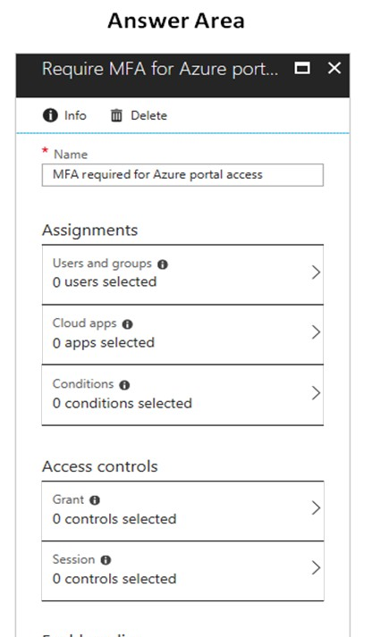

[Hide Solution](https://www.examtopics.com/exams/microsoft/az-204/view/2/) [Discussion   **6**](https://www.examtopics.com/exams/microsoft/az-204/view/2/)

**Correct Answer:** 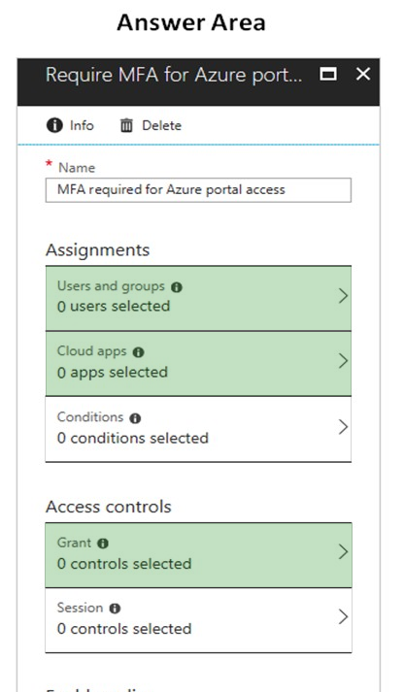  
Box 1:  
The conditional access policy must be applied or assigned to Users and Groups.  
Box 2:  
The conditional access policy must be applied when users access the Azure portal, which is a cloud app. That is: Microsoft Azure Management  
Box 3:  
Access control must require multi-factor authentication when granting access.  
Reference:  
https://docs.microsoft.com/en-us/azure/active-directory/conditional-access/app-based-mfa

Question #14*Topic 1*

You manage an Azure SQL database that allows for Azure AD authentication.  
You need to make sure that database developers can connect to the SQL database via Microsoft SQL Server Management Studio (SSMS). You also need to make sure the developers use their on-premises Active Directory account for authentication. Your strategy should allow for authentication prompts to be kept to a minimum.  
Which of the following should you implement?

* A. Azure AD token.
* B. Azure Multi-Factor authentication.
* C. Active Directory integrated authentication. **Most Voted**
* D. OATH software tokens.

[Hide Solution](https://www.examtopics.com/exams/microsoft/az-204/view/2/) [Discussion   **8**](https://www.examtopics.com/exams/microsoft/az-204/view/2/)

**Correct Answer:** *C* [🗳️](https://www.examtopics.com/exams/microsoft/az-204/view/2/)  
Azure AD can be the initial Azure AD managed domain. Azure AD can also be an on-premises Active Directory Domain Services that is federated with the Azure  
AD.  
Using an Azure AD identity to connect using SSMS or SSDT  
The following procedures show you how to connect to a SQL database with an Azure AD identity using SQL Server Management Studio or SQL Server Database  
Tools.  
Active Directory integrated authentication  
Use this method if you are logged in to Windows using your Azure Active Directory credentials from a federated domain.  
1. Start Management Studio or Data Tools and in the Connect to Server (or Connect to Database Engine) dialog box, in the Authentication box, select Active  
Directory - Integrated. No password is needed or can be entered because your existing credentials will be presented for the connection.  
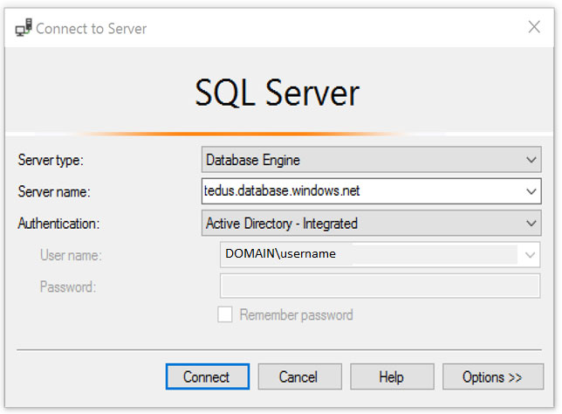  
2. Select the Options button, and on the Connection Properties page, in the Connect to database box, type the name of the user database you want to connect to.  
(The AD domain name or tenant IDג€ option is only supported for Universal with MFA connection options, otherwise it is greyed out.)

*Community vote distribution*

C (100%)

Question #15*Topic 1*

You are developing an application to transfer data between on-premises file servers and Azure Blob storage. The application stores keys, secrets, and certificates in Azure Key Vault and makes use of the Azure Key Vault APIs.  
You want to configure the application to allow recovery of an accidental deletion of the key vault or key vault objects for 90 days after deletion.  
What should you do?

* A. Run the Add-AzKeyVaultKey cmdlet.
* B. Run the az keyvault update --enable-soft-delete true --enable-purge-protection true CLI. **Most Voted**
* C. Implement virtual network service endpoints for Azure Key Vault.
* D. Run the az keyvault update --enable-soft-delete false CLI.

[Hide Solution](https://www.examtopics.com/exams/microsoft/az-204/view/2/) [Discussion   **12**](https://www.examtopics.com/exams/microsoft/az-204/view/2/)

**Correct Answer:** *B* [🗳️](https://www.examtopics.com/exams/microsoft/az-204/view/2/)  
When soft-delete is enabled, resources marked as deleted resources are retained for a specified period (90 days by default). The service further provides a mechanism for recovering the deleted object, essentially undoing the deletion.  
Purge protection is an optional Key Vault behavior and is not enabled by default. Purge protection can only be enabled once soft-delete is enabled.  
When purge protection is on, a vault or an object in the deleted state cannot be purged until the retention period has passed. Soft-deleted vaults and objects can still be recovered, ensuring that the retention policy will be followed.  
The default retention period is 90 days, but it is possible to set the retention policy interval to a value from 7 to 90 days through the Azure portal. Once the retention policy interval is set and saved it cannot be changed for that vault.  
Reference:  
https://docs.microsoft.com/en-us/azure/key-vault/general/overview-soft-delete

*Community vote distribution*

B (100%)

Question #16*Topic 1*

HOTSPOT -  
You have developed a Web App for your company. The Web App provides services and must run in multiple regions.  
You want to be notified whenever the Web App uses more than 85 percent of the available CPU cores over a 5 minute period. Your solution must minimize costs.  
Which command should you use? To answer, select the appropriate settings in the answer area.  
NOTE: Each correct selection is worth one point.  
Hot Area:  
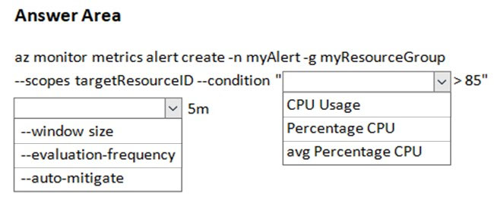

[Hide Solution](https://www.examtopics.com/exams/microsoft/az-204/view/2/) [Discussion   **18**](https://www.examtopics.com/exams/microsoft/az-204/view/2/)

**Correct Answer:** 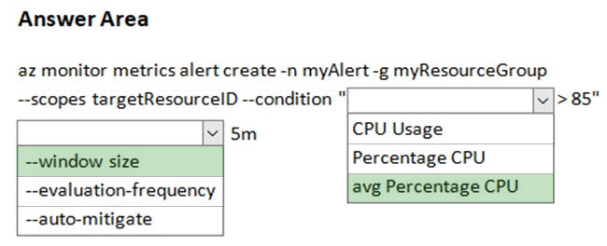  
Reference:  
https://docs.microsoft.com/sv-se/cli/azure/monitor/metrics/alert

Question #17*Topic 1*

Note: The question is included in a number of questions that depicts the identical set-up. However, every question has a distinctive result. Establish if the solution satisfies the requirements.  
You are configuring a web app that delivers streaming video to users. The application makes use of continuous integration and deployment.  
You need to ensure that the application is highly available and that the users' streaming experience is constant. You also want to configure the application to store data in a geographic location that is nearest to the user.  
Solution: You include the use of Azure Redis Cache in your design.  
Does the solution meet the goal?

* A. Yes
* B. No **Most Voted**

[Hide Solution](https://www.examtopics.com/exams/microsoft/az-204/view/2/) [Discussion   **19**](https://www.examtopics.com/exams/microsoft/az-204/view/2/)

**Correct Answer:** *B* [🗳️](https://www.examtopics.com/exams/microsoft/az-204/view/2/)

*Community vote distribution*

B (100%)

Question #18*Topic 1*

Note: The question is included in a number of questions that depicts the identical set-up. However, every question has a distinctive result. Establish if the solution satisfies the requirements.  
You are configuring a web app that delivers streaming video to users. The application makes use of continuous integration and deployment.  
You need to ensure that the application is highly available and that the users' streaming experience is constant. You also want to configure the application to store data in a geographic location that is nearest to the user.  
Solution: You include the use of an Azure Content Delivery Network (CDN) in your design.  
Does the solution meet the goal?

* A. Yes **Most Voted**
* B. No

[Hide Solution](https://www.examtopics.com/exams/microsoft/az-204/view/2/) [Discussion   **13**](https://www.examtopics.com/exams/microsoft/az-204/view/2/)

**Correct Answer:** *A* [🗳️](https://www.examtopics.com/exams/microsoft/az-204/view/2/)  
Reference:  
https://docs.microsoft.com/en-in/azure/cdn/

*Community vote distribution*

A (100%)

Question #19*Topic 1*

Note: The question is included in a number of questions that depicts the identical set-up. However, every question has a distinctive result. Establish if the solution satisfies the requirements.  
You are configuring a web app that delivers streaming video to users. The application makes use of continuous integration and deployment.  
You need to ensure that the application is highly available and that the users' streaming experience is constant. You also want to configure the application to store data in a geographic location that is nearest to the user.  
Solution: You include the use of a Storage Area Network (SAN) in your design.  
Does the solution meet the goal?

* A. Yes
* B. No **Most Voted**

[Hide Solution](https://www.examtopics.com/exams/microsoft/az-204/view/2/) [Discussion   **14**](https://www.examtopics.com/exams/microsoft/az-204/view/2/)

**Correct Answer:** *B* [🗳️](https://www.examtopics.com/exams/microsoft/az-204/view/2/)

*Community vote distribution*

B (100%)

Question #20*Topic 1*

You develop a Web App on a tier D1 app service plan.  
You notice that page load times increase during periods of peak traffic.  
You want to implement automatic scaling when CPU load is above 80 percent. Your solution must minimize costs.  
What should you do first?

* A. Enable autoscaling on the Web App.
* B. Switch to the Premium App Service tier plan.
* C. Switch to the Standard App Service tier plan. **Most Voted**
* D. Switch to the Azure App Services consumption plan.

[Hide Solution](https://www.examtopics.com/exams/microsoft/az-204/view/2/) [Discussion   **21**](https://www.examtopics.com/exams/microsoft/az-204/view/2/)

**Correct Answer:** *C* [🗳️](https://www.examtopics.com/exams/microsoft/az-204/view/2/)  
Configure the web app to the Standard App Service Tier. The Standard tier supports auto-scaling, and we should minimize the cost. We can then enable autoscaling on the web app, add a scale rule and add a Scale condition.  
Reference:  
https://docs.microsoft.com/en-us/azure/monitoring-and-diagnostics/monitoring-autoscale-get-started https://azure.microsoft.com/en-us/pricing/details/app-service/plans/

*Community vote distribution*

C (100%)

Question #21*Topic 1*

Your company's Azure subscription includes an Azure Log Analytics workspace.  
Your company has a hundred on-premises servers that run either Windows Server 2012 R2 or Windows Server 2016, and is linked to the Azure Log Analytics workspace. The Azure Log Analytics workspace is set up to gather performance counters associated with security from these linked servers.  
You must configure alerts based on the information gathered by the Azure Log Analytics workspace.  
You have to make sure that alert rules allow for dimensions, and that alert creation time should be kept to a minimum. Furthermore, a single alert notification must be created when the alert is created and when the alert is resolved.  
You need to make use of the necessary signal type when creating the alert rules.  
Which of the following is the option you should use?

* A. The Activity log signal type.
* B. The Application Log signal type.
* C. The Metric signal type. **Most Voted**
* D. The Audit Log signal type.

[Hide Solution](https://www.examtopics.com/exams/microsoft/az-204/view/3/) [Discussion   **11**](https://www.examtopics.com/exams/microsoft/az-204/view/3/)

**Correct Answer:** *C* [🗳️](https://www.examtopics.com/exams/microsoft/az-204/view/3/)  
Metric alerts in Azure Monitor provide a way to get notified when one of your metrics cross a threshold. Metric alerts work on a range of multi-dimensional platform metrics, custom metrics, Application Insights standard and custom metrics.  
Note: Signals are emitted by the target resource and can be of several types. Metric, Activity log, Application Insights, and Log.  
Reference:  
https://docs.microsoft.com/en-us/azure/azure-monitor/platform/alerts-metric

*Community vote distribution*

C (100%)

Question #22*Topic 1*

You are developing a .NET Core MVC application that allows customers to research independent holiday accommodation providers.  
You want to implement Azure Search to allow the application to search the index by using various criteria to locate documents related to accommodation.  
You want the application to allow customers to search the index by using regular expressions.  
What should you do?

* A. Configure the SearchMode property of the SearchParameters class.
* B. Configure the QueryType property of the SearchParameters class.
* C. Configure the Facets property of the SearchParameters class.
* D. Configure the Filter property of the SearchParameters class.

[Hide Solution](https://www.examtopics.com/exams/microsoft/az-204/view/3/) [Discussion   **15**](https://www.examtopics.com/exams/microsoft/az-204/view/3/)

**Correct Answer:** *B* [🗳️](https://www.examtopics.com/exams/microsoft/az-204/view/3/)  
The SearchParameters.QueryType Property gets or sets a value that specifies the syntax of the search query. The default is 'simple'. Use 'full' if your query uses the Lucene query syntax.  
You can write queries against Azure Search based on the rich Lucene Query Parser syntax for specialized query forms: wildcard, fuzzy search, proximity search, regular expressions are a few examples.  
Reference:  
https://docs.microsoft.com/en-us/dotnet/api/microsoft.azure.search.models.searchparameters https://docs.microsoft.com/en-us/dotnet/api/microsoft.azure.search.models.searchparameters.querytype

*Community vote distribution*

B (100%)

Question #23*Topic 1*

You are a developer at your company.  
You need to update the definitions for an existing Logic App.  
What should you use?

* A. the Enterprise Integration Pack (EIP)
* B. the Logic App Code View **Most Voted**
* C. the API Connections
* D. the Logic Apps Designer

[Hide Solution](https://www.examtopics.com/exams/microsoft/az-204/view/3/) [Discussion   **16**](https://www.examtopics.com/exams/microsoft/az-204/view/3/)

**Correct Answer:** *B* [🗳️](https://www.examtopics.com/exams/microsoft/az-204/view/3/)  
Edit JSON - Azure portal -  
1. Sign in to the Azure portal.  
2. From the left menu, choose All services. In the search box, find "logic apps", and then from the results, select your logic app.  
3. On your logic app's menu, under Development Tools, select Logic App Code View.  
4. The Code View editor opens and shows your logic app definition in JSON format.  
Reference:  
https://docs.microsoft.com/en-us/azure/logic-apps/logic-apps-enterprise-integration-overview https://docs.microsoft.com/en-us/azure/logic-apps/logic-apps-author-definitions

*Community vote distribution*

B (83%)

D (17%)

Question #24*Topic 1*

Note: The question is included in a number of questions that depicts the identical set-up. However, every question has a distinctive result. Establish if the solution satisfies the requirements.  
You are developing a solution for a public facing API.  
The API back end is hosted in an Azure App Service instance. You have implemented a RESTful service for the API back end.  
You must configure back-end authentication for the API Management service instance.  
Solution: You configure Basic gateway credentials for the Azure resource.  
Does the solution meet the goal?

* A. Yes
* B. No **Most Voted**

[Hide Solution](https://www.examtopics.com/exams/microsoft/az-204/view/3/) [Discussion   **30**](https://www.examtopics.com/exams/microsoft/az-204/view/3/)

**Correct Answer:** *B* [🗳️](https://www.examtopics.com/exams/microsoft/az-204/view/3/)  
API Management allows to secure access to the back-end service of an API using client certificates.  
Reference:  
https://docs.microsoft.com/en-us/rest/api/apimanagement/apimanagementrest/azure-api-management-rest-api-backend-entity

*Community vote distribution*

B (72%)

A (28%)

Question #25*Topic 1*

Note: The question is included in a number of questions that depicts the identical set-up. However, every question has a distinctive result. Establish if the solution satisfies the requirements.  
You are developing a solution for a public facing API.  
The API back end is hosted in an Azure App Service instance. You have implemented a RESTful service for the API back end.  
You must configure back-end authentication for the API Management service instance.  
Solution: You configure Client cert gateway credentials for the HTTP(s) endpoint.  
Does the solution meet the goal?

* A. Yes **Most Voted**
* B. No

[Hide Solution](https://www.examtopics.com/exams/microsoft/az-204/view/3/) [Discussion   **24**](https://www.examtopics.com/exams/microsoft/az-204/view/3/)

**Correct Answer:** *B* [🗳️](https://www.examtopics.com/exams/microsoft/az-204/view/3/)  
The API back end is hosted in an Azure App Service instance. It is an Azure resource and not an HTTP(s) endpoint.  
Reference:  
https://docs.microsoft.com/en-us/rest/api/apimanagement/apimanagementrest/azure-api-management-rest-api-backend-entity

*Community vote distribution*

A (73%)

B (27%)

Question #26*Topic 1*

Note: The question is included in a number of questions that depicts the identical set-up. However, every question has a distinctive result. Establish if the solution satisfies the requirements.  
You are developing a solution for a public facing API.  
The API back end is hosted in an Azure App Service instance. You have implemented a RESTful service for the API back end.  
You must configure back-end authentication for the API Management service instance.  
Solution: You configure Basic gateway credentials for the HTTP(s) endpoint.  
Does the solution meet the goal?

* A. Yes **Most Voted**
* B. No

[Hide Solution](https://www.examtopics.com/exams/microsoft/az-204/view/3/) [Discussion   **22**](https://www.examtopics.com/exams/microsoft/az-204/view/3/)

**Correct Answer:** *B* [🗳️](https://www.examtopics.com/exams/microsoft/az-204/view/3/)  
API Management allows to secure access to the back-end service of an API using client certificates. Furthermore, the API back end is hosted in an Azure App  
Service instance. It is an Azure resource and not an HTTP(s) endpoint.  
Reference:  
https://docs.microsoft.com/en-us/rest/api/apimanagement/apimanagementrest/azure-api-management-rest-api-backend-entity

*Community vote distribution*

A (56%)

B (44%)

Question #27*Topic 1*

Note: The question is included in a number of questions that depicts the identical set-up. However, every question has a distinctive result. Establish if the solution satisfies the requirements.  
You are developing a solution for a public facing API.  
The API back end is hosted in an Azure App Service instance. You have implemented a RESTful service for the API back end.  
You must configure back-end authentication for the API Management service instance.  
Solution: You configure Client cert gateway credentials for the Azure resource.  
Does the solution meet the goal?

* A. Yes
* B. No **Most Voted**

[Hide Solution](https://www.examtopics.com/exams/microsoft/az-204/view/3/) [Discussion   **26**](https://www.examtopics.com/exams/microsoft/az-204/view/3/)

**Correct Answer:** *A* [🗳️](https://www.examtopics.com/exams/microsoft/az-204/view/3/)  
API Management allows to secure access to the back-end service of an API using client certificates.  
Reference:  
https://docs.microsoft.com/en-us/rest/api/apimanagement/apimanagementrest/azure-api-management-rest-api-backend-entity

*Community vote distribution*

B (69%)

A (31%)

Question #28*Topic 1*

You are developing a .NET Core MVC application that allows customers to research independent holiday accommodation providers.  
You want to implement Azure Search to allow the application to search the index by using various criteria to locate documents related to accommodation venues.  
You want the application to list holiday accommodation venues that fall within a specific price range and are within a specified distance to an airport.  
What should you do?

* A. Configure the SearchMode property of the SearchParameters class.
* B. Configure the QueryType property of the SearchParameters class.
* C. Configure the Facets property of the SearchParameters class.
* D. Configure the Filter property of the SearchParameters class. **Most Voted**

[Hide Solution](https://www.examtopics.com/exams/microsoft/az-204/view/3/) [Discussion   **19**](https://www.examtopics.com/exams/microsoft/az-204/view/3/)

**Correct Answer:** *D* [🗳️](https://www.examtopics.com/exams/microsoft/az-204/view/3/)  
The Filter property gets or sets the OData $filter expression to apply to the search query.  
Reference:  
https://docs.microsoft.com/en-us/dotnet/api/microsoft.azure.search.models.searchparameters https://docs.microsoft.com/en-us/dotnet/api/microsoft.azure.search.models.searchparameters.querytype

*Community vote distribution*

D (100%)

Question #29*Topic 1*

You are a developer at your company.  
You need to edit the workflows for an existing Logic App.  
What should you use?

* A. the Enterprise Integration Pack (EIP)
* B. the Logic App Code View **Most Voted**
* C. the API Connections
* D. the Logic Apps Designer **Most Voted**

[Hide Solution](https://www.examtopics.com/exams/microsoft/az-204/view/3/) [Discussion   **34**](https://www.examtopics.com/exams/microsoft/az-204/view/3/)

**Correct Answer:** *A* [🗳️](https://www.examtopics.com/exams/microsoft/az-204/view/3/)  
For business-to-business (B2B) solutions and seamless communication between organizations, you can build automated scalable enterprise integration workflows by using the Enterprise Integration Pack (EIP) with Azure Logic Apps.  
Reference:  
https://docs.microsoft.com/en-us/azure/logic-apps/logic-apps-enterprise-integration-overview https://docs.microsoft.com/en-us/azure/logic-apps/logic-apps-author-definitions

*Community vote distribution*

D (64%)

B (36%)

Question #30*Topic 1*

DRAG DROP -  
You are a developer for a company that provides a bookings management service in the tourism industry. You are implementing Azure Search for the tour agencies listed in your company's solution.  
You create the index in Azure Search. You now need to use the Azure Search .NET SDK to import the relevant data into the Azure Search service.  
Which three actions should you perform in sequence? To answer, move the appropriate actions from the list of actions from left to right and arrange them in the correct order.  
Select and Place:  
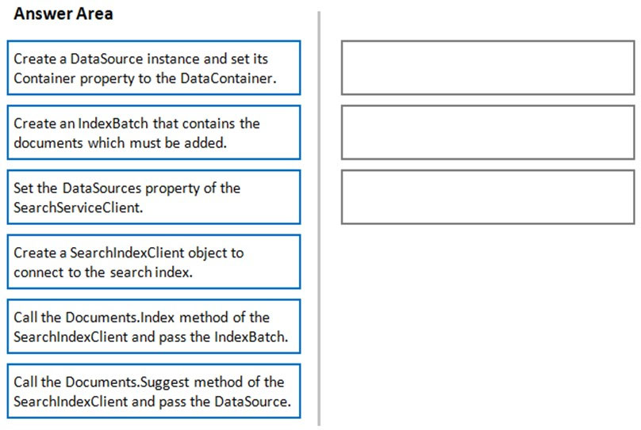

[Hide Solution](https://www.examtopics.com/exams/microsoft/az-204/view/3/) [Discussion   **8**](https://www.examtopics.com/exams/microsoft/az-204/view/3/)

**Correct Answer:** 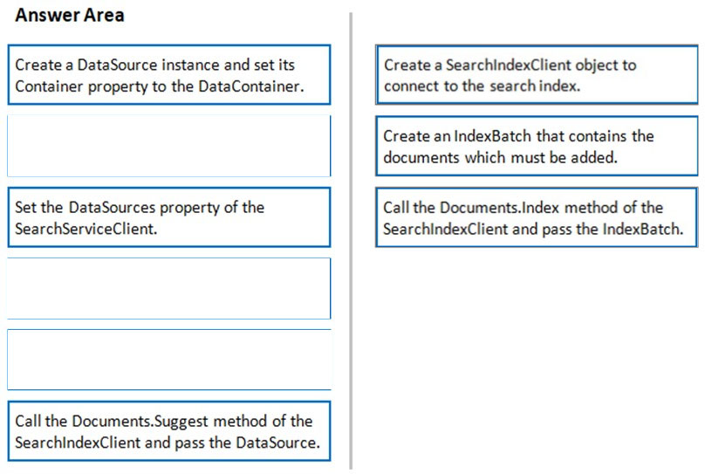  
1. The index needs to be populated. To do this, we will need a SearchIndexClient. There are two ways to obtain one: by constructing it, or by calling  
Indexes.GetClient on the SearchServiceClient. Here we will use the first method.  
2. Create the indexBatch with the documents  
Something like:  
var hotels = new Hotel[];  
{  
new Hotel()  
{  
HotelId = "3",  
BaseRate = 129.99,  
Description = "Close to town hall and the river"  
}  
};  
ג€¦  
var batch = IndexBatch.Upload(hotels);  
3. The next step is to populate the newly-created index  
Example:  
var batch = IndexBatch.Upload(hotels);  
try  
{  
indexClient.Documents.Index(batch);  
}  
Reference:  
https://docs.microsoft.com/en-us/azure/search/search-howto-dotnet-sdk

Question #31*Topic 1*

You are developing an application that applies a set of governance policies for internal and external services, as well as for applications.  
You develop a stateful ASP.NET Core 2.1 web application named PolicyApp and deploy it to an Azure App Service Web App. The PolicyApp reacts to events from  
Azure Event Grid and performs policy actions based on those events.  
You have the following requirements:  
✑ Authentication events must be used to monitor users when they sign in and sign out.  
✑ All authentication events must be processed by PolicyApp.  
✑ Sign outs must be processed as fast as possible.  
What should you do?

* A. Create a new Azure Event Grid subscription for all authentication events. Use the subscription to process sign-out events.
* B. Create a separate Azure Event Grid handler for sign-in and sign-out events.
* C. Create separate Azure Event Grid topics and subscriptions for sign-in and sign-out events. **Most Voted**
* D. Add a subject prefix to sign-out events. Create an Azure Event Grid subscription. Configure the subscription to use the subjectBeginsWith filter. **Most Voted**

[Hide Solution](https://www.examtopics.com/exams/microsoft/az-204/view/4/) [Discussion   **35**](https://www.examtopics.com/exams/microsoft/az-204/view/4/)

**Correct Answer:** *D* [🗳️](https://www.examtopics.com/exams/microsoft/az-204/view/4/)  
Reference:  
https://docs.microsoft.com/en-us/azure/event-grid/subscription-creation-schema

*Community vote distribution*

C (54%)

D (46%)

Question #32*Topic 1*

HOTSPOT -  
You are developing a C++ application that compiles to a native application named process.exe. The application accepts images as input and returns images in one of the following image formats: GIF, PNG, or JPEG.  
You must deploy the application as an Azure Function.  
You need to configure the function and host json files.  
How should you complete the json files? To answer, select the appropriate options in the answer area.  
NOTE: Each correct selection is worth one point.  
Hot Area:  
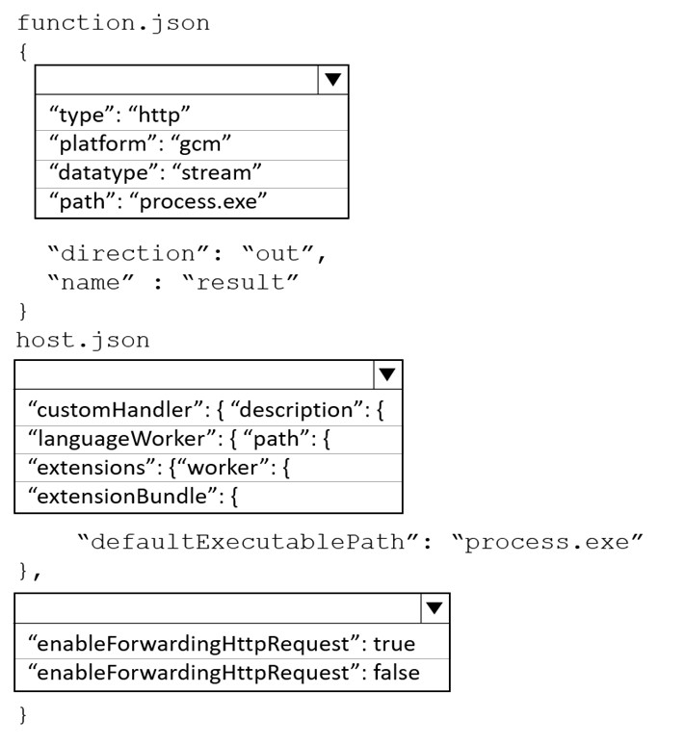

[Hide Solution](https://www.examtopics.com/exams/microsoft/az-204/view/4/) [Discussion   **24**](https://www.examtopics.com/exams/microsoft/az-204/view/4/)

**Correct Answer:** 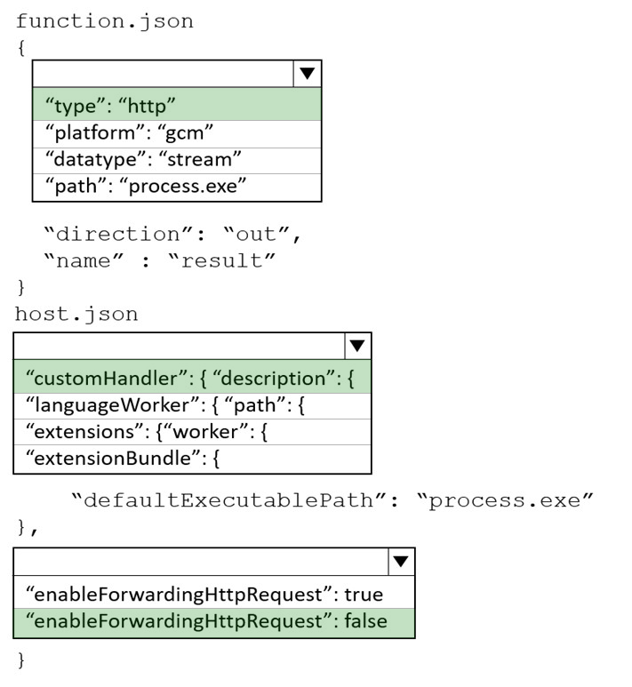  
Box 1: "type": "http"  
Box 2: "customHandler": { "description":{  
A custom handler is defined by configuring the host.json file with details on how to run the web server via the customHandler section.  
The customHandler section points to a target as defined by the defaultExecutablePath.  
Example:  
"customHandler": {  
"description": {  
"defaultExecutablePath": "handler.exe"  
Box 3: "enableForwardingHttpRequest": false  
Incorrect:  
For HTTP-triggered functions with no additional bindings or outputs, you may want your handler to work directly with the HTTP request and response instead of the custom handler request and response payloads. This behavior can be configured in host.json using the enableForwardingHttpRequest setting.  
At the root of the app, the host.json file is configured to run handler.exe and enableForwardingHttpRequest is set to true.  
Reference:  
https://docs.microsoft.com/en-us/azure/azure-functions/functions-custom-handlers

Question #33*Topic 1*

HOTSPOT  
-  
  
You are developing an Azure Static Web app that contains training materials for a tool company. Each tool’s training material is contained in a static web page that is linked from the tool’s publicly available description page.  
  
A user must be authenticated using Azure AD prior to viewing training.  
  
You need to ensure that the user can view training material pages after authentication.  
  
How should you complete the configuration file? To answer, select the appropriate options in the answer area.  
  
NOTE: Each correct selection is worth one point.  
  
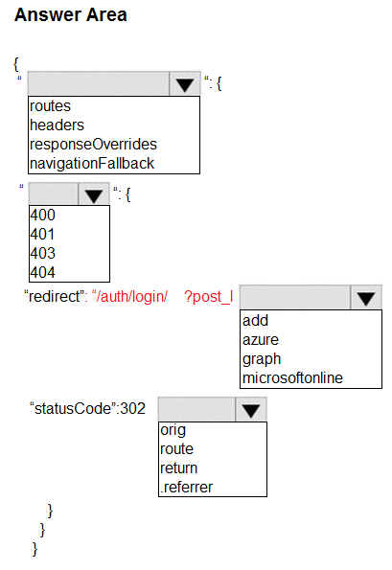

[Hide Solution](https://www.examtopics.com/exams/microsoft/az-204/view/4/) [Discussion   **11**](https://www.examtopics.com/exams/microsoft/az-204/view/4/)

**Correct Answer:** 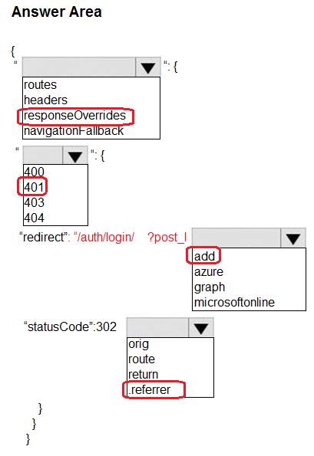

Question #34*Topic 1*

HOTSPOT  
-  
  
You are authoring a set of nested Azure Resource Manager templates to deploy Azure resources. You author an Azure Resource Manager template named mainTemplate.json that contains the following linked templates: linkedTemplate1.json, linkedTemplate2.json.  
  
You add parameters to a parameters template file named mainTemplate.parameters,json. You save all templates on a local device in the C:\templates\ folder.  
  
You have the following requirements:  
  
• Store the templates in Azure for later deployment.  
• Enable versioning of the templates.  
• Manage access to the templates by using Azure RBAC.  
• Ensure that users have read-only access to the templates.  
• Allow users to deploy the templates.  
  
You need to store the templates in Azure.  
  
How should you complete the command? To answer, select the appropriate options in the answer area.  
  
NOTE: Each correct selection is worth one point.  
  
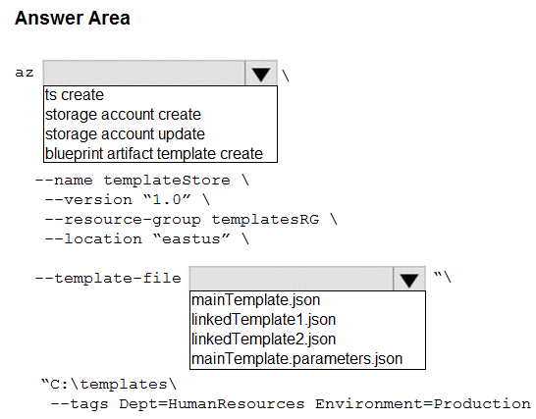

[Hide Solution](https://www.examtopics.com/exams/microsoft/az-204/view/4/) [Discussion   **7**](https://www.examtopics.com/exams/microsoft/az-204/view/4/)

**Correct Answer:** 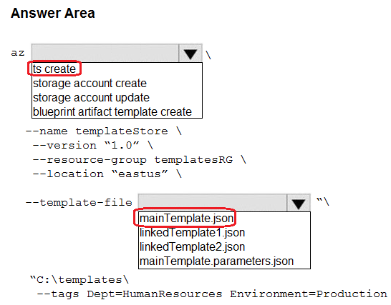

Question #35*Topic 1*

HOTSPOT  
-  
  
You are developing a service where customers can report news events from a browser using Azure Web PubSub. The service is implemented as an Azure Function App that uses the JSON WebSocket subprotocol to receive news events.  
  
You need to implement the bindings for the Azure Function App.  
  
How should you configure the binding? To answer, select the appropriate options in the answer area.  
  
NOTE: Each correct selection is worth one point.  
  
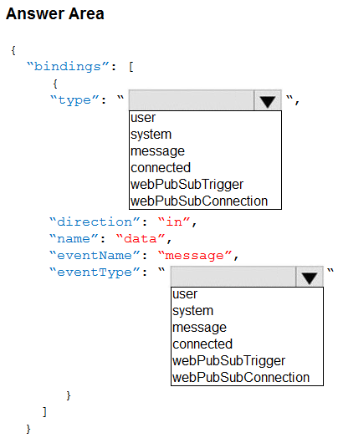

[Hide Solution](https://www.examtopics.com/exams/microsoft/az-204/view/4/) [Discussion   **8**](https://www.examtopics.com/exams/microsoft/az-204/view/4/)

**Correct Answer:** 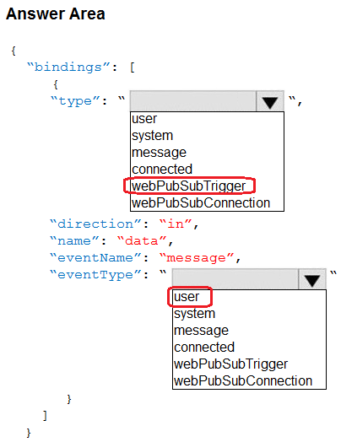

Question #36*Topic 1*

HOTSPOT  
-  
  
You are building a software-as-a-service (SaaS) application that analyzes DNA data that will run on Azure virtual machines (VMs) in an availability zone. The data is stored on managed disks attached to the VM. The performance of the analysis is determined by the speed of the disk attached to the VM.  
  
You have the following requirements:  
  
• The application must be able to quickly revert to the previous day’s data if a systemic error is detected.  
• The application must minimize downtime in the case of an Azure datacenter outage.  
  
You need to provision the managed disk for the VM to maximize performance while meeting the requirements.  
  
Which type of Azure Managed Disk should you use? To answer, select the appropriate options in the answer area.  
  
NOTE: Each correct selection is worth one point.  
  
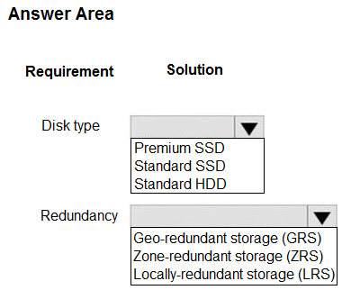

[Hide Solution](https://www.examtopics.com/exams/microsoft/az-204/view/4/) [Discussion   **9**](https://www.examtopics.com/exams/microsoft/az-204/view/4/)

**Correct Answer:** 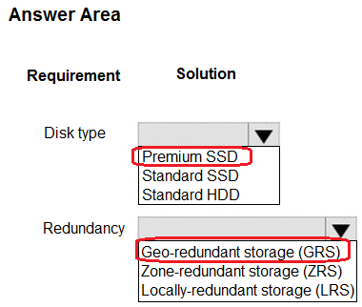

Question #37*Topic 1*

HOTSPOT  
-  
  
You are developing an application that includes two Docker containers.  
  
The application must meet the following requirements:  
  
• The containers must not run as root.  
• The containers must be deployed to Azure Container Instances by using a YAML file.  
• The containers must share a lifecycle, resources, local network, and storage volume.  
• The storage volume must persist through container crashes.  
• The storage volume must be deployed on stop or restart of the containers.  
  
You need to configure Azure Container Instances for the application.  
  
Which configuration values should you use? To answer, select the appropriate options in the answer area.  
  
NOTE: Each correct selection is worth one point.  
  
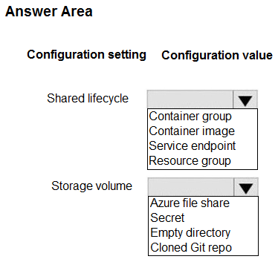

[Hide Solution](https://www.examtopics.com/exams/microsoft/az-204/view/4/) [Discussion   **18**](https://www.examtopics.com/exams/microsoft/az-204/view/4/)

**Correct Answer:** **

**Topic 2 - Question Set 2**

Question #1*Topic 2*

HOTSPOT -  
You are implementing a software as a service (SaaS) ASP.NET Core web service that will run as an Azure Web App. The web service will use an on-premises  
SQL Server database for storage. The web service also includes a WebJob that processes data updates. Four customers will use the web service.  
✑ Each instance of the WebJob processes data for a single customer and must run as a singleton instance.  
✑ Each deployment must be tested by using deployment slots prior to serving production data.  
✑ Azure costs must be minimized.  
✑ Azure resources must be located in an isolated network.  
You need to configure the App Service plan for the Web App.  
How should you configure the App Service plan? To answer, select the appropriate settings in the answer area.  
NOTE: Each correct selection is worth one point.  
Hot Area:  
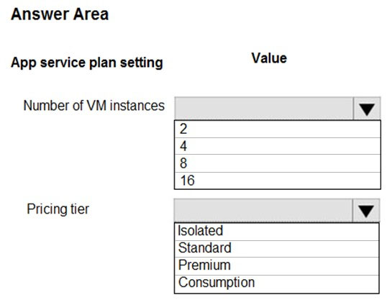

[Hide Solution](https://www.examtopics.com/exams/microsoft/az-204/view/4/) [Discussion   **34**](https://www.examtopics.com/exams/microsoft/az-204/view/4/)

**Correct Answer:** 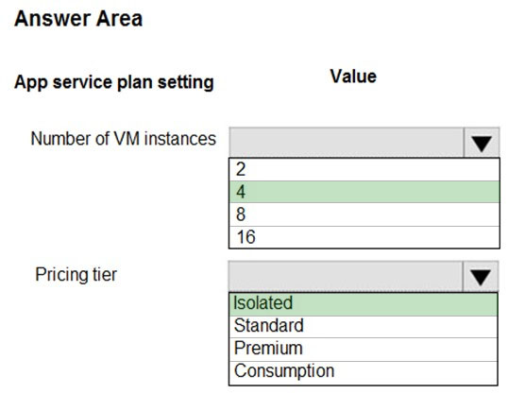  
Number of VM instances: 4 -  
You are not charged extra for deployment slots.  
  
Pricing tier: Isolated -  
The App Service Environment (ASE) is a powerful feature offering of the Azure App Service that gives network isolation and improved scale capabilities. It is essentially a deployment of the Azure App Service into a subnet of a customer's Azure Virtual Network (VNet).  
Reference:  
https://azure.microsoft.com/sv-se/blog/announcing-app-service-isolated-more-power-scale-and-ease-of-use/

Question #2*Topic 2*

DRAG DROP -  
You are a developer for a software as a service (SaaS) company that uses an Azure Function to process orders. The Azure Function currently runs on an Azure  
Function app that is triggered by an Azure Storage queue.  
You are preparing to migrate the Azure Function to Kubernetes using Kubernetes-based Event Driven Autoscaling (KEDA).  
You need to configure Kubernetes Custom Resource Definitions (CRD) for the Azure Function.  
Which CRDs should you configure? To answer, drag the appropriate CRD types to the correct locations. Each CRD type may be used once, more than once, or not at all. You may need to drag the split bar between panes or scroll to view content.  
NOTE: Each correct selection is worth one point.  
Select and Place:  
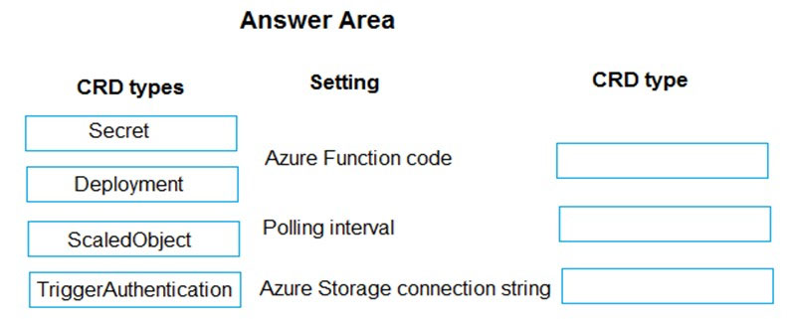

[Hide Solution](https://www.examtopics.com/exams/microsoft/az-204/view/4/) [Discussion   **16**](https://www.examtopics.com/exams/microsoft/az-204/view/4/)

**Correct Answer:** 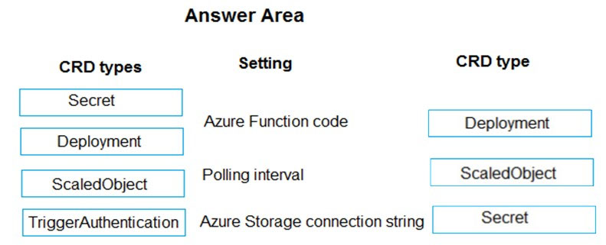  
Box 1: Deployment -  
To deploy Azure Functions to Kubernetes use the func kubernetes deploy command has several attributes that directly control how our app scales, once it is deployed to Kubernetes.  
  
Box 2: ScaledObject -  
With --polling-interval, we can control the interval used by KEDA to check Azure Service Bus Queue for messages.  
Example of ScaledObject with polling interval  
apiVersion: keda.k8s.io/v1alpha1  
kind: ScaledObject  
metadata:  
name: transformer-fn  
namespace: tt  
labels:  
deploymentName: transformer-fn  
spec:  
scaleTargetRef:  
deploymentName: transformer-fn  
pollingInterval: 5  
minReplicaCount: 0  
maxReplicaCount: 100  
  
Box 3: Secret -  
Store connection strings in Kubernetes Secrets.  
Example: to create the Secret in our demo Namespace:  
# create the k8s demo namespace  
kubectl create namespace tt  
# grab connection string from Azure Service Bus  
KEDA_SCALER_CONNECTION_STRING=$(az servicebus queue authorization-rule keys list \  
-g $RG_NAME \  
--namespace-name $SBN_NAME \  
--queue-name inbound \  
-n keda-scaler \  
--query "primaryConnectionString" \  
-o tsv)  
# create the kubernetes secret  
kubectl create secret generic tt-keda-auth \  
--from-literal KedaScaler=$KEDA_SCALER_CONNECTION_STRING \  
--namespace tt  
Reference:  
https://www.thinktecture.com/en/kubernetes/serverless-workloads-with-keda/

Question #3*Topic 2*

HOTSPOT -  
You are creating a CLI script that creates an Azure web app and related services in Azure App Service. The web app uses the following variables:  
  
You need to automatically deploy code from GitHub to the newly created web app.  
How should you complete the script? To answer, select the appropriate options in the answer area.  
NOTE: Each correct selection is worth one point.  
Hot Area:  
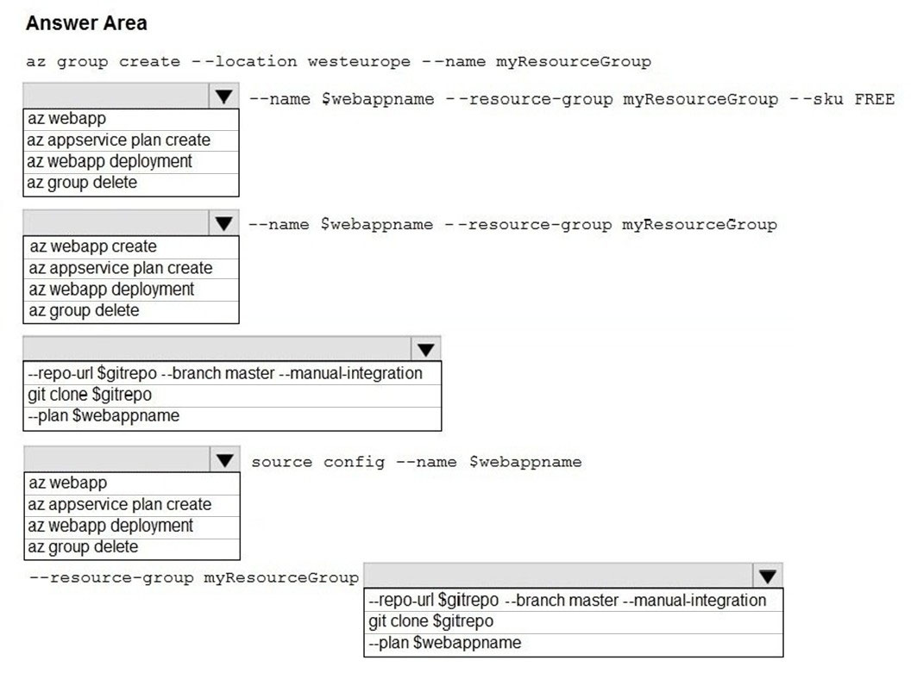

[Hide Solution](https://www.examtopics.com/exams/microsoft/az-204/view/4/) [Discussion   **31**](https://www.examtopics.com/exams/microsoft/az-204/view/4/)

**Correct Answer:** 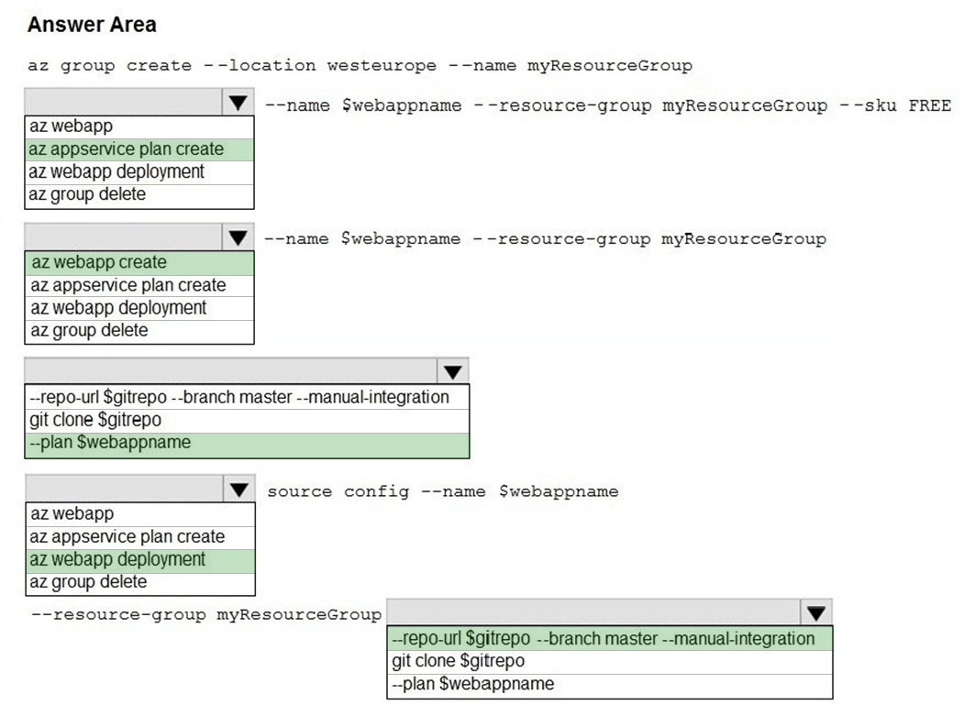  
Box 1: az appservice plan create  
The azure group creates command successfully returns JSON result. Now we can use resource group to create a azure app service plan  
  
Box 2: az webapp create -  
Create a new web app..  
  
Box 3: --plan $webappname -  
..with the serviceplan we created in step 1.  
  
Box 4: az webapp deployment -  
Continuous Delivery with GitHub. Example:  
az webapp deployment source config --name firstsamplewebsite1 --resource-group websites--repo-url $gitrepo --branch master --git-token $token  
Box 5: --repo-url $gitrepo --branch master --manual-integration  
Reference:  
https://medium.com/@satish1v/devops-your-way-to-azure-web-apps-with-azure-cli-206ed4b3e9b1

Question #4*Topic 2*

Note: This question is part of a series of questions that present the same scenario. Each question in the series contains a unique solution that might meet the stated goals. Some question sets might have more than one correct solution, while others might not have a correct solution.  
After you answer a question in this section, you will NOT be able to return to it. As a result, these questions will not appear in the review screen.  
You develop a software as a service (SaaS) offering to manage photographs. Users upload photos to a web service which then stores the photos in Azure  
Storage Blob storage. The storage account type is General-purpose V2.  
When photos are uploaded, they must be processed to produce and save a mobile-friendly version of the image. The process to produce a mobile-friendly version of the image must start in less than one minute.  
You need to design the process that starts the photo processing.  
Solution: Trigger the photo processing from Blob storage events.  
Does the solution meet the goal?

* A. Yes
* B. No **Most Voted**

[Hide Solution](https://www.examtopics.com/exams/microsoft/az-204/view/5/) [Discussion   **64**](https://www.examtopics.com/exams/microsoft/az-204/view/5/)

**Correct Answer:** *B* [🗳️](https://www.examtopics.com/exams/microsoft/az-204/view/5/)  
You need to catch the triggered event, so move the photo processing to an Azure Function triggered from the blob upload.  
Note: Azure Storage events allow applications to react to events. Common Blob storage event scenarios include image or video processing, search indexing, or any file-oriented workflow.  
Events are pushed using Azure Event Grid to subscribers such as Azure Functions, Azure Logic Apps, or even to your own http listener.  
However, the processing must start in less than one minute.  
Note: Only storage accounts of kind StorageV2 (general purpose v2) and BlobStorage support event integration. Storage (general purpose v1) does not support integration with Event Grid.  
Reference:  
https://docs.microsoft.com/en-us/azure/storage/blobs/storage-blob-event-overview

*Community vote distribution*

B (67%)

A (33%)

Question #5*Topic 2*

Note: This question is part of a series of questions that present the same scenario. Each question in the series contains a unique solution that might meet the stated goals. Some question sets might have more than one correct solution, while others might not have a correct solution.  
After you answer a question in this section, you will NOT be able to return to it. As a result, these questions will not appear in the review screen.  
You develop and deploy an Azure App Service API app to a Windows-hosted deployment slot named Development. You create additional deployment slots named Testing and Production. You enable auto swap on the Production deployment slot.  
You need to ensure that scripts run and resources are available before a swap operation occurs.  
Solution: Update the web.config file to include the applicationInitialization configuration element. Specify custom initialization actions to run the scripts.  
Does the solution meet the goal?

* A. No
* B. Yes **Most Voted**

[Hide Solution](https://www.examtopics.com/exams/microsoft/az-204/view/5/) [Discussion   **23**](https://www.examtopics.com/exams/microsoft/az-204/view/5/)

**Correct Answer:** *A* [🗳️](https://www.examtopics.com/exams/microsoft/az-204/view/5/)  
Specify custom warm-up.  
Some apps might require custom warm-up actions before the swap. The applicationInitialization configuration element in web.config lets you specify custom initialization actions. The swap operation waits for this custom warm-up to finish before swapping with the target slot. Here's a sample web.config fragment.  
<system.webServer>  
<applicationInitialization>  
<add initializationPage="/" hostName="[app hostname]" />  
<add initializationPage="/Home/About" hostName="[app hostname]" />  
</applicationInitialization>  
</system.webServer>  
Reference:  
https://docs.microsoft.com/en-us/azure/app-service/deploy-staging-slots#troubleshoot-swaps

*Community vote distribution*

B (81%)

A (19%)

Question #6*Topic 2*

Note: This question is part of a series of questions that present the same scenario. Each question in the series contains a unique solution that might meet the stated goals. Some question sets might have more than one correct solution, while others might not have a correct solution.  
After you answer a question in this section, you will NOT be able to return to it. As a result, these questions will not appear in the review screen.  
You develop and deploy an Azure App Service API app to a Windows-hosted deployment slot named Development. You create additional deployment slots named Testing and Production. You enable auto swap on the Production deployment slot.  
You need to ensure that scripts run and resources are available before a swap operation occurs.  
Solution: Enable auto swap for the Testing slot. Deploy the app to the Testing slot.  
Does the solution meet the goal?

* A. No **Most Voted**
* B. Yes

[Hide Solution](https://www.examtopics.com/exams/microsoft/az-204/view/5/) [Discussion   **15**](https://www.examtopics.com/exams/microsoft/az-204/view/5/)

**Correct Answer:** *B* [🗳️](https://www.examtopics.com/exams/microsoft/az-204/view/5/)  
Instead update the web.config file to include the applicationInitialization configuration element. Specify custom initialization actions to run the scripts.  
Note: Some apps might require custom warm-up actions before the swap. The applicationInitialization configuration element in web.config lets you specify custom initialization actions. The swap operation waits for this custom warm-up to finish before swapping with the target slot. Here's a sample web.config fragment.  
<system.webServer>  
<applicationInitialization>  
<add initializationPage="/" hostName="[app hostname]" />  
<add initializationPage="/Home/About" hostName="[app hostname]" />  
</applicationInitialization>  
</system.webServer>  
Reference:  
https://docs.microsoft.com/en-us/azure/app-service/deploy-staging-slots#troubleshoot-swaps

*Community vote distribution*

A (70%)

B (30%)

Question #7*Topic 2*

Note: This question is part of a series of questions that present the same scenario. Each question in the series contains a unique solution that might meet the stated goals. Some question sets might have more than one correct solution, while others might not have a correct solution.  
After you answer a question in this section, you will NOT be able to return to it. As a result, these questions will not appear in the review screen.  
You develop and deploy an Azure App Service API app to a Windows-hosted deployment slot named Development. You create additional deployment slots named Testing and Production. You enable auto swap on the Production deployment slot.  
You need to ensure that scripts run and resources are available before a swap operation occurs.  
Solution: Disable auto swap. Update the app with a method named statuscheck to run the scripts. Re-enable auto swap and deploy the app to the Production slot.  
Does the solution meet the goal?

* A. No **Most Voted**
* B. Yes

[Hide Solution](https://www.examtopics.com/exams/microsoft/az-204/view/5/) [Discussion   **21**](https://www.examtopics.com/exams/microsoft/az-204/view/5/)

**Correct Answer:** *B* [🗳️](https://www.examtopics.com/exams/microsoft/az-204/view/5/)  
Instead update the web.config file to include the applicationInitialization configuration element. Specify custom initialization actions to run the scripts.  
Note: Some apps might require custom warm-up actions before the swap. The applicationInitialization configuration element in web.config lets you specify custom initialization actions. The swap operation waits for this custom warm-up to finish before swapping with the target slot. Here's a sample web.config fragment.  
<system.webServer>  
<applicationInitialization>  
<add initializationPage="/" hostName="[app hostname]" />  
<add initializationPage="/Home/About" hostName="[app hostname]" />  
</applicationInitialization>  
</system.webServer>  
Reference:  
https://docs.microsoft.com/en-us/azure/app-service/deploy-staging-slots#troubleshoot-swaps

*Community vote distribution*

A (86%)

14%

Question #8*Topic 2*

Note: This question is part of a series of questions that present the same scenario. Each question in the series contains a unique solution that might meet the stated goals. Some question sets might have more than one correct solution, while others might not have a correct solution.  
After you answer a question in this section, you will NOT be able to return to it. As a result, these questions will not appear in the review screen.  
You develop a software as a service (SaaS) offering to manage photographs. Users upload photos to a web service which then stores the photos in Azure  
Storage Blob storage. The storage account type is General-purpose V2.  
When photos are uploaded, they must be processed to produce and save a mobile-friendly version of the image. The process to produce a mobile-friendly version of the image must start in less than one minute.  
You need to design the process that starts the photo processing.  
Solution: Convert the Azure Storage account to a BlockBlobStorage storage account.  
Does the solution meet the goal?

* A. Yes
* B. No **Most Voted**

[Hide Solution](https://www.examtopics.com/exams/microsoft/az-204/view/5/) [Discussion   **25**](https://www.examtopics.com/exams/microsoft/az-204/view/5/)

**Correct Answer:** *B* [🗳️](https://www.examtopics.com/exams/microsoft/az-204/view/5/)  
Not necessary to convert the account, instead move photo processing to an Azure Function triggered from the blob upload..  
Azure Storage events allow applications to react to events. Common Blob storage event scenarios include image or video processing, search indexing, or any file- oriented workflow.  
Note: Only storage accounts of kind StorageV2 (general purpose v2) and BlobStorage support event integration. Storage (general purpose v1) does not support integration with Event Grid.  
Reference:  
https://docs.microsoft.com/en-us/azure/storage/blobs/storage-blob-event-overview

*Community vote distribution*

B (88%)

13%

Question #9*Topic 2*

HOTSPOT -  
You are developing an Azure Web App. You configure TLS mutual authentication for the web app.  
You need to validate the client certificate in the web app. To answer, select the appropriate options in the answer area.  
NOTE: Each correct selection is worth one point.  
Hot Area:  
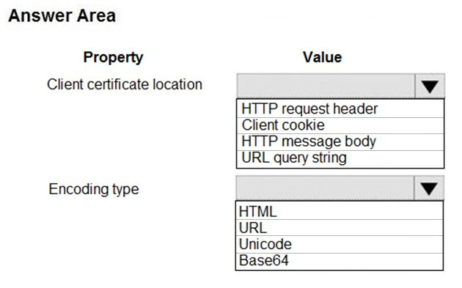

[Hide Solution](https://www.examtopics.com/exams/microsoft/az-204/view/5/) [Discussion   **23**](https://www.examtopics.com/exams/microsoft/az-204/view/5/)

**Correct Answer:** 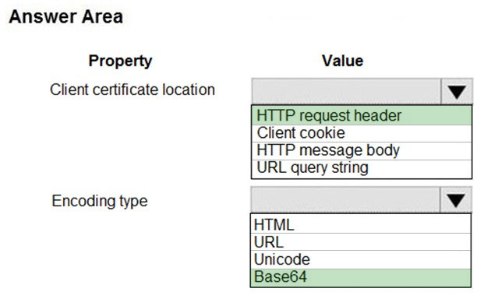  
Accessing the client certificate from App Service.  
If you are using ASP.NET and configure your app to use client certificate authentication, the certificate will be available through the HttpRequest.ClientCertificate property. For other application stacks, the client cert will be available in your app through a base64 encoded value in the "X-ARR-ClientCert" request header. Your application can create a certificate from this value and then use it for authentication and authorization purposes in your application.  
Reference:  
https://docs.microsoft.com/en-us/azure/app-service/app-service-web-configure-tls-mutual-auth

Question #10*Topic 2*

DRAG DROP -  
You are developing a Docker/Go using Azure App Service Web App for Containers. You plan to run the container in an App Service on Linux. You identify a  
Docker container image to use.  
None of your current resource groups reside in a location that supports Linux. You must minimize the number of resource groups required.  
You need to create the application and perform an initial deployment.  
Which three Azure CLI commands should you use to develop the solution? To answer, move the appropriate commands from the list of commands to the answer area and arrange them in the correct order.  
Select and Place:  
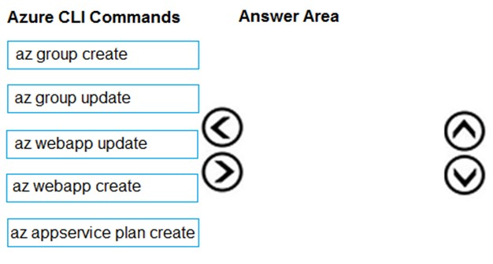

[Hide Solution](https://www.examtopics.com/exams/microsoft/az-204/view/5/) [Discussion   **53**](https://www.examtopics.com/exams/microsoft/az-204/view/5/)

**Correct Answer:** 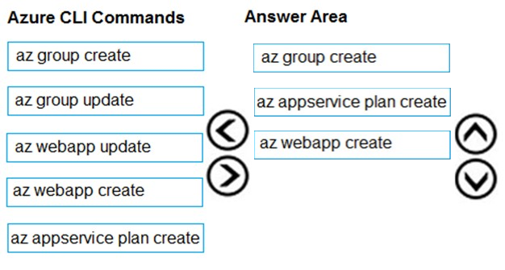  
You can host native Linux applications in the cloud by using Azure Web Apps. To create a Web App for Containers, you must run Azure CLI commands that create a group, then a service plan, and finally the web app itself.  
  
Step 1: az group create -  
In the Cloud Shell, create a resource group with the az group create command.  
Step 2: az appservice plan create  
In the Cloud Shell, create an App Service plan in the resource group with the az appservice plan create command.  
  
Step 3: az webapp create -  
In the Cloud Shell, create a web app in the myAppServicePlan App Service plan with the az webapp create command. Don't forget to replace with a unique app name, and <docker-ID> with your Docker ID.  
Reference:  
https://docs.microsoft.com/mt-mt/azure/app-service/containers/quickstart-docker-go?view=sql-server-ver15

Question #11*Topic 2*

DRAG DROP -  
Fourth Coffee has an ASP.NET Core web app that runs in Docker. The app is mapped to the www.fourthcoffee.com domain.  
Fourth Coffee is migrating this application to Azure.  
You need to provision an App Service Web App to host this docker image and map the custom domain to the App Service web app.  
A resource group named FourthCoffeePublicWebResourceGroup has been created in the WestUS region that contains an App Service Plan named  
AppServiceLinuxDockerPlan.  
Which order should the CLI commands be used to develop the solution? To answer, move all of the Azure CLI commands from the list of commands to the answer area and arrange them in the correct order.  
Select and Place:  
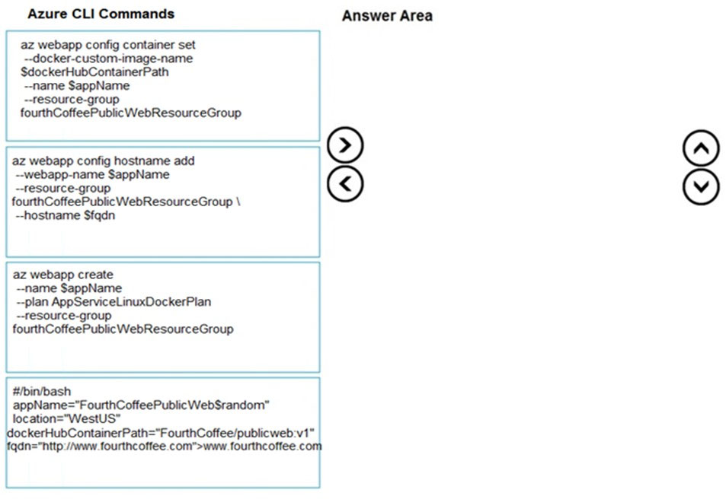

[Hide Solution](https://www.examtopics.com/exams/microsoft/az-204/view/5/) [Discussion   **23**](https://www.examtopics.com/exams/microsoft/az-204/view/5/)

**Correct Answer:** 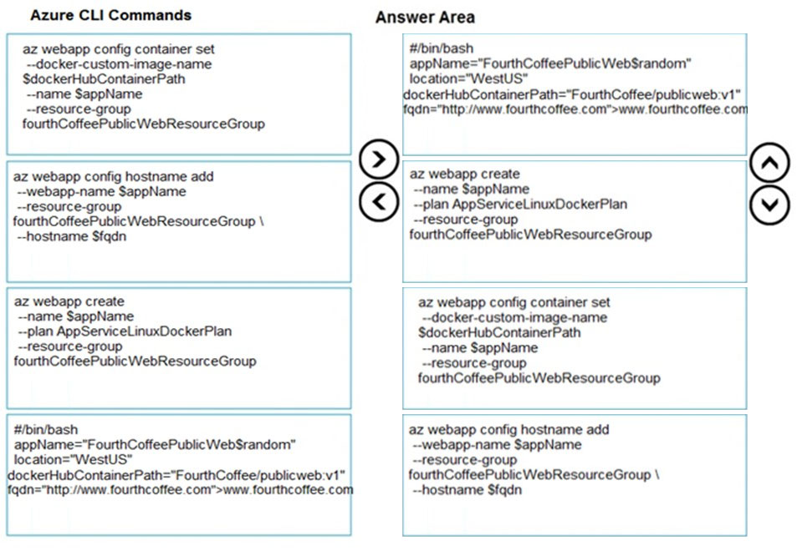  
Step 1: #bin/bash -  
The appName is used when the webapp-name is created in step 2.  
  
Step 2: az webapp create -  
Create a web app. In the Cloud Shell, create a web app in the myAppServicePlan App Service plan with the az webapp create command.  
Step 3: az webapp config container set  
In Create a web app, you specified an image on Docker Hub in the az webapp create command. This is good enough for a public image. To use a private image, you need to configure your Docker account ID and password in your Azure web app.  
Step 4: az webapp config hostname add  
The webapp-name is used when the webapp is created in step 2.  
In the Cloud Shell, follow the az webapp create command with az webapp config container set.  
Reference:  
https://docs.microsoft.com/en-us/azure/app-service/containers/tutorial-custom-docker-image https://docs.microsoft.com/en-us/azure/app-service/tutorial-custom-container?pivots=container-linux https://docs.microsoft.com/en-us/azure/app-service/scripts/cli-configure-custom-domain

Question #12*Topic 2*

DRAG DROP -  
You are developing a serverless Java application on Azure. You create a new Azure Key Vault to work with secrets from a new Azure Functions application.  
The application must meet the following requirements:  
✑ Reference the Azure Key Vault without requiring any changes to the Java code.  
✑ Dynamically add and remove instances of the Azure Functions host based on the number of incoming application events.  
✑ Ensure that instances are perpetually warm to avoid any cold starts.  
✑ Connect to a VNet.  
✑ Authentication to the Azure Key Vault instance must be removed if the Azure Function application is deleted.  
You need to grant the Azure Functions application access to the Azure Key Vault.  
Which three actions should you perform in sequence? To answer, move the appropriate actions from the list of actions to the answer area and arrange them in the correct order.  
Select and Place:  
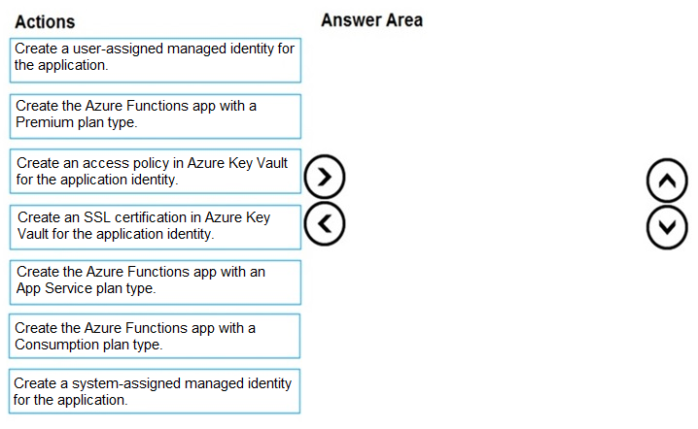

[Hide Solution](https://www.examtopics.com/exams/microsoft/az-204/view/5/) [Discussion   **39**](https://www.examtopics.com/exams/microsoft/az-204/view/5/)

**Correct Answer:** 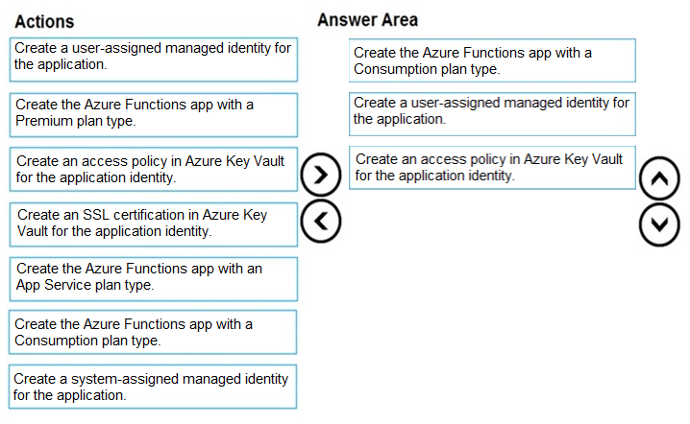  
Step 1: Create the Azure Functions app with a Consumption plan type.  
Use the Consumption plan for serverless.  
Step 2: Create a system-assigned managed identity for the application.  
Create a system-assigned managed identity for your application.  
Key Vault references currently only support system-assigned managed identities. User-assigned identities cannot be used.  
Step 3: Create an access policy in Key Vault for the application identity.  
Create an access policy in Key Vault for the application identity you created earlier. Enable the "Get" secret permission on this policy. Do not configure the  
"authorized application" or applicationId settings, as this is not compatible with a managed identity.  
Reference:  
https://docs.microsoft.com/en-us/azure/app-service/app-service-key-vault-references

Question #13*Topic 2*

You develop a website. You plan to host the website in Azure. You expect the website to experience high traffic volumes after it is published.  
You must ensure that the website remains available and responsive while minimizing cost.  
You need to deploy the website.  
What should you do?

* A. Deploy the website to a virtual machine. Configure the virtual machine to automatically scale when the CPU load is high.
* B. Deploy the website to an App Service that uses the Shared service tier. Configure the App Service plan to automatically scale when the CPU load is high.
* C. Deploy the website to a virtual machine. Configure a Scale Set to increase the virtual machine instance count when the CPU load is high.
* D. Deploy the website to an App Service that uses the Standard service tier. Configure the App Service plan to automatically scale when the CPU load is high. **Most Voted**

[Hide Solution](https://www.examtopics.com/exams/microsoft/az-204/view/5/) [Discussion   **42**](https://www.examtopics.com/exams/microsoft/az-204/view/5/)

**Correct Answer:** *D* [🗳️](https://www.examtopics.com/exams/microsoft/az-204/view/5/)  
Windows Azure Web Sites (WAWS) offers 3 modes: Standard, Free, and Shared.  
Standard mode carries an enterprise-grade SLA (Service Level Agreement) of 99.9% monthly, even for sites with just one instance.  
Standard mode runs on dedicated instances, making it different from the other ways to buy Windows Azure Web Sites.  
Incorrect Answers:  
B: Shared and Free modes do not offer the scaling flexibility of Standard, and they have some important limits.  
Shared mode, just as the name states, also uses shared Compute resources, and also has a CPU limit. So, while neither Free nor Shared is likely to be the best choice for your production environment due to these limits.

*Community vote distribution*

D (100%)

Question #14*Topic 2*

HOTSPOT -  
A company is developing a Java web app. The web app code is hosted in a GitHub repository located at https://github.com/Contoso/webapp.  
The web app must be evaluated before it is moved to production. You must deploy the initial code release to a deployment slot named staging.  
You need to create the web app and deploy the code.  
How should you complete the commands? To answer, select the appropriate options in the answer area.  
NOTE: Each correct selection is worth one point.  
Hot Area:  
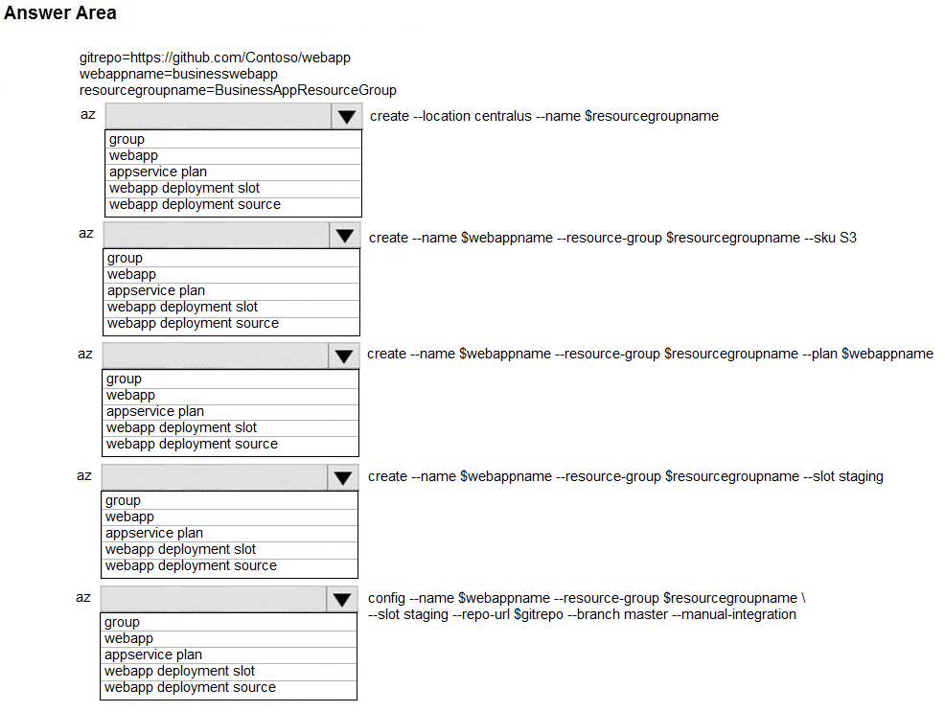

[Hide Solution](https://www.examtopics.com/exams/microsoft/az-204/view/6/) [Discussion   **37**](https://www.examtopics.com/exams/microsoft/az-204/view/6/)

**Correct Answer:** 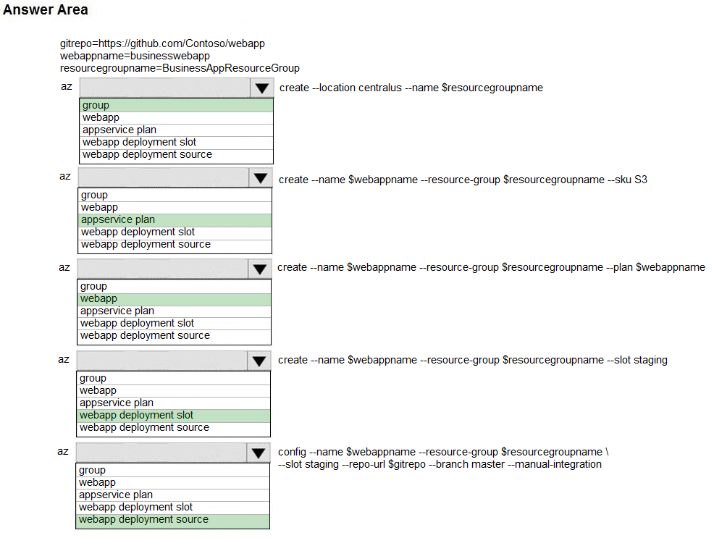  
Box 1: group -  
# Create a resource group.  
az group create --location westeurope --name myResourceGroup  
  
Box 2: appservice plan -  
# Create an App Service plan in STANDARD tier (minimum required by deployment slots). az appservice plan create --name $webappname --resource-group myResourceGroup --sku S1  
  
Box 3: webapp -  
# Create a web app.  
az webapp create --name $webappname --resource-group myResourceGroup \  
--plan $webappname  
  
Box 4: webapp deployment slot -  
#Create a deployment slot with the name "staging".  
az webapp deployment slot create --name $webappname --resource-group myResourceGroup \  
--slot staging  
  
Box 5: webapp deployment source -  
# Deploy sample code to "staging" slot from GitHub.  
az webapp deployment source config --name $webappname --resource-group myResourceGroup \  
--slot staging --repo-url $gitrepo --branch master --manual-integration  
Reference:  
https://docs.microsoft.com/en-us/azure/app-service/scripts/cli-deploy-staging-environment

Question #15*Topic 2*

HOTSPOT -  
You have a web service that is used to pay for food deliveries. The web service uses Azure Cosmos DB as the data store.  
You plan to add a new feature that allows users to set a tip amount. The new feature requires that a property named tip on the document in Cosmos DB must be present and contain a numeric value.  
There are many existing websites and mobile apps that use the web service that will not be updated to set the tip property for some time.  
How should you complete the trigger?  
NOTE: Each correct selection is worth one point.  
Hot Area:  
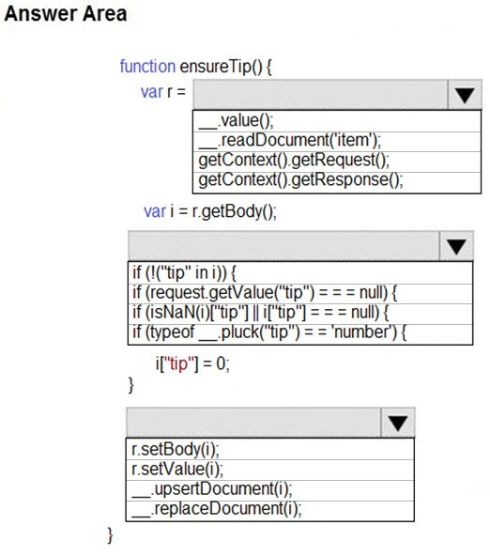

[Hide Solution](https://www.examtopics.com/exams/microsoft/az-204/view/6/) [Discussion   **87**](https://www.examtopics.com/exams/microsoft/az-204/view/6/)

**Correct Answer:** 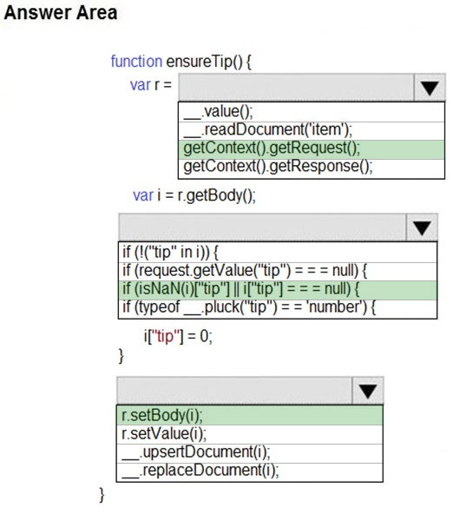

Question #16*Topic 2*

Note: This question is part of a series of questions that present the same scenario. Each question in the series contains a unique solution that might meet the stated goals. Some question sets might have more than one correct solution, while others might not have a correct solution.  
After you answer a question in this section, you will NOT be able to return to it. As a result, these questions will not appear in the review screen.  
You develop an HTTP triggered Azure Function app to process Azure Storage blob data. The app is triggered using an output binding on the blob.  
The app continues to time out after four minutes. The app must process the blob data.  
You need to ensure the app does not time out and processes the blob data.  
Solution: Use the Durable Function async pattern to process the blob data.  
Does the solution meet the goal?

* A. Yes **Most Voted**
* B. No

[Hide Solution](https://www.examtopics.com/exams/microsoft/az-204/view/6/) [Discussion   **119**](https://www.examtopics.com/exams/microsoft/az-204/view/6/)

**Correct Answer:** *B* [🗳️](https://www.examtopics.com/exams/microsoft/az-204/view/6/)  
Instead pass the HTTP trigger payload into an Azure Service Bus queue to be processed by a queue trigger function and return an immediate HTTP success response.  
Note: Large, long-running functions can cause unexpected timeout issues. General best practices include:  
Whenever possible, refactor large functions into smaller function sets that work together and return responses fast. For example, a webhook or HTTP trigger function might require an acknowledgment response within a certain time limit; it's common for webhooks to require an immediate response. You can pass the  
HTTP trigger payload into a queue to be processed by a queue trigger function. This approach lets you defer the actual work and return an immediate response.  
Reference:  
https://docs.microsoft.com/en-us/azure/azure-functions/functions-best-practices

*Community vote distribution*

A (81%)

B (19%)

Question #17*Topic 2*

Note: This question is part of a series of questions that present the same scenario. Each question in the series contains a unique solution that might meet the stated goals. Some question sets might have more than one correct solution, while others might not have a correct solution.  
After you answer a question in this section, you will NOT be able to return to it. As a result, these questions will not appear in the review screen.  
You develop an HTTP triggered Azure Function app to process Azure Storage blob data. The app is triggered using an output binding on the blob.  
The app continues to time out after four minutes. The app must process the blob data.  
You need to ensure the app does not time out and processes the blob data.  
Solution: Pass the HTTP trigger payload into an Azure Service Bus queue to be processed by a queue trigger function and return an immediate HTTP success response.  
Does the solution meet the goal?

* A. Yes **Most Voted**
* B. No **Most Voted**

[Hide Solution](https://www.examtopics.com/exams/microsoft/az-204/view/6/) [Discussion   **55**](https://www.examtopics.com/exams/microsoft/az-204/view/6/)

**Correct Answer:** *A* [🗳️](https://www.examtopics.com/exams/microsoft/az-204/view/6/)  
Large, long-running functions can cause unexpected timeout issues. General best practices include:  
Whenever possible, refactor large functions into smaller function sets that work together and return responses fast. For example, a webhook or HTTP trigger function might require an acknowledgment response within a certain time limit; it's common for webhooks to require an immediate response. You can pass the  
HTTP trigger payload into a queue to be processed by a queue trigger function. This approach lets you defer the actual work and return an immediate response.  
Reference:  
https://docs.microsoft.com/en-us/azure/azure-functions/functions-best-practices

*Community vote distribution*

A (55%)

B (45%)

Question #18*Topic 2*

Note: This question is part of a series of questions that present the same scenario. Each question in the series contains a unique solution that might meet the stated goals. Some question sets might have more than one correct solution, while others might not have a correct solution.  
After you answer a question in this section, you will NOT be able to return to it. As a result, these questions will not appear in the review screen.  
You develop an HTTP triggered Azure Function app to process Azure Storage blob data. The app is triggered using an output binding on the blob.  
The app continues to time out after four minutes. The app must process the blob data.  
You need to ensure the app does not time out and processes the blob data.  
Solution: Configure the app to use an App Service hosting plan and enable the Always On setting.  
Does the solution meet the goal?

* A. Yes
* B. No

[Hide Solution](https://www.examtopics.com/exams/microsoft/az-204/view/6/) [Discussion   **20**](https://www.examtopics.com/exams/microsoft/az-204/view/6/)

**Correct Answer:** *B* [🗳️](https://www.examtopics.com/exams/microsoft/az-204/view/6/)  
Instead pass the HTTP trigger payload into an Azure Service Bus queue to be processed by a queue trigger function and return an immediate HTTP success response.  
Note: Large, long-running functions can cause unexpected timeout issues. General best practices include:  
Whenever possible, refactor large functions into smaller function sets that work together and return responses fast. For example, a webhook or HTTP trigger function might require an acknowledgment response within a certain time limit; it's common for webhooks to require an immediate response. You can pass the  
HTTP trigger payload into a queue to be processed by a queue trigger function. This approach lets you defer the actual work and return an immediate response.  
Reference:  
https://docs.microsoft.com/en-us/azure/azure-functions/functions-best-practices

*Community vote distribution*

B (67%)

A (33%)

Question #19*Topic 2*

Note: This question is part of a series of questions that present the same scenario. Each question in the series contains a unique solution that might meet the stated goals. Some question sets might have more than one correct solution, while others might not have a correct solution.  
After you answer a question in this section, you will NOT be able to return to it. As a result, these questions will not appear in the review screen.  
You develop a software as a service (SaaS) offering to manage photographs. Users upload photos to a web service which then stores the photos in Azure  
Storage Blob storage. The storage account type is General-purpose V2.  
When photos are uploaded, they must be processed to produce and save a mobile-friendly version of the image. The process to produce a mobile-friendly version of the image must start in less than one minute.  
You need to design the process that starts the photo processing.  
Solution: Move photo processing to an Azure Function triggered from the blob upload.  
Does the solution meet the goal?

* A. Yes **Most Voted**
* B. No **Most Voted**

[Hide Solution](https://www.examtopics.com/exams/microsoft/az-204/view/6/) [Discussion   **53**](https://www.examtopics.com/exams/microsoft/az-204/view/6/)

**Correct Answer:** *A* [🗳️](https://www.examtopics.com/exams/microsoft/az-204/view/6/)  
Azure Storage events allow applications to react to events. Common Blob storage event scenarios include image or video processing, search indexing, or any file- oriented workflow.  
Events are pushed using Azure Event Grid to subscribers such as Azure Functions, Azure Logic Apps, or even to your own http listener.  
Note: Only storage accounts of kind StorageV2 (general purpose v2) and BlobStorage support event integration. Storage (general purpose v1) does not support integration with Event Grid.  
Reference:  
https://docs.microsoft.com/en-us/azure/storage/blobs/storage-blob-event-overview

*Community vote distribution*

B (50%)

A (50%)

Question #20*Topic 2*

You are developing an application that uses Azure Blob storage.  
The application must read the transaction logs of all the changes that occur to the blobs and the blob metadata in the storage account for auditing purposes. The changes must be in the order in which they occurred, include only create, update, delete, and copy operations and be retained for compliance reasons.  
You need to process the transaction logs asynchronously.  
What should you do?

* A. Process all Azure Blob storage events by using Azure Event Grid with a subscriber Azure Function app.
* B. Enable the change feed on the storage account and process all changes for available events. **Most Voted**
* C. Process all Azure Storage Analytics logs for successful blob events.
* D. Use the Azure Monitor HTTP Data Collector API and scan the request body for successful blob events.

[Hide Solution](https://www.examtopics.com/exams/microsoft/az-204/view/6/) [Discussion   **22**](https://www.examtopics.com/exams/microsoft/az-204/view/6/)

**Correct Answer:** *B* [🗳️](https://www.examtopics.com/exams/microsoft/az-204/view/6/)  
Change feed support in Azure Blob Storage  
The purpose of the change feed is to provide transaction logs of all the changes that occur to the blobs and the blob metadata in your storage account. The change feed provides ordered, guaranteed, durable, immutable, read-only log of these changes. Client applications can read these logs at any time, either in streaming or in batch mode. The change feed enables you to build efficient and scalable solutions that process change events that occur in your Blob Storage account at a low cost.  
Reference:  
https://docs.microsoft.com/en-us/azure/storage/blobs/storage-blob-change-feed

*Community vote distribution*

B (100%)

Question #21*Topic 2*

DRAG DROP -  
You plan to create a Docker image that runs an ASP.NET Core application named ContosoApp. You have a setup script named setupScript.ps1 and a series of application files including ContosoApp.dll.  
You need to create a Dockerfile document that meets the following requirements:  
✑ Call setupScripts.ps1 when the container is built.  
✑ Run ContosoApp.dll when the container starts.  
The Dockerfile document must be created in the same folder where ContosoApp.dll and setupScript.ps1 are stored.  
Which five commands should you use to develop the solution? To answer, move the appropriate commands from the list of commands to the answer area and arrange them in the correct order.  
Select and Place:  
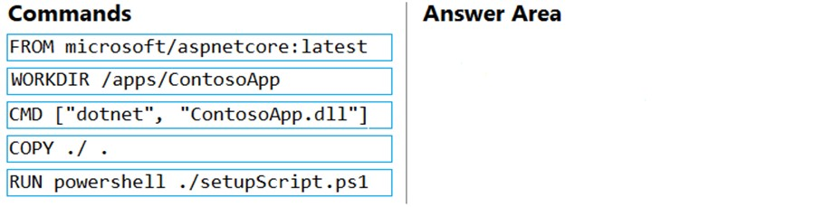

[Hide Solution](https://www.examtopics.com/exams/microsoft/az-204/view/6/) [Discussion   **52**](https://www.examtopics.com/exams/microsoft/az-204/view/6/)

**Correct Answer:** 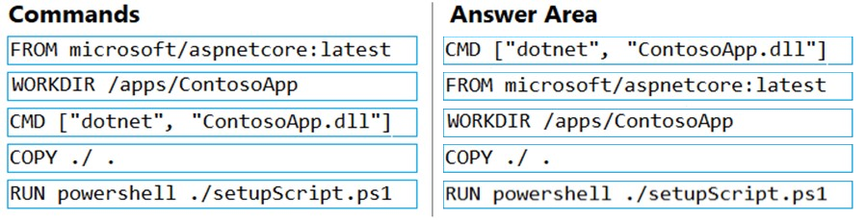  
Box 1: CMD [..]  
Cmd starts a new instance of the command interpreter, Cmd.exe.  
Syntax: CMD <string>  
Specifies the command you want to carry out.  
Box 2: FROM microsoft/aspnetcore-build:latest  
  
Box 3: WORKDIR /apps/ContosoApp -  
Bxo 4: COPY ./ .  
Box 5: RUN powershell ./setupScript.ps1

Question #22*Topic 2*

You are developing an Azure Function App that processes images that are uploaded to an Azure Blob container.  
Images must be processed as quickly as possible after they are uploaded, and the solution must minimize latency. You create code to process images when the  
Function App is triggered.  
You need to configure the Function App.  
What should you do?

* A. Use an App Service plan. Configure the Function App to use an Azure Blob Storage input trigger.
* B. Use a Consumption plan. Configure the Function App to use an Azure Blob Storage trigger.
* C. Use a Consumption plan. Configure the Function App to use a Timer trigger.
* D. Use an App Service plan. Configure the Function App to use an Azure Blob Storage trigger. **Most Voted**
* E. Use a Consumption plan. Configure the Function App to use an Azure Blob Storage input trigger.

[Hide Solution](https://www.examtopics.com/exams/microsoft/az-204/view/6/) [Discussion   **67**](https://www.examtopics.com/exams/microsoft/az-204/view/6/)

**Correct Answer:** *B* [🗳️](https://www.examtopics.com/exams/microsoft/az-204/view/6/)  
The Blob storage trigger starts a function when a new or updated blob is detected. The blob contents are provided as input to the function.  
The Consumption plan limits a function app on one virtual machine (VM) to 1.5 GB of memory.  
Reference:  
https://docs.microsoft.com/en-us/azure/azure-functions/functions-bindings-storage-blob-trigger

*Community vote distribution*

D (100%)

Question #23*Topic 2*

HOTSPOT -  
You are configuring a new development environment for a Java application.  
The environment requires a Virtual Machine Scale Set (VMSS), several storage accounts, and networking components.  
The VMSS must not be created until the storage accounts have been successfully created and an associated load balancer and virtual network is configured.  
How should you complete the Azure Resource Manager template? To answer, select the appropriate options in the answer area.  
NOTE: Each correct selection is worth one point.  
Hot Area:  
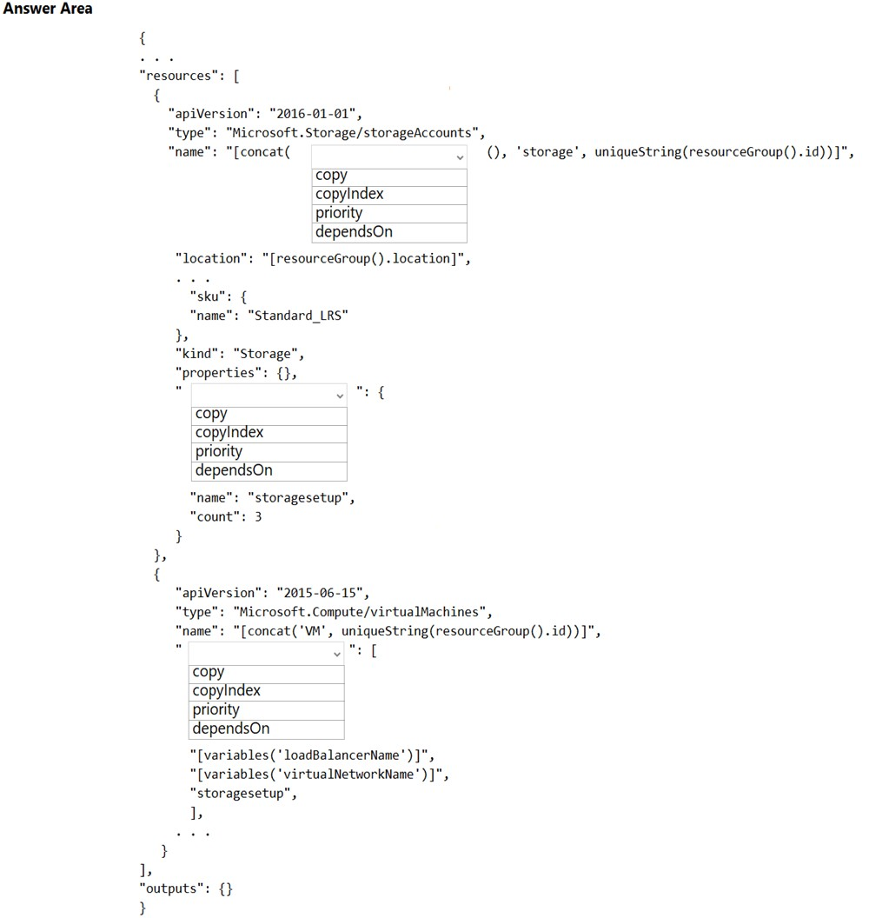

[Hide Solution](https://www.examtopics.com/exams/microsoft/az-204/view/6/) [Discussion   **16**](https://www.examtopics.com/exams/microsoft/az-204/view/6/)

**Correct Answer:** 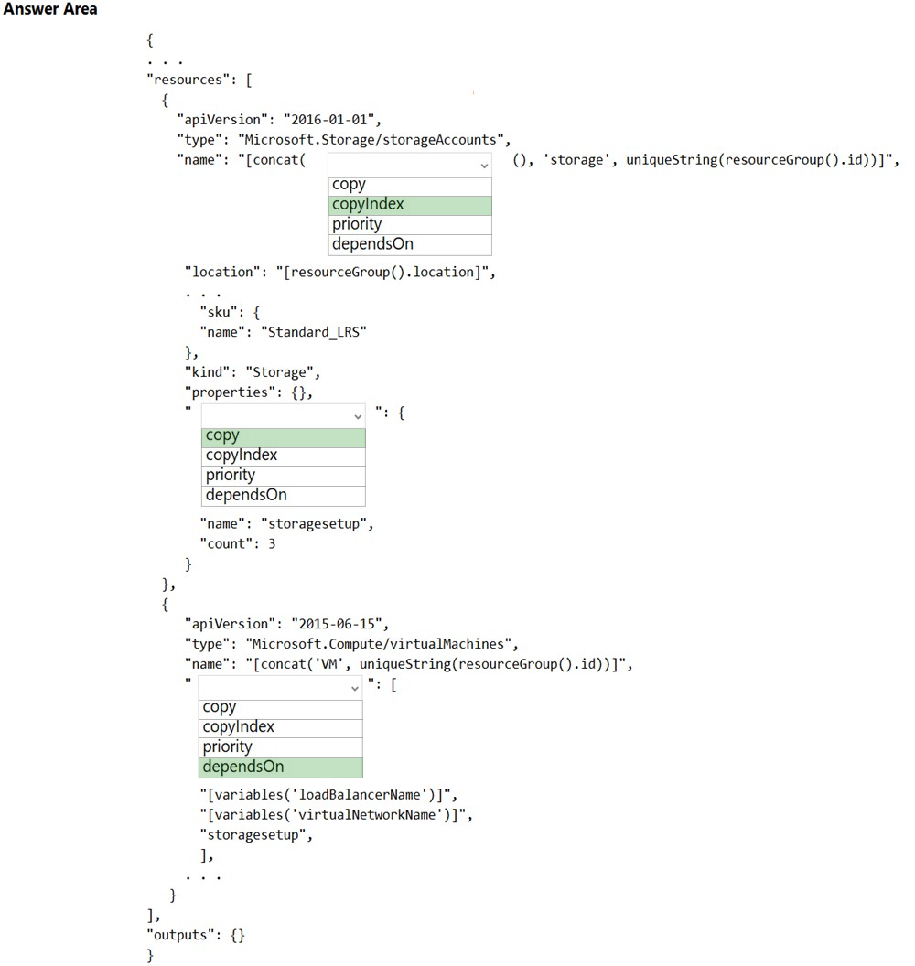  
Box 1: copyIndex -  
Notice that the name of each resource includes the copyIndex() function, which returns the current iteration in the loop. copyIndex() is zero-based.  
  
Box 2: copy -  
By adding the copy element to the resources section of your template, you can dynamically set the number of resources to deploy.  
  
Box 3: dependsOn -  
Example:  
"type": "Microsoft.Compute/virtualMachineScaleSets",  
"apiVersion": "2020-06-01",  
"name": "[variables('namingInfix')]",  
"location": "[parameters('location')]",  
"sku": {  
"name": "[parameters('vmSku')]",  
"tier": "Standard",  
"capacity": "[parameters('instanceCount')]"  
},  
"dependsOn": [  
"[resourceId('Microsoft.Network/loadBalancers', variables('loadBalancerName'))]",  
"[resourceId('Microsoft.Network/virtualNetworks', variables('virtualNetworkName'))]"  
],  
Reference:  
https://docs.microsoft.com/en-us/azure/azure-resource-manager/templates/copy-resources https://docs.microsoft.com/en-us/azure/virtual-machine-scale-sets/quick-create-template-windows

Question #24*Topic 2*

HOTSPOT -  
You are developing an Azure Function App by using Visual Studio. The app will process orders input by an Azure Web App. The web app places the order information into Azure Queue Storage.  
You need to review the Azure Function App code shown below.  
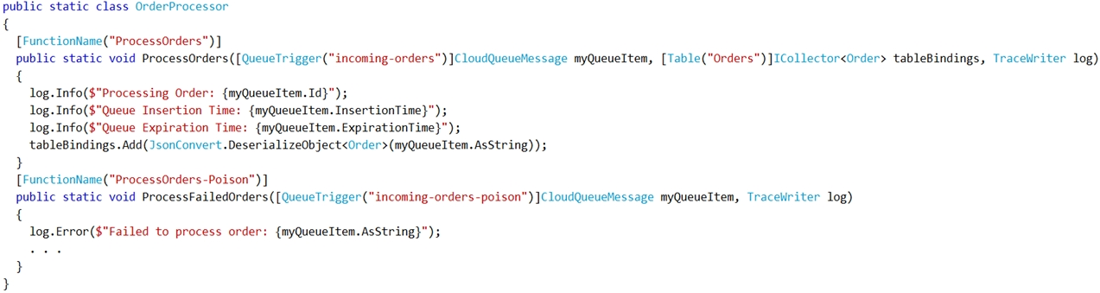  
NOTE: Each correct selection is worth one point.  
Hot Area:  
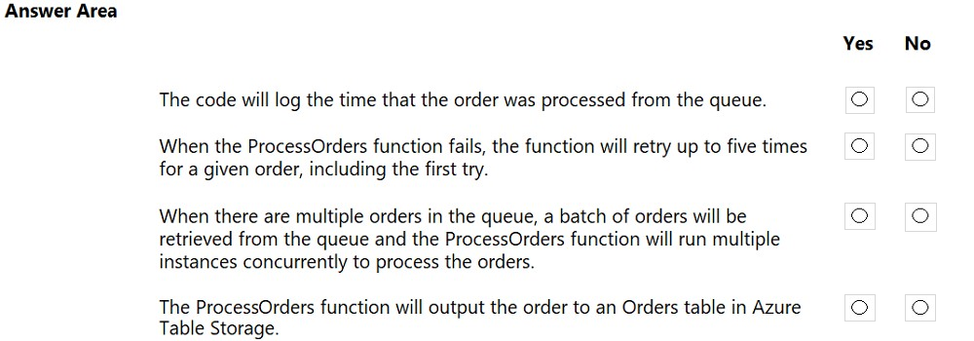

[Hide Solution](https://www.examtopics.com/exams/microsoft/az-204/view/7/) [Discussion   **15**](https://www.examtopics.com/exams/microsoft/az-204/view/7/)

**Correct Answer:** 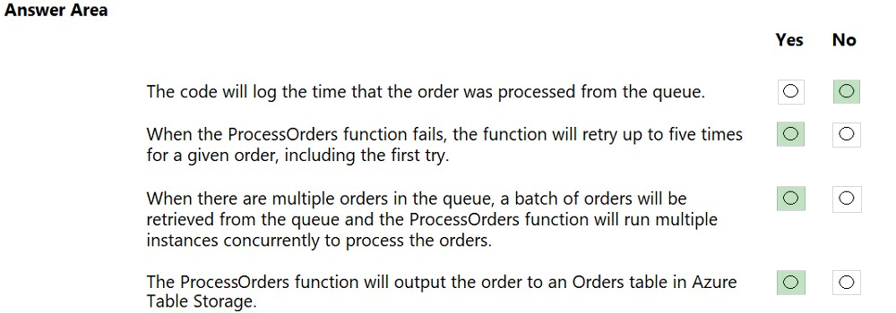  
Box 1: No -  
ExpirationTime - The time that the message expires.  
InsertionTime - The time that the message was added to the queue.  
  
Box 2: Yes -  
maxDequeueCount - The number of times to try processing a message before moving it to the poison queue. Default value is 5.  
  
Box 3: Yes -  
When there are multiple queue messages waiting, the queue trigger retrieves a batch of messages and invokes function instances concurrently to process them.  
By default, the batch size is 16. When the number being processed gets down to 8, the runtime gets another batch and starts processing those messages. So the maximum number of concurrent messages being processed per function on one virtual machine (VM) is 24.  
  
Box 4: Yes -  
Reference:  
https://docs.microsoft.com/en-us/azure/azure-functions/functions-bindings-storage-queue

Question #25*Topic 2*

DRAG DROP -  
You are developing a solution for a hospital to support the following use cases:  
✑ The most recent patient status details must be retrieved even if multiple users in different locations have updated the patient record.  
✑ Patient health monitoring data retrieved must be the current version or the prior version.  
✑ After a patient is discharged and all charges have been assessed, the patient billing record contains the final charges.  
You provision a Cosmos DB NoSQL database and set the default consistency level for the database account to Strong. You set the value for Indexing Mode to  
Consistent.  
You need to minimize latency and any impact to the availability of the solution. You must override the default consistency level at the query level to meet the required consistency guarantees for the scenarios.  
Which consistency levels should you implement? To answer, drag the appropriate consistency levels to the correct requirements. Each consistency level may be used once, more than once, or not at all. You may need to drag the split bar between panes or scroll to view content.  
NOTE: Each correct selection is worth one point.  
Select and Place:  
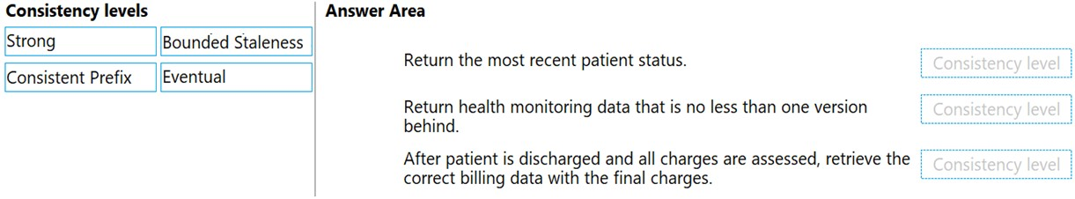

[Hide Solution](https://www.examtopics.com/exams/microsoft/az-204/view/7/) [Discussion   **48**](https://www.examtopics.com/exams/microsoft/az-204/view/7/)

**Correct Answer:** 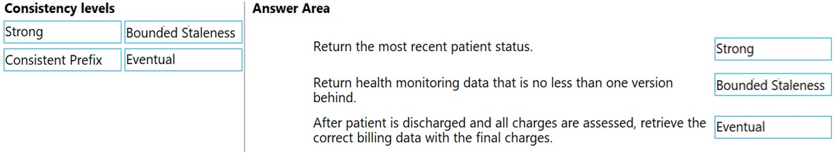  
Box 1: Strong -  
Strong: Strong consistency offers a linearizability guarantee. The reads are guaranteed to return the most recent committed version of an item. A client never sees an uncommitted or partial write. Users are always guaranteed to read the latest committed write.  
  
Box 2: Bounded staleness -  
Bounded staleness: The reads are guaranteed to honor the consistent-prefix guarantee. The reads might lag behind writes by at most "K" versions (that is  
"updates") of an item or by "t" time interval. When you choose bounded staleness, the "staleness" can be configured in two ways:  
The number of versions (K) of the item  
The time interval (t) by which the reads might lag behind the writes  
  
Box 3: Eventual -  
Eventual: There's no ordering guarantee for reads. In the absence of any further writes, the replicas eventually converge.  
Incorrect Answers:  
Consistent prefix: Updates that are returned contain some prefix of all the updates, with no gaps. Consistent prefix guarantees that reads never see out-of-order writes.  
Reference:  
https://docs.microsoft.com/en-us/azure/cosmos-db/consistency-levels

Question #26*Topic 2*

HOTSPOT -  
You are configuring a development environment for your team. You deploy the latest Visual Studio image from the Azure Marketplace to your Azure subscription.  
The development environment requires several software development kits (SDKs) and third-party components to support application development across the organization. You install and customize the deployed virtual machine (VM) for your development team. The customized VM must be saved to allow provisioning of a new team member development environment.  
You need to save the customized VM for future provisioning.  
Which tools or services should you use? To answer, select the appropriate options in the answer area.  
NOTE: Each correct selection is worth one point.  
Hot Area:  
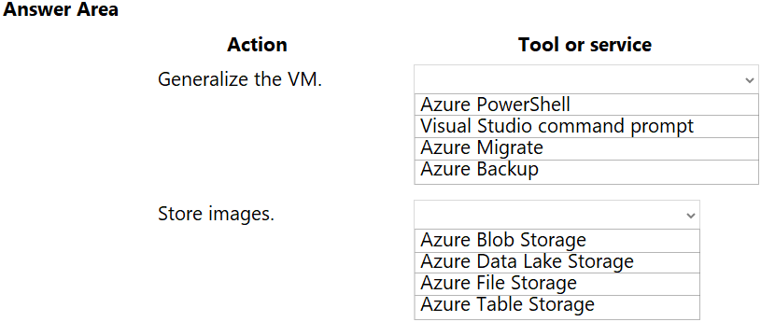

[Hide Solution](https://www.examtopics.com/exams/microsoft/az-204/view/7/) [Discussion   **19**](https://www.examtopics.com/exams/microsoft/az-204/view/7/)

**Correct Answer:** 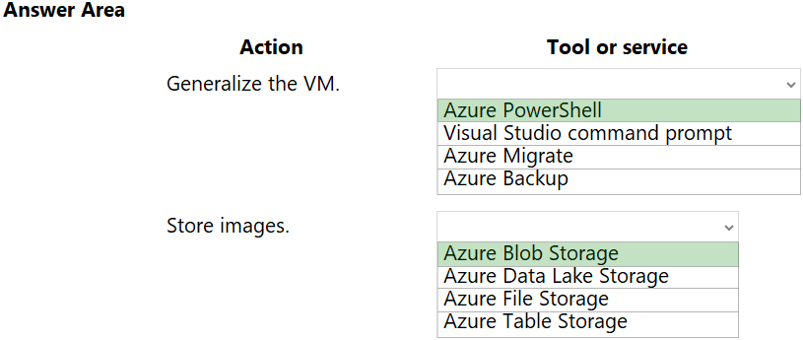  
Box 1: Azure Powershell -  
Creating an image directly from the VM ensures that the image includes all of the disks associated with the VM, including the OS disk and any data disks.  
Before you begin, make sure that you have the latest version of the Azure PowerShell module.  
You use Sysprep to generalize the virtual machine, then use Azure PowerShell to create the image.  
  
Box 2: Azure Blob Storage -  
You can store images in Azure Blob Storage.  
Reference:  
https://docs.microsoft.com/en-us/azure/virtual-machines/windows/capture-image-resource#create-an-image-of-a-vm-using-powershell

Question #27*Topic 2*

You are preparing to deploy a website to an Azure Web App from a GitHub repository. The website includes static content generated by a script.  
You plan to use the Azure Web App continuous deployment feature.  
You need to run the static generation script before the website starts serving traffic.  
What are two possible ways to achieve this goal? Each correct answer presents a complete solution.  
NOTE: Each correct selection is worth one point.

* A. Add the path to the static content generation tool to WEBSITE_RUN_FROM_PACKAGE setting in the host.json file.
* B. Add a PreBuild target in the websites csproj project file that runs the static content generation script. **Most Voted**
* C. Create a file named run.cmd in the folder /run that calls a script which generates the static content and deploys the website.
* D. Create a file named .deployment in the root of the repository that calls a script which generates the static content and deploys the website. **Most Voted**

[Hide Solution](https://www.examtopics.com/exams/microsoft/az-204/view/7/) [Discussion   **66**](https://www.examtopics.com/exams/microsoft/az-204/view/7/)

**Correct Answer:** *AD* [🗳️](https://www.examtopics.com/exams/microsoft/az-204/view/7/)  
A: In Azure, you can run your functions directly from a deployment package file in your function app. The other option is to deploy your files in the d:\home\site  
\wwwroot directory of your function app (see A above).  
To enable your function app to run from a package, you just add a WEBSITE_RUN_FROM_PACKAGE setting to your function app settings.  
Note: The host.json metadata file contains global configuration options that affect all functions for a function app.  
D: To customize your deployment, include a .deployment file in the repository root.  
You just need to add a file to the root of your repository with the name .deployment and the content:  
[config]  
command = YOUR COMMAND TO RUN FOR DEPLOYMENT  
this command can be just running a script (batch file) that has all that is required for your deployment, like copying files from the repository to the web root directory for example.  
Reference:  
https://github.com/projectkudu/kudu/wiki/Custom-Deployment-Script https://docs.microsoft.com/bs-latn-ba/azure/azure-functions/run-functions-from-deployment-package

*Community vote distribution*

BD (88%)

8%

Question #28*Topic 2*

DRAG DROP -  
You are developing an application to use Azure Blob storage. You have configured Azure Blob storage to include change feeds.  
A copy of your storage account must be created in another region. Data must be copied from the current storage account to the new storage account directly between the storage servers.  
You need to create a copy of the storage account in another region and copy the data.  
In which order should you perform the actions? To answer, move all actions from the list of actions to the answer area and arrange them in the correct order.  
Select and Place:  
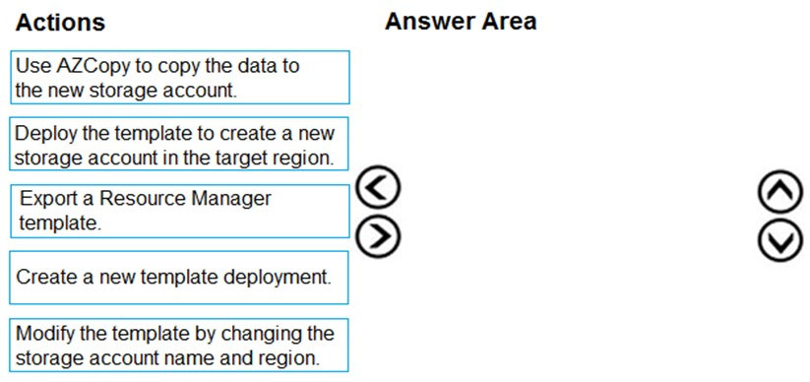

[Hide Solution](https://www.examtopics.com/exams/microsoft/az-204/view/7/) [Discussion   **58**](https://www.examtopics.com/exams/microsoft/az-204/view/7/)

**Correct Answer:** 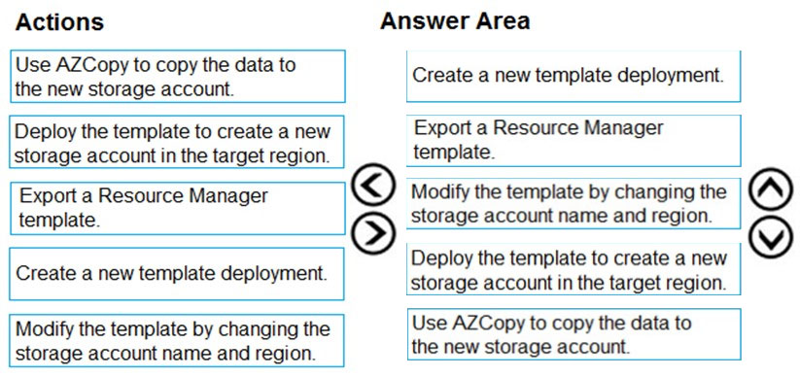  
To move a storage account, create a copy of your storage account in another region. Then, move your data to that account by using AzCopy, or another tool of your choice.  
The steps are:  
✑ Export a template.  
✑ Modify the template by adding the target region and storage account name.  
✑ Deploy the template to create the new storage account.  
✑ Configure the new storage account.  
✑ Move data to the new storage account.  
✑ Delete the resources in the source region.  
Note: You must enable the change feed on your storage account to begin capturing and recording changes. You can enable and disable changes by using Azure  
Resource Manager templates on Portal or Powershell.  
Reference:  
https://docs.microsoft.com/en-us/azure/storage/common/storage-account-move https://docs.microsoft.com/en-us/azure/storage/blobs/storage-blob-change-feed

Question #29*Topic 2*

DRAG DROP -  
You are preparing to deploy an Azure virtual machine (VM)-based application.  
The VMs that run the application have the following requirements:  
✑ When a VM is provisioned the firewall must be automatically configured before it can access Azure resources.  
✑ Supporting services must be installed by using an Azure PowerShell script that is stored in Azure Storage.  
You need to ensure that the requirements are met.  
Which features should you use? To answer, drag the appropriate features to the correct requirements. Each feature may be used once, more than once, or not at all. You may need to drag the split bar between panes or scroll to view content.  
NOTE: Each correct selection is worth one point.  
Select and Place:  
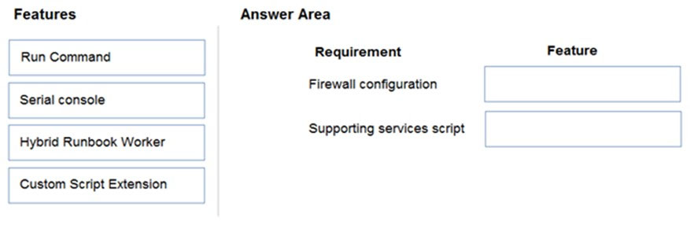

[Hide Solution](https://www.examtopics.com/exams/microsoft/az-204/view/7/) [Discussion   **35**](https://www.examtopics.com/exams/microsoft/az-204/view/7/)

**Correct Answer:** 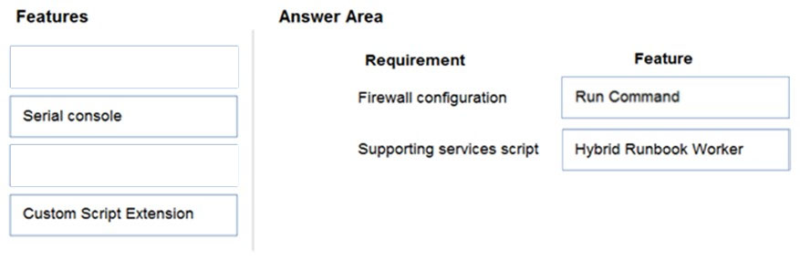  
Reference:  
https://docs.microsoft.com/en-us/azure/automation/automation-hybrid-runbook-worker https://docs.microsoft.com/en-us/azure/virtual-machines/windows/run-command

Question #30*Topic 2*

HOTSPOT -  
A company is developing a Node.js web app. The web app code is hosted in a GitHub repository located at https://github.com/TailSpinToys/webapp.  
The web app must be reviewed before it is moved to production. You must deploy the initial code release to a deployment slot named review.  
You need to create the web app and deploy the code.  
How should you complete the commands? To answer, select the appropriate options in the answer area.  
NOTE: Each correct selection is worth one point.  
Hot Area:  
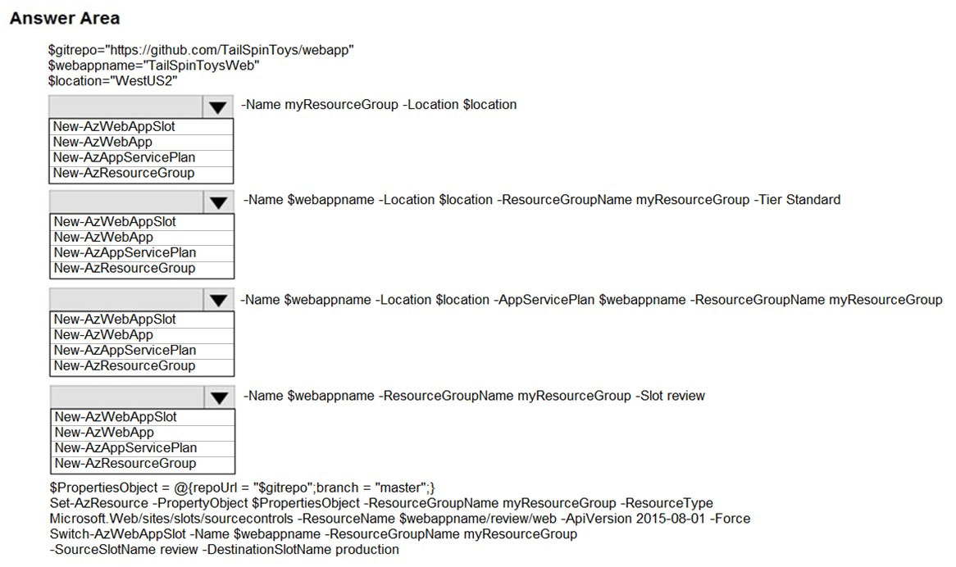

[Hide Solution](https://www.examtopics.com/exams/microsoft/az-204/view/7/) [Discussion   **20**](https://www.examtopics.com/exams/microsoft/az-204/view/7/)

**Correct Answer:** 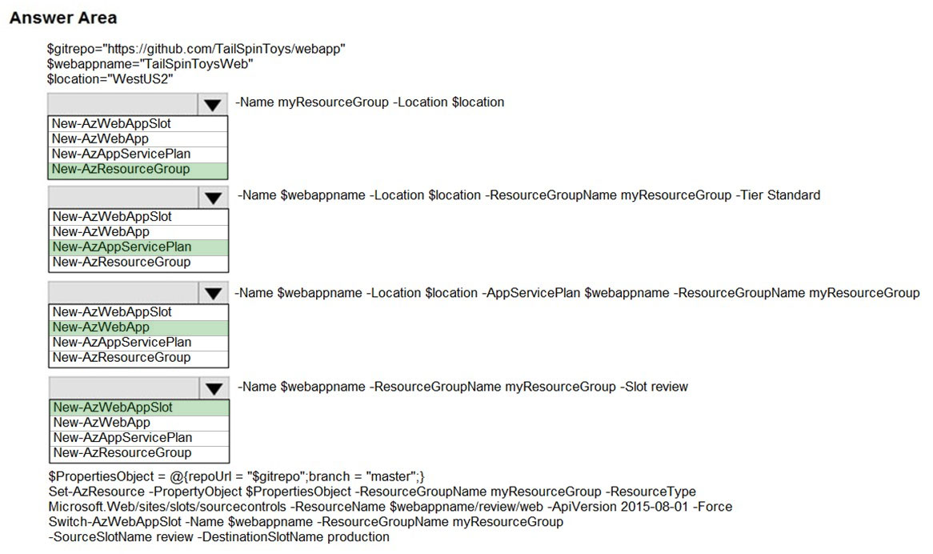  
Box 1: New-AzResourceGroup -  
The New-AzResourceGroup cmdlet creates an Azure resource group.  
  
Box 2: New-AzAppServicePlan -  
The New-AzAppServicePlan cmdlet creates an Azure App Service plan in a given location  
  
Box 3: New-AzWebApp -  
The New-AzWebApp cmdlet creates an Azure Web App in a given a resource group  
  
Box 4: New-AzWebAppSlot -  
The New-AzWebAppSlot cmdlet creates an Azure Web App slot.  
Reference:  
https://docs.microsoft.com/en-us/powershell/module/az.resources/new-azresourcegroup?view=azps-2.3.2 https://docs.microsoft.com/en-us/powershell/module/az.websites/new-azappserviceplan?view=azps-2.3.2 https://docs.microsoft.com/en-us/powershell/module/az.websites/new-azwebapp?view=azps-2.3.2 https://docs.microsoft.com/en-us/powershell/module/az.websites/new-azwebappslot?view=azps-2.3.2

Question #31*Topic 2*

HOTSPOT -  
You are developing an application that needs access to an Azure virtual machine (VM).  
The access lifecycle for the application must be associated with the VM service instance.  
You need to enable managed identity for the VM.  
How should you complete the PowerShell segment? To answer, select the appropriate options in the answer area.  
NOTE: Each correct selection is worth one point.  
Hot Area:  
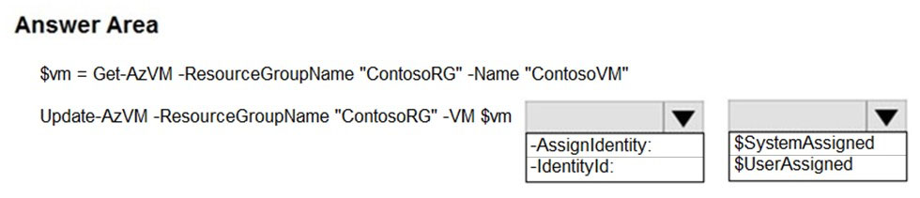

[Hide Solution](https://www.examtopics.com/exams/microsoft/az-204/view/7/) [Discussion   **62**](https://www.examtopics.com/exams/microsoft/az-204/view/7/)

**Correct Answer:** 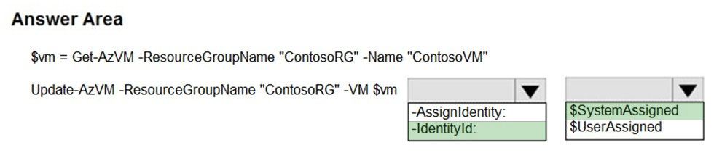  
Box 1: -IdentityType -  
Enable system-assigned managed identity on an existing Azure VM:  
To enable a system-assigned managed identity, use the -IdentityType switch on the Update-AzVM cmdlet (see below).  
  
Box 2: $SystemAssigned -  
$vm = Get-AzVM -ResourceGroupName myResourceGroup -Name myVM  
Update-AzVM -ResourceGroupName myResourceGroup -VM $vm -IdentityType SystemAssigned  
Reference:  
https://docs.microsoft.com/en-us/azure/active-directory/managed-identities-azure-resources/qs-configure-powershell-windows-vm

Question #32*Topic 2*

Note: This question is part of a series of questions that present the same scenario. Each question in the series contains a unique solution that might meet the stated goals. Some question sets might have more than one correct solution, while others might not have a correct solution.  
After you answer a question in this section, you will NOT be able to return to it. As a result, these questions will not appear in the review screen.  
You develop a software as a service (SaaS) offering to manage photographs. Users upload photos to a web service which then stores the photos in Azure  
Storage Blob storage. The storage account type is General-purpose V2.  
When photos are uploaded, they must be processed to produce and save a mobile-friendly version of the image. The process to produce a mobile-friendly version of the image must start in less than one minute.  
You need to design the process that starts the photo processing.  
Solution: Create an Azure Function app that uses the Consumption hosting model and that is triggered from the blob upload.  
Does the solution meet the goal?

* A. Yes
* B. No **Most Voted**

[Hide Solution](https://www.examtopics.com/exams/microsoft/az-204/view/7/) [Discussion   **44**](https://www.examtopics.com/exams/microsoft/az-204/view/7/)

**Correct Answer:** *A* [🗳️](https://www.examtopics.com/exams/microsoft/az-204/view/7/)  
In the Consumption hosting plan, resources are added dynamically as required by your functions.  
Reference:  
https://docs.microsoft.com/en-us/azure/azure-functions/functions-create-storage-blob-triggered-function

*Community vote distribution*

B (100%)

Question #33*Topic 2*

Note: This question is part of a series of questions that present the same scenario. Each question in the series contains a unique solution that might meet the stated goals. Some question sets might have more than one correct solution, while others might not have a correct solution.  
After you answer a question in this section, you will NOT be able to return to it. As a result, these questions will not appear in the review screen.  
You develop and deploy an Azure App Service API app to a Windows-hosted deployment slot named Development. You create additional deployment slots named Testing and Production. You enable auto swap on the Production deployment slot.  
You need to ensure that scripts run and resources are available before a swap operation occurs.  
Solution: Update the app with a method named statuscheck to run the scripts. Update the app settings for the app. Set the  
WEBSITE_SWAP_WARMUP_PING_PATH and WEBSITE_SWAP_WARMUP_PING_STATUSES with a path to the new method and appropriate response codes.  
Does the solution meet the goal?

* A. No
* B. Yes **Most Voted**

[Hide Solution](https://www.examtopics.com/exams/microsoft/az-204/view/7/) [Discussion   **51**](https://www.examtopics.com/exams/microsoft/az-204/view/7/)

**Correct Answer:** *A* [🗳️](https://www.examtopics.com/exams/microsoft/az-204/view/7/)  
These are valid warm-up behavior options, but are not helpful in fixing swap problems.  
Instead update the web.config file to include the applicationInitialization configuration element. Specify custom initialization actions to run the scripts.  
Note: Some apps might require custom warm-up actions before the swap. The applicationInitialization configuration element in web.config lets you specify custom initialization actions. The swap operation waits for this custom warm-up to finish before swapping with the target slot. Here's a sample web.config fragment.  
<system.webServer>  
<applicationInitialization>  
<add initializationPage="/" hostName="[app hostname]" />  
<add initializationPage="/Home/About" hostName="[app hostname]" />  
</applicationInitialization>  
</system.webServer>  
Reference:  
https://docs.microsoft.com/en-us/azure/app-service/deploy-staging-slots#troubleshoot-swaps

*Community vote distribution*

B (80%)

A (20%)

Question #34*Topic 2*

HOTSPOT -  
You create the following PowerShell script:  
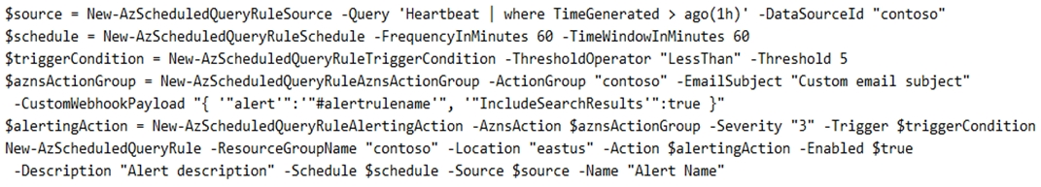  
For each of the following statements, select Yes if the statement is true. Otherwise, select No.  
NOTE: Each correct selection is worth one point.  
Hot Area:  
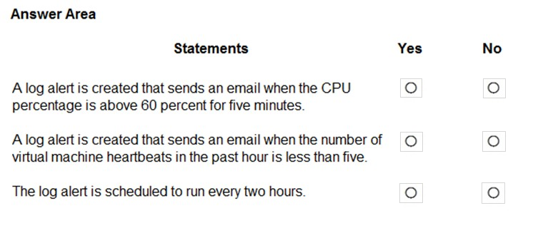

[Hide Solution](https://www.examtopics.com/exams/microsoft/az-204/view/8/) [Discussion   **19**](https://www.examtopics.com/exams/microsoft/az-204/view/8/)

**Correct Answer:** 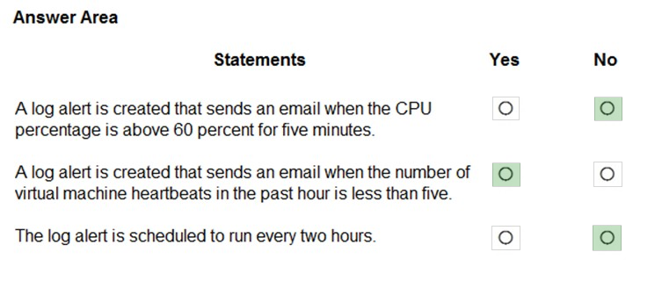  
Box 1: No -  
The AzScheduledQueryRuleSource is Heartbeat, not CPU.  
  
Box 2: Yes -  
The AzScheduledQueryRuleSource is Heartbeat!  
Note: New-AzScheduledQueryRuleTriggerCondition creates an object of type Trigger Condition. This object is to be passed to the command that creates Alerting  
Action object.  
  
Box 3: No -  
The schedule is 60 minutes, not two hours.  
-FrequencyInMinutes: The alert frequency.  
-TimeWindowInMinutes: The alert time window  
The New-AzAscheduledQueryRuleSchedule command creates an object of type Schedule. This object is to be passed to the command that creates Log Alert  
Rule.  
Reference:  
https://docs.microsoft.com/en-us/powershell/module/az.monitor/new-azscheduledqueryrule https://docs.microsoft.com/en-us/powershell/module/az.monitor/new-azscheduledqueryruletriggercondition

Question #35*Topic 2*

DRAG DROP -  
You are developing an Azure Function app.  
The app must meet the following requirements:  
✑ Enable developers to write the functions by using the Rust language.  
✑ Declaratively connect to an Azure Blob Storage account.  
You need to implement the app.  
Which Azure Function app features should you use? To answer, drag the appropriate features to the correct requirements. Each feature may be used once, more than once, or not at all. You may need to drag the split bar between panes or scroll to view content.  
NOTE: Each correct selection is worth one point.  
Select and Place:  
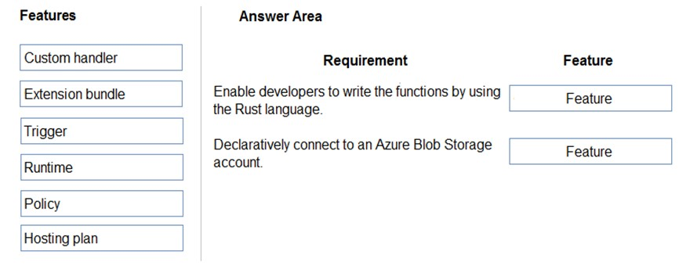

[Hide Solution](https://www.examtopics.com/exams/microsoft/az-204/view/8/) [Discussion   **37**](https://www.examtopics.com/exams/microsoft/az-204/view/8/)

**Correct Answer:** 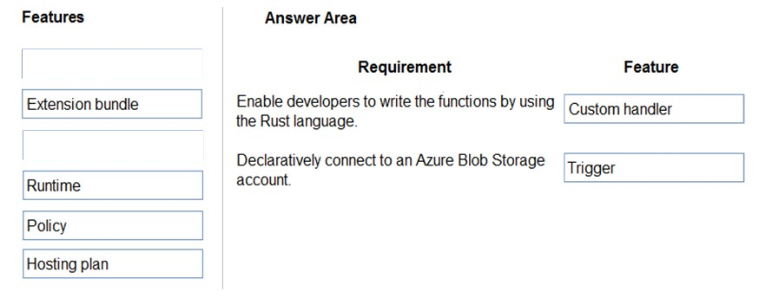  
Box 1: Custom handler -  
Custom handlers can be used to create functions in any language or runtime by running an HTTP server process, for example Go or Rust.  
  
Box 2: Trigger -  
Functions are invoked by a trigger and can have exactly one. In addition to invoking the function, certain triggers also serve as bindings. You may also define multiple bindings in addition to the trigger. Bindings provide a declarative way to connect data to your code.  
Reference:  
https://docs.microsoft.com/en-us/azure/azure-functions/create-first-function-vs-code-other https://docs.microsoft.com/en-us/dotnet/architecture/serverless/azure-functions

Question #36*Topic 2*

HOTSPOT -  
You are developing an ASP.NET Core web application. You plan to deploy the application to Azure Web App for Containers.  
The application needs to store runtime diagnostic data that must be persisted across application restarts. You have the following code:  
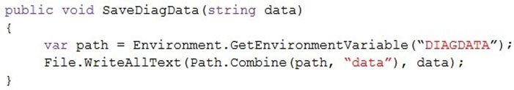  
You need to configure the application settings so that diagnostic data is stored as required.  
How should you configure the web app's settings? To answer, select the appropriate options in the answer area.  
NOTE: Each correct selection is worth one point.  
Hot Area:  
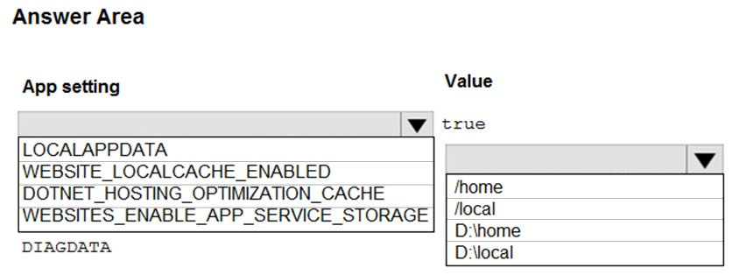

[Hide Solution](https://www.examtopics.com/exams/microsoft/az-204/view/8/) [Discussion   **32**](https://www.examtopics.com/exams/microsoft/az-204/view/8/)

**Correct Answer:** 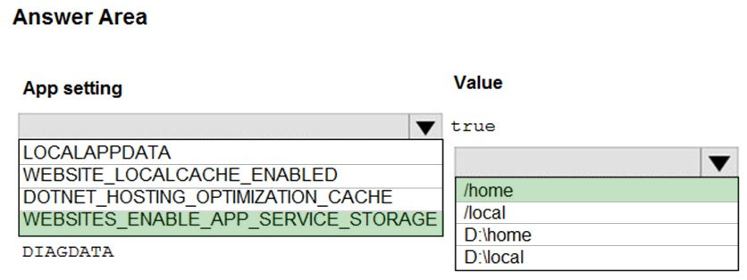  
Box 1: If WEBSITES_ENABLE_APP_SERVICE_STORAGE  
If WEBSITES_ENABLE_APP_SERVICE_STORAGE setting is unspecified or set to true, the /home/ directory will be shared across scale instances, and files written will persist across restarts  
  
Box 2: /home -  
Reference:  
https://docs.microsoft.com/en-us/azure/app-service/containers/app-service-linux-faq

Question #37*Topic 2*

You are developing a web app that is protected by Azure Web Application Firewall (WAF). All traffic to the web app is routed through an Azure Application  
Gateway instance that is used by multiple web apps. The web app address is contoso.azurewebsites.net.  
All traffic must be secured with SSL. The Azure Application Gateway instance is used by multiple web apps.  
You need to configure the Azure Application Gateway for the web app.  
Which two actions should you perform? Each correct answer presents part of the solution.  
NOTE: Each correct selection is worth one point.

* A. In the Azure Application Gateway's HTTP setting, enable the Use for App service setting. **Most Voted**
* B. Convert the web app to run in an Azure App service environment (ASE).
* C. Add an authentication certificate for contoso.azurewebsites.net to the Azure Application Gateway.
* D. In the Azure Application Gateway's HTTP setting, set the value of the Override backend path option to contoso22.azurewebsites.net. **Most Voted**

[Hide Solution](https://www.examtopics.com/exams/microsoft/az-204/view/8/) [Discussion   **43**](https://www.examtopics.com/exams/microsoft/az-204/view/8/)

**Correct Answer:** *AD* [🗳️](https://www.examtopics.com/exams/microsoft/az-204/view/8/)  
D: The ability to specify a host override is defined in the HTTP settings and can be applied to any back-end pool during rule creation.  
The ability to derive the host name from the IP or FQDN of the back-end pool members. HTTP settings also provide an option to dynamically pick the host name from a back-end pool member's FQDN if configured with the option to derive host name from an individual back-end pool member.  
A (not C): SSL termination and end to end SSL with multi-tenant services.  
In case of end to end SSL, trusted Azure services such as Azure App service web apps do not require whitelisting the backends in the application gateway.  
Therefore, there is no need to add any authentication certificates.  
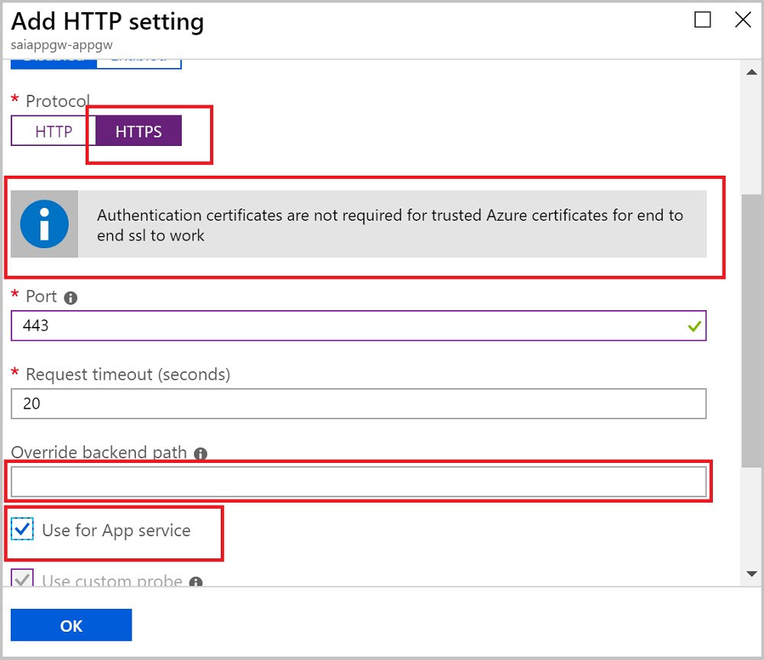  
Reference:  
https://docs.microsoft.com/en-us/azure/application-gateway/application-gateway-web-app-overview

*Community vote distribution*

AD (100%)

Question #38*Topic 2*

Note: This question is part of a series of questions that present the same scenario. Each question in the series contains a unique solution that might meet the stated goals. Some question sets might have more than one correct solution, while others might not have a correct solution.  
After you answer a question in this section, you will NOT be able to return to it. As a result, these questions will not appear in the review screen.  
You develop a software as a service (SaaS) offering to manage photographs. Users upload photos to a web service which then stores the photos in Azure  
Storage Blob storage. The storage account type is General-purpose V2.  
When photos are uploaded, they must be processed to produce and save a mobile-friendly version of the image. The process to produce a mobile-friendly version of the image must start in less than one minute.  
You need to design the process that starts the photo processing.  
Solution: Use the Azure Blob Storage change feed to trigger photo processing.  
Does the solution meet the goal?

* A. Yes
* B. No **Most Voted**

[Hide Solution](https://www.examtopics.com/exams/microsoft/az-204/view/8/) [Discussion   **14**](https://www.examtopics.com/exams/microsoft/az-204/view/8/)

**Correct Answer:** *B* [🗳️](https://www.examtopics.com/exams/microsoft/az-204/view/8/)  
The change feed is a log of changes that are organized into hourly segments but appended to and updated every few minutes. These segments are created only when there are blob change events that occur in that hour.  
Instead catch the triggered event, so move the photo processing to an Azure Function triggered from the blob upload.  
Reference:  
https://docs.microsoft.com/en-us/azure/storage/blobs/storage-blob-change-feed https://docs.microsoft.com/en-us/azure/storage/blobs/storage-blob-event-overview

*Community vote distribution*

B (100%)

Question #39*Topic 2*

You are developing a web application that runs as an Azure Web App. The web application stores data in Azure SQL Database and stores files in an Azure  
Storage account. The web application makes HTTP requests to external services as part of normal operations.  
The web application is instrumented with Application Insights. The external services are OpenTelemetry compliant.  
You need to ensure that the customer ID of the signed in user is associated with all operations throughout the overall system.  
What should you do?

* A. Add the customer ID for the signed in user to the CorrelationContext in the web application **Most Voted**
* B. On the current SpanContext, set the TraceId to the customer ID for the signed in user
* C. Set the header Ocp-Apim-Trace to the customer ID for the signed in user
* D. Create a new SpanContext with the TraceFlags value set to the customer ID for the signed in user

[Hide Solution](https://www.examtopics.com/exams/microsoft/az-204/view/8/) [Discussion   **12**](https://www.examtopics.com/exams/microsoft/az-204/view/8/)

**Correct Answer:** *A* [🗳️](https://www.examtopics.com/exams/microsoft/az-204/view/8/)  
Reference:  
https://docs.microsoft.com/en-us/azure/azure-monitor/app/correlation

*Community vote distribution*

A (77%)

B (23%)

Question #40*Topic 2*

HOTSPOT -  
You are developing an Azure Function App. You develop code by using a language that is not supported by the Azure Function App host. The code language supports HTTP primitives.  
You must deploy the code to a production Azure Function App environment.  
You need to configure the app for deployment.  
Which configuration values should you use? To answer, select the appropriate options in the answer area.  
NOTE: Each correct selection is worth one point.  
Hot Area:  
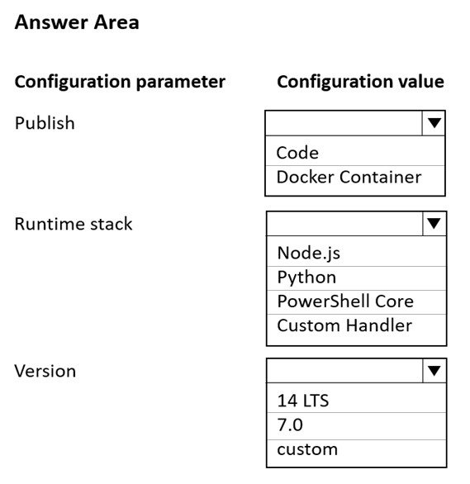

[Hide Solution](https://www.examtopics.com/exams/microsoft/az-204/view/8/) [Discussion   **23**](https://www.examtopics.com/exams/microsoft/az-204/view/8/)

**Correct Answer:** 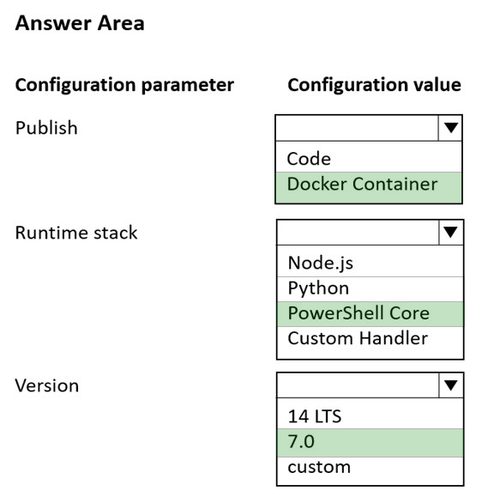  
Box 1: Docker container -  
A custom handler can be deployed to every Azure Functions hosting option. If your handler requires operating system or platform dependencies (such as a language runtime), you may need to use a custom container. You can create and deploy your code to Azure Functions as a custom Docker container.  
  
Box 2: PowerShell core -  
When creating a function app in Azure for custom handlers, we recommend you select .NET Core as the stack. A "Custom" stack for custom handlers will be added in the future.  
PowerShell Core (PSC) is based on the new .NET Core runtime.  
  
Box 3: 7.0 -  
On Windows: The Azure Az PowerShell module is also supported for use with PowerShell 5.1 on Windows.  
On Linux: PowerShell 7.0.6 LTS, PowerShell 7.1.3, or higher is the recommended version of PowerShell for use with the Azure Az PowerShell module on all platforms.  
Reference:  
https://docs.microsoft.com/en-us/azure/azure-functions/functions-create-function-linux-custom-image https://docs.microsoft.com/en-us/powershell/azure/install-az-ps?view=azps-7.1.0

Question #41*Topic 2*

DRAG DROP -  
You provision virtual machines (VMs) as development environments.  
One VM does not start. The VM is stuck in a Windows update process. You attach the OS disk for the affected VM to a recovery VM.  
You need to correct the issue.  
In which order should you perform the actions? To answer, move the appropriate actions from the list of actions to the answer area and arrange them in the correct order.  
Select and Place:  
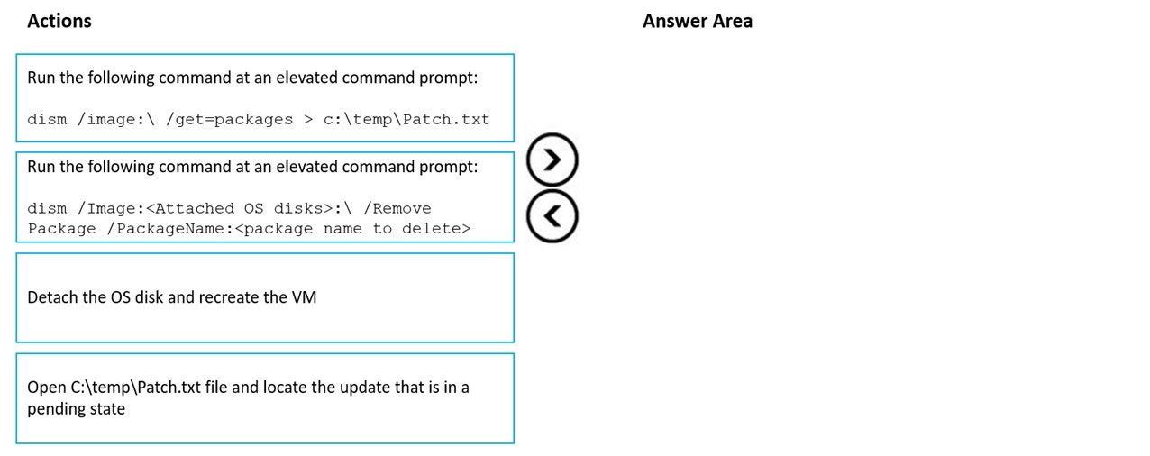

[Hide Solution](https://www.examtopics.com/exams/microsoft/az-204/view/8/) [Discussion   **7**](https://www.examtopics.com/exams/microsoft/az-204/view/8/)

**Correct Answer:** 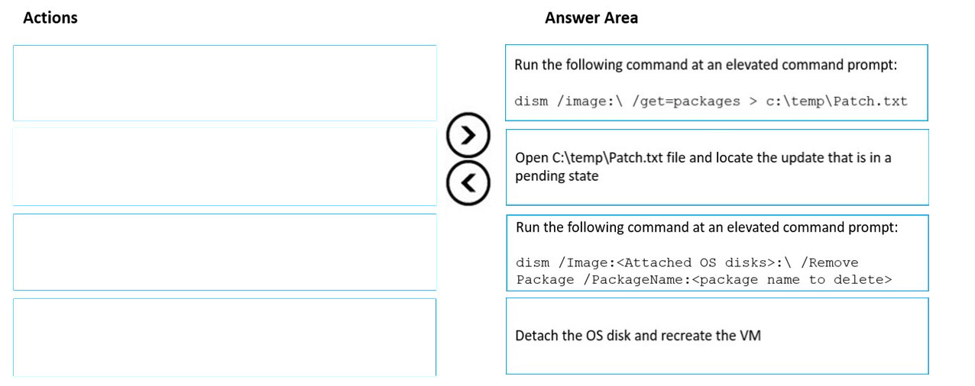  
Remove the update that causes the problem  
1. Take a snapshot of the OS disk of the affected VM as a backup.  
2. Attach the OS disk to a recovery VM.  
3. Once the OS disk is attached on the recovery VM, run diskmgmt.msc to open Disk Management, and ensure the attached disk is ONLINE.  
4. (Step 1) Open an elevated command prompt instance (Run as administrator). Run the following command to get the list of the update packages that are on the attached OS disk: dism /image:<Attached OS disk>:\ /get-packages > c:\temp\Patch_level  
5. (Step 2) Open the C:\temp\Patch_level.txt file, and then read it from the bottom up. Locate the update that's in Install Pending or Uninstall Pending state.  
6. Remove the update that caused the problem:  
dism /Image:<Attached OS disk>:\ /Remove-Package /PackageName:<PACK  
7. (Step 4) Detach the OS disk and recreate the VM. Then check whether the issue is resolved.  
Reference:  
https://docs.microsoft.com/en-us/troubleshoot/azure/virtual-machines/troubleshoot-stuck-updating-boot-error

Question #42*Topic 2*

Note: This question is part of a series of questions that present the same scenario. Each question in the series contains a unique solution that might meet the stated goals. Some question sets might have more than one correct solution, while others might not have a correct solution.  
After you answer a question in this section, you will NOT be able to return to it. As a result, these questions will not appear in the review screen.  
You develop an HTTP triggered Azure Function app to process Azure Storage blob data. The app is triggered using an output binding on the blob.  
The app continues to time out after four minutes. The app must process the blob data.  
You need to ensure the app does not time out and processes the blob data.  
Solution: Update the functionTimeout property of the host.json project file to 10 minutes.  
Does the solution meet the goal?

* A. Yes
* B. No **Most Voted**

[Hide Solution](https://www.examtopics.com/exams/microsoft/az-204/view/8/) [Discussion   **6**](https://www.examtopics.com/exams/microsoft/az-204/view/8/)

**Correct Answer:** *B* [🗳️](https://www.examtopics.com/exams/microsoft/az-204/view/8/)  
Instead pass the HTTP trigger payload into an Azure Service Bus queue to be processed by a queue trigger function and return an immediate HTTP success response.  
Note: Large, long-running functions can cause unexpected timeout issues. General best practices include:  
Whenever possible, refactor large functions into smaller function sets that work together and return responses fast. For example, a webhook or HTTP trigger function might require an acknowledgment response within a certain time limit; it's common for webhooks to require an immediate response. You can pass the  
HTTP trigger payload into a queue to be processed by a queue trigger function. This approach lets you defer the actual work and return an immediate response.  
Reference:  
https://docs.microsoft.com/en-us/azure/azure-functions/functions-best-practices

*Community vote distribution*

B (100%)

Question #43*Topic 2*

HOTSPOT -  
You are developing an Azure Durable Function based application that processes a list of input values. The application is monitored using a console application that retrieves JSON data from an Azure Function diagnostic endpoint.  
During processing a single instance of invalid input does not cause the function to fail. Invalid input must be available to the monitoring application.  
You need to implement the Azure Durable Function and the monitoring console application.  
How should you complete the code segments? To answer, select the appropriate options in the answer area.  
NOTE: Each correct selection is worth one point.  
Hot Area:  
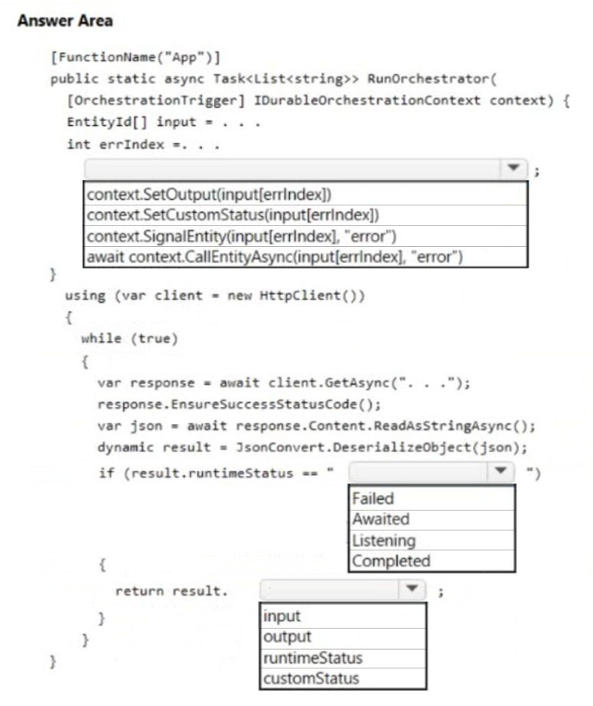

[Hide Solution](https://www.examtopics.com/exams/microsoft/az-204/view/8/) [Discussion   **24**](https://www.examtopics.com/exams/microsoft/az-204/view/8/)

**Correct Answer:** 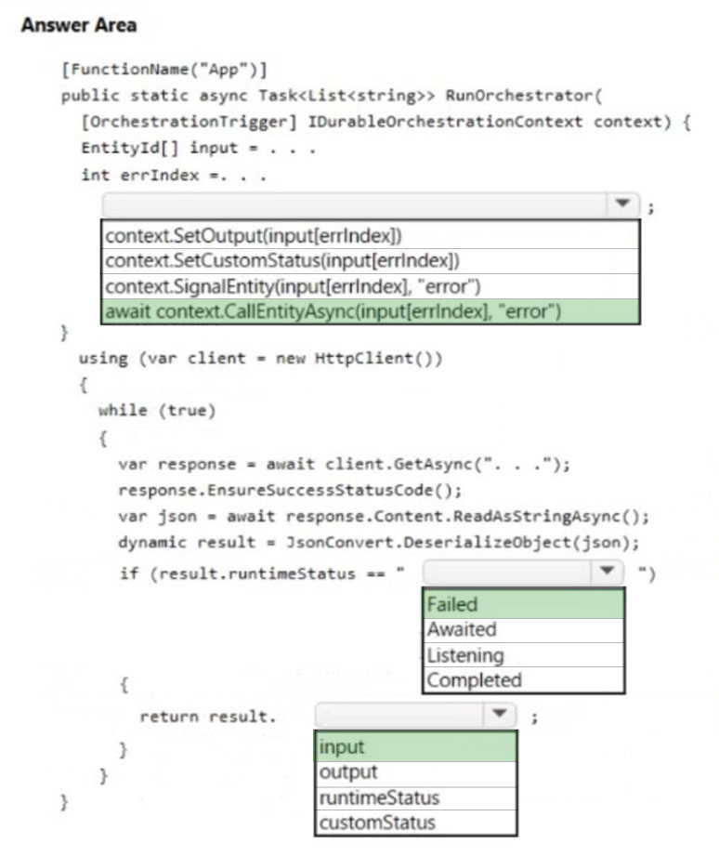  
Box 1: await context.CallEntityAsync(input[errindex],"error")  
Orchestration signals and calls an entity  
Orchestrator functions can access entities by using APIs on the orchestration trigger binding.  
Example:  
[FunctionName("CounterOrchestration")]  
public static async Task Run(  
[OrchestrationTrigger] IDurableOrchestrationContext context)  
{  
var entityId = new EntityId(nameof(Counter), "myCounter");  
// Two-way call to the entity which returns a value - awaits the response int currentValue = await context.CallEntityAsync<int>(entityId, "Get");  
  
Box 2: Failed -  
During processing a single instance of invalid input does not cause the function to fail.  
Note: RuntimeStatus: One of the following values:  
Failed: The instance failed with an error.  
Completed: The instance has completed normally.  
Terminated: The instance was stopped abruptly.  
Pending: The instance has been scheduled but has not yet started running.  
Running: The instance has started running.  
ContinuedAsNew: The instance has restarted itself with a new history. This state is a transient state.  
  
Box 3: Input -  
Invalid input must be available to the monitoring application.  
Reference:  
https://docs.microsoft.com/en-us/azure/azure-functions/durable/durable-functions-entities https://docs.microsoft.com/en-us/azure/azure-functions/durable/durable-functions-instance-management

Question #44*Topic 2*

You are developing an Azure Durable Function to manage an online ordering process.  
The process must call an external API to gather product discount information.  
You need to implement the Azure Durable Function.  
Which Azure Durable Function types should you use? Each correct answer presents part of the solution.  
NOTE: Each correct selection is worth one point.

* A. Orchestrator **Most Voted**
* B. Entity
* C. Client
* D. Activity **Most Voted**

[Hide Solution](https://www.examtopics.com/exams/microsoft/az-204/view/9/) [Discussion   **27**](https://www.examtopics.com/exams/microsoft/az-204/view/9/)

**Correct Answer:** *AB* [🗳️](https://www.examtopics.com/exams/microsoft/az-204/view/9/)  
The Durable Functions extension exposes a set of built-in HTTP APIs that can be used to perform management tasks on orchestrations, entities, and task hubs.  
These HTTP APIs are extensibility webhooks that are authorized by the Azure Functions host but handled directly by the Durable Functions extension.  
Reference:  
https://docs.microsoft.com/en-us/azure/azure-functions/durable/durable-functions-http-api

*Community vote distribution*

AD (88%)

13%

Question #45*Topic 2*

DRAG DROP -  
You are authoring a set of nested Azure Resource Manager templates to deploy multiple Azure resources.  
The templates must be tested before deployment and must follow recommended practices.  
You need to validate and test the templates before deployment.  
Which tools should you use? To answer, drag the appropriate tools to the correct requirements. Each tool may be used once, more than once, or not at all. You may need to drag the split bar between panes or scroll to view content.  
NOTE: Each correct selection is worth one point.  
Select and Place:  
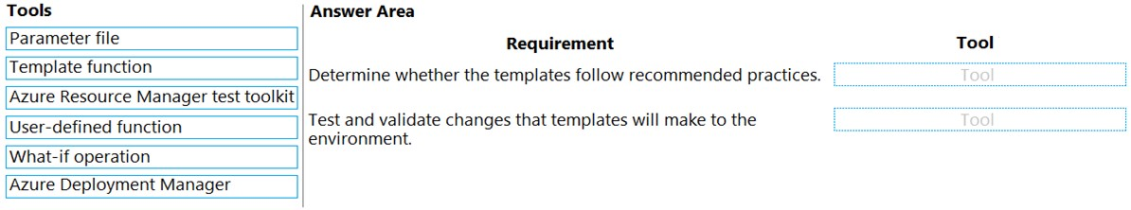

[Hide Solution](https://www.examtopics.com/exams/microsoft/az-204/view/9/) [Discussion   **12**](https://www.examtopics.com/exams/microsoft/az-204/view/9/)

**Correct Answer:** 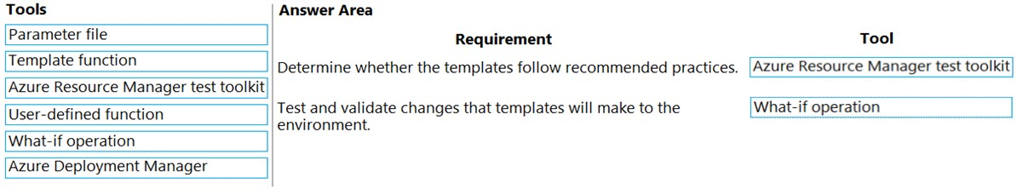  
Box 1: Azure Resource Manager test toolkit  
  
Use ARM template test toolkit -  
The Azure Resource Manager template (ARM template) test toolkit checks whether your template uses recommended practices. When your template isn't compliant with recommended practices, it returns a list of warnings with the suggested changes. By using the test toolkit, you can learn how to avoid common problems in template development.  
  
Box 2: What-if operation -  
ARM template deployment what-if operation  
Before deploying an Azure Resource Manager template (ARM template), you can preview the changes that will happen. Azure Resource Manager provides the what-if operation to let you see how resources will change if you deploy the template. The what-if operation doesn't make any changes to existing resources.  
Instead, it predicts the changes if the specified template is deployed.  
Reference:  
https://docs.microsoft.com/en-us/azure/azure-resource-manager/templates/test-toolkit https://docs.microsoft.com/en-us/azure/azure-resource-manager/templates/deploy-what-if

Question #46*Topic 2*

You develop Azure Durable Functions to manage vehicle loans.  
  
The loan process includes multiple actions that must be run in a specified order. One of the actions includes a customer credit check process, which may require multiple days to process.  
  
You need to implement Azure Durable Functions for the loan process.  
  
Which Azure Durable Functions type should you use?

* A. orchestrator **Most Voted**
* B. client
* C. entity
* D. activity

[Hide Solution](https://www.examtopics.com/exams/microsoft/az-204/view/9/) [Discussion   **4**](https://www.examtopics.com/exams/microsoft/az-204/view/9/)

**Correct Answer:** *A* [🗳️](https://www.examtopics.com/exams/microsoft/az-204/view/9/)

*Community vote distribution*

A (100%)

Question #47*Topic 2*

HOTSPOT  
-  
  
You are developing an Azure Function app.  
  
All functions in the app meet the following requirements:  
  
• Run until either a successful run or until 10 run attempts occur.  
• Ensure that there are at least 20 seconds between attempts for up to 15 minutes.  
  
You need to configure the host.json file.  
  
How should you complete the code segment? To answer, select the appropriate options in the answer area.  
  
NOTE: Each correct selection is worth one point.  
  


[Hide Solution](https://www.examtopics.com/exams/microsoft/az-204/view/9/) [Discussion   **9**](https://www.examtopics.com/exams/microsoft/az-204/view/9/)

**Correct Answer:** 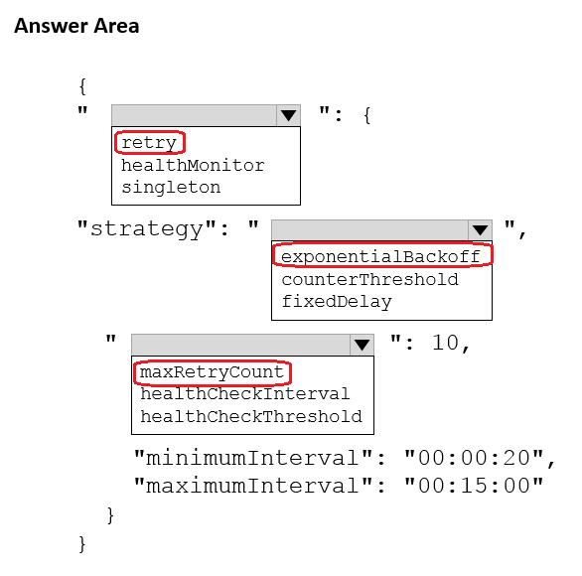

Question #48*Topic 2*

You develop Azure Web Apps for a commercial diving company. Regulations require that all divers fill out a health questionnaire every 15 days after each diving job starts.  
  
You need to configure the Azure Web Apps so that the instance count scales up when divers are filling out the questionnaire and scales down after they are complete.  
  
You need to configure autoscaling.  
  
What are two possible auto scaling configurations to achieve this goal? Each correct answer presents a complete solution.  
  
NOTE: Each correct selection is worth one point.

* A. Recurrence profile **Most Voted**
* B. CPU usage-based autoscaling
* C. Fixed date profile **Most Voted**
* D. Predictive autoscaling

[Hide Solution](https://www.examtopics.com/exams/microsoft/az-204/view/9/) [Discussion   **14**](https://www.examtopics.com/exams/microsoft/az-204/view/9/)

**Correct Answer:** *CD* [🗳️](https://www.examtopics.com/exams/microsoft/az-204/view/9/)

*Community vote distribution*

AC (65%)

BD (24%)

12%

**Topic 3 - Question Set 3**

Question #1*Topic 3*

HOTSPOT -  
You are developing a solution that uses the Azure Storage Client library for .NET. You have the following code: (Line numbers are included for reference only.)  
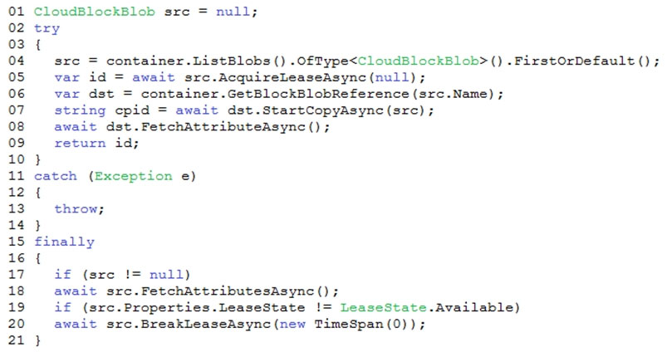  
For each of the following statements, select Yes if the statement is true. Otherwise, select No.  
NOTE: Each correct selection is worth one point.  
Hot Area:  
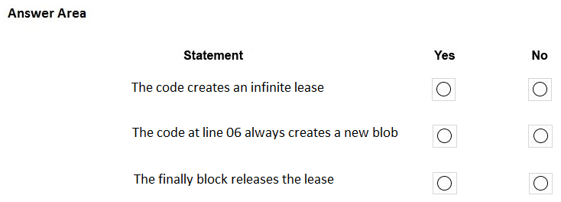

[Hide Solution](https://www.examtopics.com/exams/microsoft/az-204/view/9/) [Discussion   **37**](https://www.examtopics.com/exams/microsoft/az-204/view/9/)

**Correct Answer:** 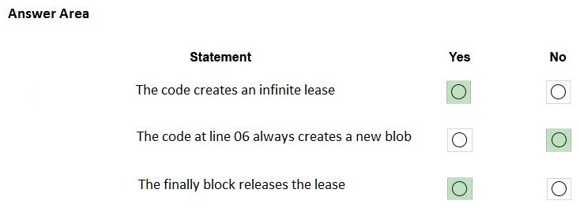  
Box 1: Yes -  
AcquireLeaseAsync does not specify leaseTime.  
leaseTime is a TimeSpan representing the span of time for which to acquire the lease, which will be rounded down to seconds. If null, an infinite lease will be acquired. If not null, this must be 15 to 60 seconds.  
  
Box 2: No -  
The GetBlockBlobReference method just gets a reference to a block blob in this container.  
  
Box 3: Yes -  
The BreakLeaseAsync method initiates an asynchronous operation that breaks the current lease on this container.  
Reference:  
https://docs.microsoft.com/en-us/dotnet/api/microsoft.azure.storage.blob.cloudblobcontainer.acquireleaseasync https://docs.microsoft.com/en-us/dotnet/api/microsoft.azure.storage.blob.cloudblobcontainer.getblockblobreference https://docs.microsoft.com/en-us/dotnet/api/microsoft.azure.storage.blob.cloudblobcontainer.breakleaseasync

Question #2*Topic 3*

You are building a website that uses Azure Blob storage for data storage. You configure Azure Blob storage lifecycle to move all blobs to the archive tier after 30 days.  
Customers have requested a service-level agreement (SLA) for viewing data older than 30 days.  
You need to document the minimum SLA for data recovery.  
Which SLA should you use?

* A. at least two days
* B. between one and 15 hours **Most Voted**
* C. at least one day
* D. between zero and 60 minutes

[Hide Solution](https://www.examtopics.com/exams/microsoft/az-204/view/9/) [Discussion   **25**](https://www.examtopics.com/exams/microsoft/az-204/view/9/)

**Correct Answer:** *B* [🗳️](https://www.examtopics.com/exams/microsoft/az-204/view/9/)  
The archive access tier has the lowest storage cost. But it has higher data retrieval costs compared to the hot and cool tiers. Data in the archive tier can take several hours to retrieve depending on the priority of the rehydration. For small objects, a high priority rehydrate may retrieve the object from archive in under 1 hour.  
Reference:  
https://docs.microsoft.com/en-us/azure/storage/blobs/storage-blob-storage-tiers?tabs=azure-portal

*Community vote distribution*

B (100%)

Question #3*Topic 3*

HOTSPOT -  
You are developing a ticket reservation system for an airline.  
The storage solution for the application must meet the following requirements:  
✑ Ensure at least 99.99% availability and provide low latency.  
✑ Accept reservations even when localized network outages or other unforeseen failures occur.  
✑ Process reservations in the exact sequence as reservations are submitted to minimize overbooking or selling the same seat to multiple travelers.  
✑ Allow simultaneous and out-of-order reservations with a maximum five-second tolerance window.  
You provision a resource group named airlineResourceGroup in the Azure South-Central US region.  
You need to provision a SQL API Cosmos DB account to support the app.  
How should you complete the Azure CLI commands? To answer, select the appropriate options in the answer area.  
NOTE: Each correct selection is worth one point.  
Hot Area:  
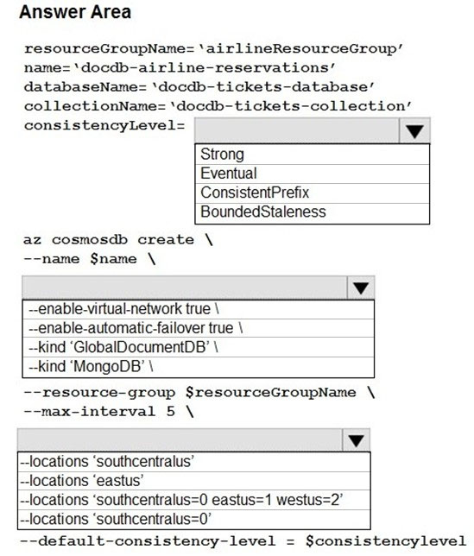

[Hide Solution](https://www.examtopics.com/exams/microsoft/az-204/view/9/) [Discussion   **31**](https://www.examtopics.com/exams/microsoft/az-204/view/9/)

**Correct Answer:** 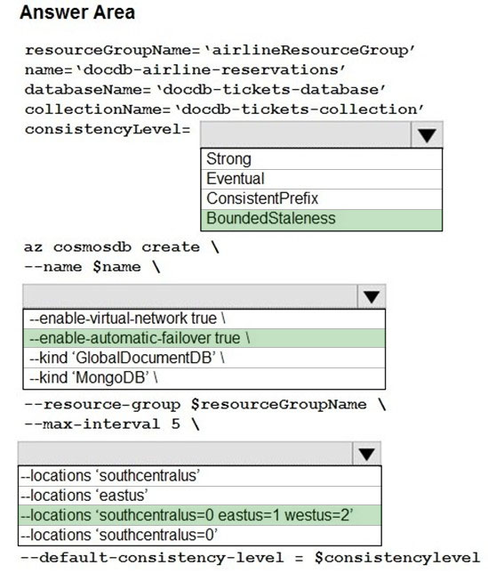  
Box 1: BoundedStaleness -  
Bounded staleness: The reads are guaranteed to honor the consistent-prefix guarantee. The reads might lag behind writes by at most "K" versions (that is,  
"updates") of an item or by "T" time interval. In other words, when you choose bounded staleness, the "staleness" can be configured in two ways:  
The number of versions (K) of the item  
The time interval (T) by which the reads might lag behind the writes  
Incorrect Answers:  
  
Strong -  
Strong consistency offers a linearizability guarantee. Linearizability refers to serving requests concurrently. The reads are guaranteed to return the most recent committed version of an item. A client never sees an uncommitted or partial write. Users are always guaranteed to read the latest committed write.  
Box 2: --enable-automatic-failover true\  
For multi-region Cosmos accounts that are configured with a single-write region, enable automatic-failover by using Azure CLI or Azure portal. After you enable automatic failover, whenever there is a regional disaster, Cosmos DB will automatically failover your account.  
Question: Accept reservations event when localized network outages or other unforeseen failures occur.  
Box 3: --locations'southcentralus=0 eastus=1 westus=2  
Need multi-region.  
Reference:  
https://docs.microsoft.com/en-us/azure/cosmos-db/consistency-levels https://github.com/MicrosoftDocs/azure-docs/blob/master/articles/cosmos-db/manage-with-cli.md

Question #4*Topic 3*

HOTSPOT -  
You are preparing to deploy a Python website to an Azure Web App using a container. The solution will use multiple containers in the same container group. The  
Dockerfile that builds the container is as follows:  
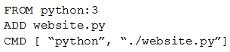  
You build a container by using the following command. The Azure Container Registry instance named images is a private registry.  
  
The user name and password for the registry is admin.  
The Web App must always run the same version of the website regardless of future builds.  
You need to create an Azure Web App to run the website.  
How should you complete the commands? To answer, select the appropriate options in the answer area.  
NOTE: Each correct selection is worth one point.  
Hot Area:  
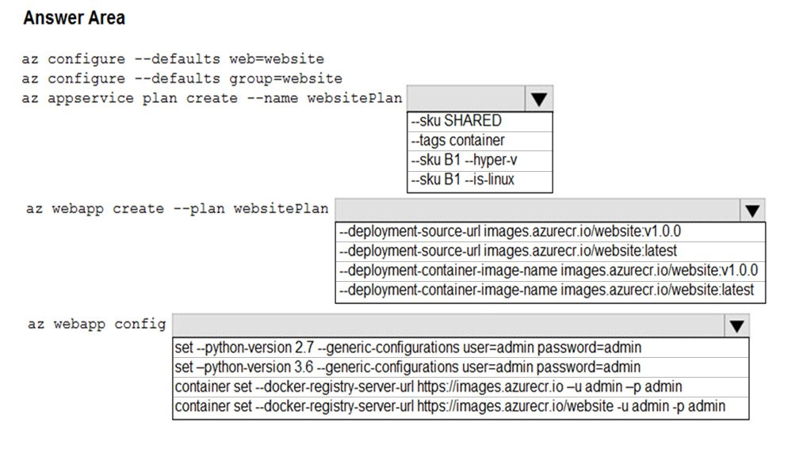

[Hide Solution](https://www.examtopics.com/exams/microsoft/az-204/view/9/) [Discussion   **25**](https://www.examtopics.com/exams/microsoft/az-204/view/9/)

**Correct Answer:** 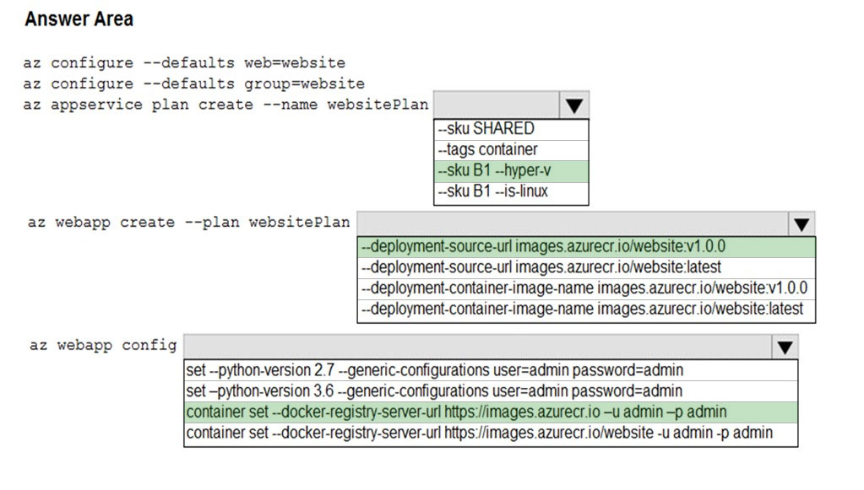  
Box 1: --SKU B1 --hyper-v -  
--hyper-v  
Host web app on Windows container.  
Box 2: --deployment-source-url images.azurecr.io/website:v1.0.0  
--deployment-source-url -u  
Git repository URL to link with manual integration.  
The Web App must always run the same version of the website regardless of future builds.  
Incorrect:  
--deployment-container-image-name -i  
Linux only. Container image name from Docker Hub, e.g. publisher/image-name:tag.  
Box 3: az webapp config container set -url https://images.azurecr.io -u admin -p admin az webapp config container set  
Set a web app container's settings.  
Paremeter: --docker-registry-server-url -r  
The container registry server url.  
The Azure Container Registry instance named images is a private registry.  
Example:  
az webapp config container set --docker-registry-server-url https://{azure-container-registry-name}.azurecr.io  
Reference:  
https://docs.microsoft.com/en-us/cli/azure/appservice/plan

Question #5*Topic 3*

HOTSPOT -  
You are developing a back-end Azure App Service that scales based on the number of messages contained in a Service Bus queue.  
A rule already exists to scale up the App Service when the average queue length of unprocessed and valid queue messages is greater than 1000.  
You need to add a new rule that will continuously scale down the App Service as long as the scale up condition is not met.  
How should you configure the Scale rule? To answer, select the appropriate options in the answer area.  
NOTE: Each correct selection is worth one point.  
Hot Area:  
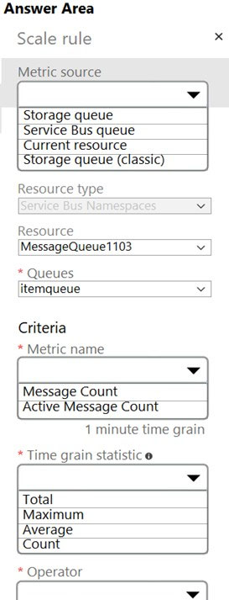

[Hide Solution](https://www.examtopics.com/exams/microsoft/az-204/view/9/) [Discussion   **22**](https://www.examtopics.com/exams/microsoft/az-204/view/9/)

**Correct Answer:** 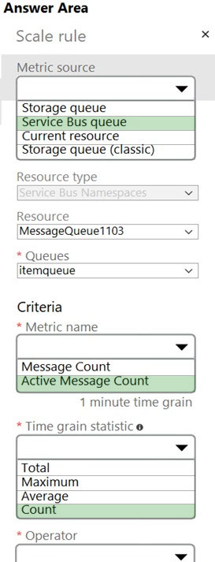  
Box 1: Service bus queue -  
You are developing a back-end Azure App Service that scales based on the number of messages contained in a Service Bus queue.  
  
Box 2: ActiveMessage Count -  
ActiveMessageCount: Messages in the queue or subscription that are in the active state and ready for delivery.  
  
Box 3: Count -  
  
Box 4: Less than or equal to -  
You need to add a new rule that will continuously scale down the App Service as long as the scale up condition is not met.  
Box 5: Decrease count by

Question #6*Topic 3*

DRAG DROP -  
You have an application that uses Azure Blob storage.  
You need to update the metadata of the blobs.  
Which three methods should you use to develop the solution? To answer, move the appropriate methods from the list of methods to the answer area and arrange them in the correct order.  
Select and Place:  
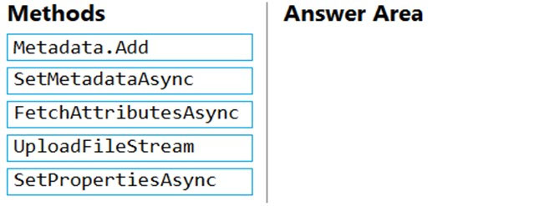

[Hide Solution](https://www.examtopics.com/exams/microsoft/az-204/view/10/) [Discussion   **44**](https://www.examtopics.com/exams/microsoft/az-204/view/10/)

**Correct Answer:** 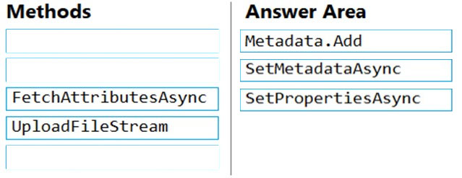  
Metadata.Add example:  
// Add metadata to the dictionary by calling the Add method  
metadata.Add("docType", "textDocuments");  
SetMetadataAsync example:  
// Set the blob's metadata.  
await blob.SetMetadataAsync(metadata);  
// Set the blob's properties.  
await blob.SetPropertiesAsync();  
Reference:  
https://docs.microsoft.com/en-us/azure/storage/blobs/storage-blob-properties-metadata

Question #7*Topic 3*

Note: This question is part of a series of questions that present the same scenario. Each question in the series contains a unique solution that might meet the stated goals. Some question sets might have more than one correct solution, while others might not have a correct solution.  
After you answer a question in this section, you will NOT be able to return to it. As a result, these questions will not appear in the review screen.  
You are developing an Azure solution to collect point-of-sale (POS) device data from 2,000 stores located throughout the world. A single device can produce  
2 megabytes (MB) of data every 24 hours. Each store location has one to five devices that send data.  
You must store the device data in Azure Blob storage. Device data must be correlated based on a device identifier. Additional stores are expected to open in the future.  
You need to implement a solution to receive the device data.  
Solution: Provision an Azure Event Grid. Configure the machine identifier as the partition key and enable capture.  
Does the solution meet the goal?

* A. Yes
* B. No **Most Voted**

[Hide Solution](https://www.examtopics.com/exams/microsoft/az-204/view/10/) [Discussion   **48**](https://www.examtopics.com/exams/microsoft/az-204/view/10/)

**Correct Answer:** *A* [🗳️](https://www.examtopics.com/exams/microsoft/az-204/view/10/)  
Reference:  
https://docs.microsoft.com/en-us/azure/event-grid/compare-messaging-services

*Community vote distribution*

B (100%)

Question #8*Topic 3*

You develop Azure solutions.  
A .NET application needs to receive a message each time an Azure virtual machine finishes processing data. The messages must NOT persist after being processed by the receiving application.  
You need to implement the .NET object that will receive the messages.  
Which object should you use?

* A. QueueClient **Most Voted**
* B. SubscriptionClient
* C. TopicClient
* D. CloudQueueClient

[Hide Solution](https://www.examtopics.com/exams/microsoft/az-204/view/10/) [Discussion   **19**](https://www.examtopics.com/exams/microsoft/az-204/view/10/)

**Correct Answer:** *D* [🗳️](https://www.examtopics.com/exams/microsoft/az-204/view/10/)  
A queue allows processing of a message by a single consumer. Need a CloudQueueClient to access the Azure VM.  
Incorrect Answers:  
B, C: In contrast to queues, topics and subscriptions provide a one-to-many form of communication in a publish and subscribe pattern. It's useful for scaling to large numbers of recipients.  
Reference:  
https://docs.microsoft.com/en-us/azure/service-bus-messaging/service-bus-queues-topics-subscriptions

*Community vote distribution*

A (100%)

Question #9*Topic 3*

DRAG DROP -  
You are maintaining an existing application that uses an Azure Blob GPv1 Premium storage account. Data older than three months is rarely used.  
Data newer than three months must be available immediately. Data older than a year must be saved but does not need to be available immediately.  
You need to configure the account to support a lifecycle management rule that moves blob data to archive storage for data not modified in the last year.  
Which three actions should you perform in sequence? To answer, move the appropriate actions from the list of actions to the answer area and arrange them in the correct order.  
Select and Place:  
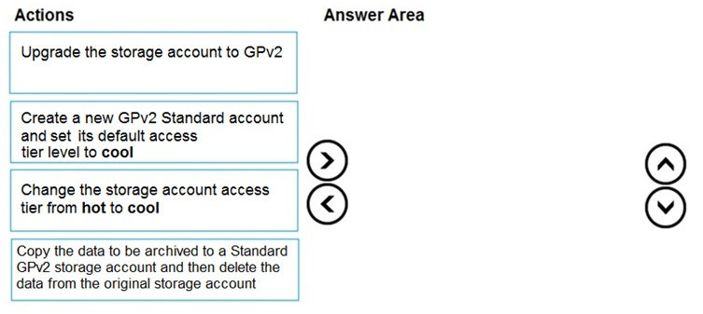

[Hide Solution](https://www.examtopics.com/exams/microsoft/az-204/view/10/) [Discussion   **61**](https://www.examtopics.com/exams/microsoft/az-204/view/10/)

**Correct Answer:** 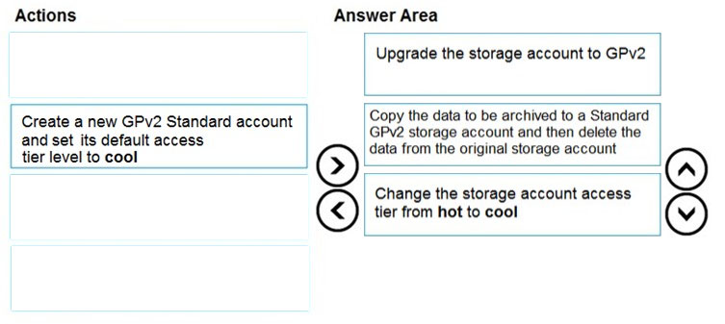  
Step 1: Upgrade the storage account to GPv2  
Object storage data tiering between hot, cool, and archive is supported in Blob Storage and General Purpose v2 (GPv2) accounts. General Purpose v1 (GPv1) accounts don't support tiering.  
You can easily convert your existing GPv1 or Blob Storage accounts to GPv2 accounts through the Azure portal.  
Step 2: Copy the data to be archived to a Standard GPv2 storage account and then delete the data from the original storage account  
Step 3: Change the storage account access tier from hot to cool  
Note: Hot - Optimized for storing data that is accessed frequently.  
Cool - Optimized for storing data that is infrequently accessed and stored for at least 30 days.  
Archive - Optimized for storing data that is rarely accessed and stored for at least 180 days with flexible latency requirements, on the order of hours.  
Only the hot and cool access tiers can be set at the account level. The archive access tier can only be set at the blob level.  
Reference:  
https://docs.microsoft.com/en-us/azure/storage/blobs/storage-blob-storage-tiers

Question #10*Topic 3*

You develop Azure solutions.  
You must connect to a No-SQL globally-distributed database by using the .NET API.  
You need to create an object to configure and execute requests in the database.  
Which code segment should you use?

* A. new Container(EndpointUri, PrimaryKey);
* B. new Database(EndpointUri, PrimaryKey);
* C. new CosmosClient(EndpointUri, PrimaryKey); **Most Voted**

[Hide Solution](https://www.examtopics.com/exams/microsoft/az-204/view/10/) [Discussion   **20**](https://www.examtopics.com/exams/microsoft/az-204/view/10/)

**Correct Answer:** *C* [🗳️](https://www.examtopics.com/exams/microsoft/az-204/view/10/)  
Example:  
// Create a new instance of the Cosmos Client  
this.cosmosClient = new CosmosClient(EndpointUri, PrimaryKey)  
//ADD THIS PART TO YOUR CODE  
await this.CreateDatabaseAsync();  
Reference:  
https://docs.microsoft.com/en-us/azure/cosmos-db/sql-api-get-started

*Community vote distribution*

C (100%)

Question #11*Topic 3*

You have an existing Azure storage account that stores large volumes of data across multiple containers.  
You need to copy all data from the existing storage account to a new storage account. The copy process must meet the following requirements:  
✑ Automate data movement.  
✑ Minimize user input required to perform the operation.  
✑ Ensure that the data movement process is recoverable.  
What should you use?

* A. AzCopy **Most Voted**
* B. Azure Storage Explorer
* C. Azure portal
* D. .NET Storage Client Library

[Hide Solution](https://www.examtopics.com/exams/microsoft/az-204/view/10/) [Discussion   **31**](https://www.examtopics.com/exams/microsoft/az-204/view/10/)

**Correct Answer:** *A* [🗳️](https://www.examtopics.com/exams/microsoft/az-204/view/10/)  
You can copy blobs, directories, and containers between storage accounts by using the AzCopy v10 command-line utility.  
The copy operation is synchronous so when the command returns, that indicates that all files have been copied.  
Reference:  
https://docs.microsoft.com/en-us/azure/storage/common/storage-use-azcopy-blobs-copy

*Community vote distribution*

A (100%)

Question #12*Topic 3*

DRAG DROP -  
You are developing a web service that will run on Azure virtual machines that use Azure Storage. You configure all virtual machines to use managed identities.  
You have the following requirements:  
✑ Secret-based authentication mechanisms are not permitted for accessing an Azure Storage account.  
✑ Must use only Azure Instance Metadata Service endpoints.  
You need to write code to retrieve an access token to access Azure Storage. To answer, drag the appropriate code segments to the correct locations. Each code segment may be used once or not at all. You may need to drag the split bar between panes or scroll to view content.  
NOTE: Each correct selection is worth one point.  
Select and Place:  
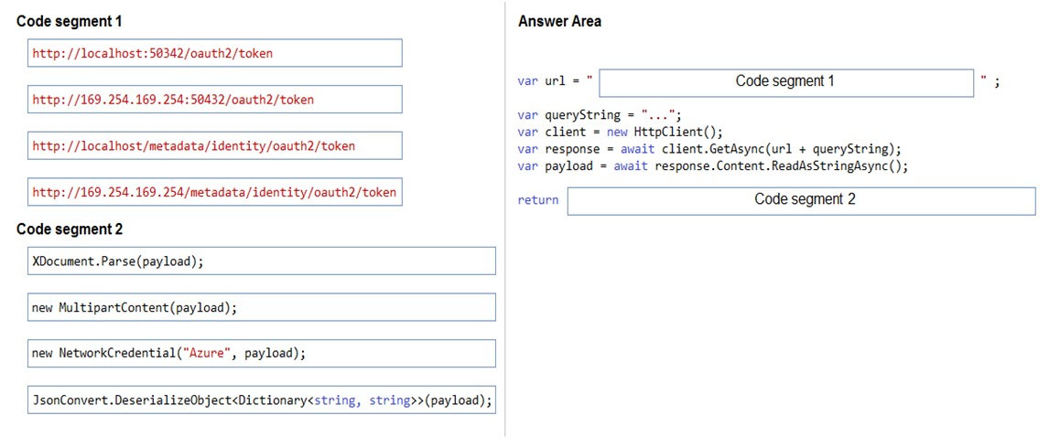

[Hide Solution](https://www.examtopics.com/exams/microsoft/az-204/view/10/) [Discussion   **13**](https://www.examtopics.com/exams/microsoft/az-204/view/10/)

**Correct Answer:** 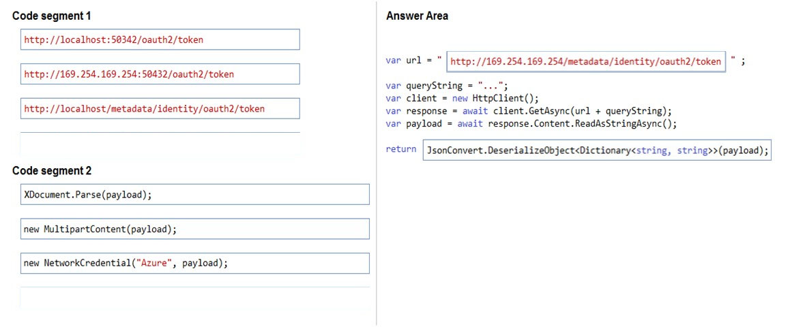  
Azure Instance Metadata Service endpoints "/oauth2/token"  
Box 1: http://169.254.169.254/metadata/identity/oauth2/token  
Sample request using the Azure Instance Metadata Service (IMDS) endpoint (recommended):  
GET 'http://169.254.169.254/metadata/identity/oauth2/token?api-version=2018-02-01&resource=https://management.azure.com/' HTTP/1.1 Metadata: true  
Box 2: JsonConvert.DeserializeObject<Dictionary<string,string>>(payload);  
Deserialized token response; returning access code.  
Reference:  
https://docs.microsoft.com/en-us/azure/active-directory/managed-identities-azure-resources/how-to-use-vm-token https://docs.microsoft.com/en-us/azure/service-fabric/how-to-managed-identity-service-fabric-app-code

Question #13*Topic 3*

DRAG DROP -  
You are developing a new page for a website that uses Azure Cosmos DB for data storage. The feature uses documents that have the following format:  
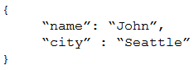  
You must display data for the new page in a specific order. You create the following query for the page:  
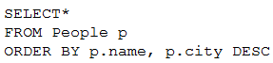  
You need to configure a Cosmos DB policy to support the query.  
How should you configure the policy? To answer, drag the appropriate JSON segments to the correct locations. Each JSON segment may be used once, more than once, or not at all. You may need to drag the split bar between panes or scroll to view content.  
NOTE: Each correct selection is worth one point.  
Select and Place:  
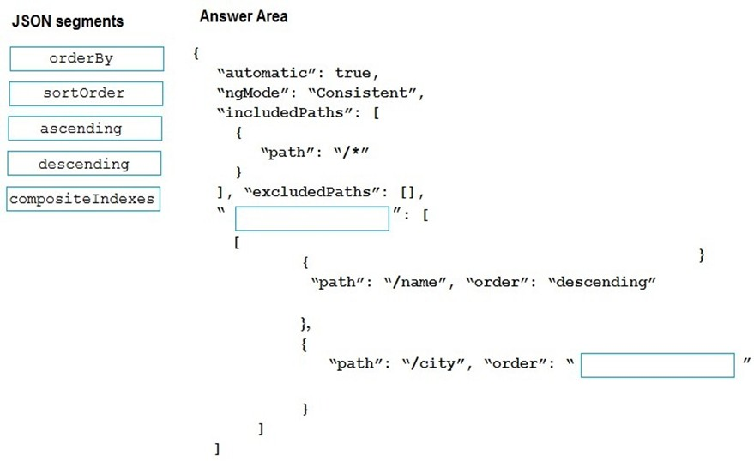

[Hide Solution](https://www.examtopics.com/exams/microsoft/az-204/view/10/) [Discussion   **68**](https://www.examtopics.com/exams/microsoft/az-204/view/10/)

**Correct Answer:** 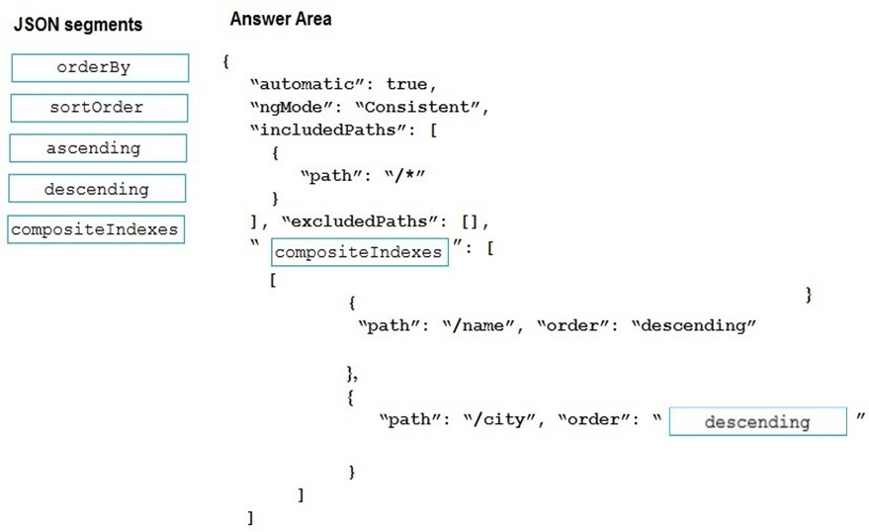  
Box 1: compositeIndexes -  
You can order by multiple properties. A query that orders by multiple properties requires a composite index.  
  
Box 2: descending -  
Example: Composite index defined for (name ASC, age ASC):  
It is optional to specify the order. If not specified, the order is ascending.  
{  
"automatic":true,  
"indexingMode":"Consistent",  
"includedPaths":[  
{  
"path":"/*"  
}  
],  
"excludedPaths":[],  
"compositeIndexes":[  
[  
{  
"path":"/name",  
},  
{  
"path":"/age",  
}  
]  
]  
}

Question #14*Topic 3*

HOTSPOT -  
You are building a traffic monitoring system that monitors traffic along six highways. The system produces time series analysis-based reports for each highway.  
Data from traffic sensors are stored in Azure Event Hub.  
Traffic data is consumed by four departments. Each department has an Azure Web App that displays the time series-based reports and contains a WebJob that processes the incoming data from Event Hub. All Web Apps run on App Service Plans with three instances.  
Data throughput must be maximized. Latency must be minimized.  
You need to implement the Azure Event Hub.  
Which settings should you use? To answer, select the appropriate options in the answer area.  
NOTE: Each correct selection is worth one point.  
Hot Area:  
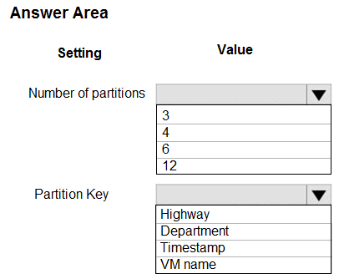

[Hide Solution](https://www.examtopics.com/exams/microsoft/az-204/view/10/) [Discussion   **81**](https://www.examtopics.com/exams/microsoft/az-204/view/10/)

**Correct Answer:** 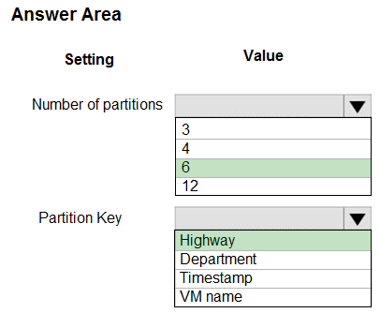  
Box 1: 6 -  
The number of partitions is specified at creation and must be between 2 and 32.  
There are 6 highways.  
  
Box 2: Highway -  
Reference:  
https://docs.microsoft.com/en-us/azure/event-hubs/event-hubs-features

Question #15*Topic 3*

DRAG DROP -  
You are developing a microservices solution. You plan to deploy the solution to a multinode Azure Kubernetes Service (AKS) cluster.  
You need to deploy a solution that includes the following features:  
✑ reverse proxy capabilities  
✑ configurable traffic routing  
✑ TLS termination with a custom certificate  
Which components should you use? To answer, drag the appropriate components to the correct requirements. Each component may be used once, more than once, or not at all. You may need to drag the split bar between panes or scroll to view content.  
NOTE: Each correct selection is worth one point.  
Select and Place:  
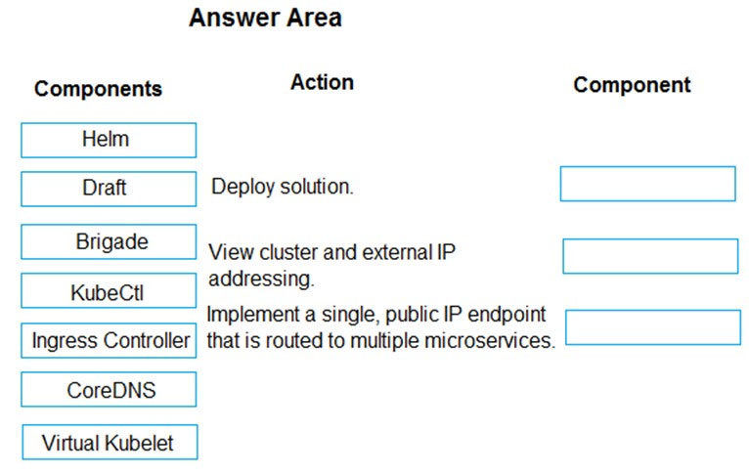

[Hide Solution](https://www.examtopics.com/exams/microsoft/az-204/view/10/) [Discussion   **20**](https://www.examtopics.com/exams/microsoft/az-204/view/10/)

**Correct Answer:** 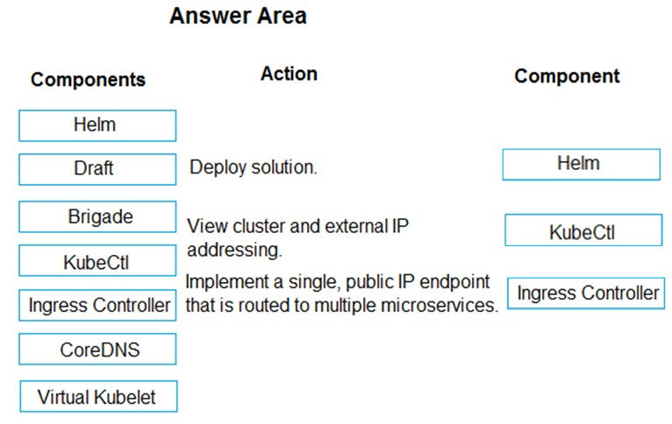  
Box 1: Helm -  
To create the ingress controller, use Helm to install nginx-ingress.  
  
Box 2: kubectl -  
To find the cluster IP address of a Kubernetes pod, use the kubectl get pod command on your local machine, with the option -o wide .  
  
Box 3: Ingress Controller -  
An ingress controller is a piece of software that provides reverse proxy, configurable traffic routing, and TLS termination for Kubernetes services. Kubernetes ingress resources are used to configure the ingress rules and routes for individual Kubernetes services.  
Incorrect Answers:  
Virtual Kubelet: Virtual Kubelet is an open-source Kubernetes kubelet implementation that masquerades as a kubelet. This allows Kubernetes nodes to be backed by Virtual Kubelet providers such as serverless cloud container platforms.  
CoreDNS: CoreDNS is a flexible, extensible DNS server that can serve as the Kubernetes cluster DNS. Like Kubernetes, the CoreDNS project is hosted by the  
CNCF.  
Reference:  
https://docs.microsoft.com/bs-cyrl-ba/azure/aks/ingress-basic <https://www.digitalocean.com/community/tutorials/how-to-inspect-kubernetes-networking>

Question #16*Topic 3*

DRAG DROP -  
You are implementing an order processing system. A point of sale application publishes orders to topics in an Azure Service Bus queue. The Label property for the topic includes the following data:  
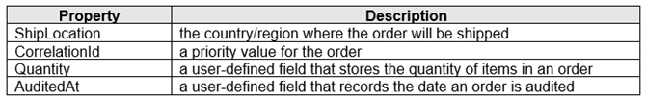  
The system has the following requirements for subscriptions:  
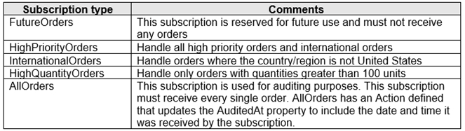  
You need to implement filtering and maximize throughput while evaluating filters.  
Which filter types should you implement? To answer, drag the appropriate filter types to the correct subscriptions. Each filter type may be used once, more than once, or not at all. You may need to drag the split bar between panes or scroll to view content.  
NOTE: Each correct selection is worth one point.  
Select and Place:  
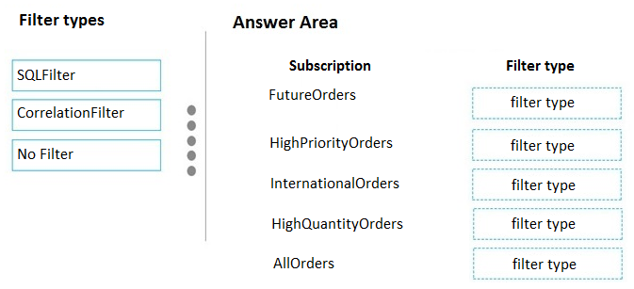

[Hide Solution](https://www.examtopics.com/exams/microsoft/az-204/view/11/) [Discussion   **134**](https://www.examtopics.com/exams/microsoft/az-204/view/11/)

**Correct Answer:** 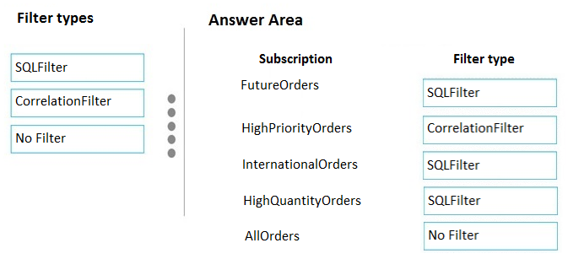  
FutureOrders: SQLFilter -  
HighPriortyOrders: CorrelationFilter  
  
CorrelationID only -  
  
InternationalOrders: SQLFilter -  
Country NOT USA requires an SQL Filter  
  
HighQuantityOrders: SQLFilter -  
Need to use relational operators so an SQL Filter is needed.  
  
AllOrders: No Filter -  
SQL Filter: SQL Filters - A SqlFilter holds a SQL-like conditional expression that is evaluated in the broker against the arriving messages' user-defined properties and system properties. All system properties must be prefixed with sys. in the conditional expression. The SQL-language subset for filter conditions tests for the existence of properties (EXISTS), as well as for null-values (IS NULL), logical NOT/AND/OR, relational operators, simple numeric arithmetic, and simple text pattern matching with LIKE.  
Correlation Filters - A CorrelationFilter holds a set of conditions that are matched against one or more of an arriving message's user and system properties. A common use is to match against the CorrelationId property, but the application can also choose to match against ContentType, Label, MessageId, ReplyTo,  
ReplyToSessionId, SessionId, To, and any user-defined properties. A match exists when an arriving message's value for a property is equal to the value specified in the correlation filter. For string expressions, the comparison is case-sensitive. When specifying multiple match properties, the filter combines them as a logical  
AND condition, meaning for the filter to match, all conditions must match.  
Boolean filters - The TrueFilter and FalseFilter either cause all arriving messages (true) or none of the arriving messages (false) to be selected for the subscription.  
Reference:  
https://docs.microsoft.com/en-us/azure/service-bus-messaging/topic-filters

Question #17*Topic 3*

DRAG DROP -  
Your company has several websites that use a company logo image. You use Azure Content Delivery Network (CDN) to store the static image.  
You need to determine the correct process of how the CDN and the Point of Presence (POP) server will distribute the image and list the items in the correct order.  
In which order do the actions occur? To answer, move all actions from the list of actions to the answer area and arrange them in the correct order.  
Select and Place:  
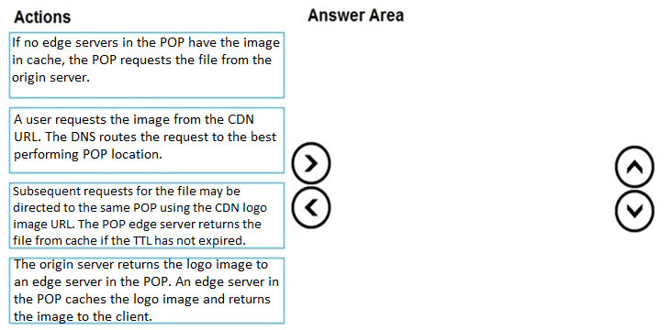

[Hide Solution](https://www.examtopics.com/exams/microsoft/az-204/view/11/) [Discussion   **24**](https://www.examtopics.com/exams/microsoft/az-204/view/11/)

**Correct Answer:** 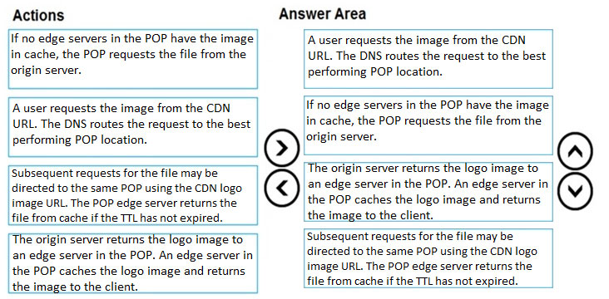  
Step 1: A user requests the image..  
A user requests a file (also called an asset) by using a URL with a special domain name, such as <endpoint name>.azureedge.net. This name can be an endpoint hostname or a custom domain. The DNS routes the request to the best performing POP location, which is usually the POP that is geographically closest to the user.  
Step 2: If no edge servers in the POP have the..  
If no edge servers in the POP have the file in their cache, the POP requests the file from the origin server. The origin server can be an Azure Web App, Azure  
Cloud Service, Azure Storage account, or any publicly accessible web server.  
Step 3: The origin server returns the..  
The origin server returns the file to an edge server in the POP.  
An edge server in the POP caches the file and returns the file to the original requestor (Alice). The file remains cached on the edge server in the POP until the time-to-live (TTL) specified by its HTTP headers expires. If the origin server didn't specify a TTL, the default TTL is seven days.  
Step 4: Subsequent requests for..  
Additional users can then request the same file by using the same URL that the original user used, and can also be directed to the same POP.  
If the TTL for the file hasn't expired, the POP edge server returns the file directly from the cache. This process results in a faster, more responsive user experience.  
Reference:  
https://docs.microsoft.com/en-us/azure/cdn/cdn-overview

Question #18*Topic 3*

You are developing an Azure Cosmos DB solution by using the Azure Cosmos DB SQL API. The data includes millions of documents. Each document may contain hundreds of properties.  
The properties of the documents do not contain distinct values for partitioning. Azure Cosmos DB must scale individual containers in the database to meet the performance needs of the application by spreading the workload evenly across all partitions over time.  
You need to select a partition key.  
Which two partition keys can you use? Each correct answer presents a complete solution.  
NOTE: Each correct selection is worth one point.

* A. a single property value that does not appear frequently in the documents
* B. a value containing the collection name
* C. a single property value that appears frequently in the documents
* D. a concatenation of multiple property values with a random suffix appended **Most Voted**
* E. a hash suffix appended to a property value **Most Voted**

[Hide Solution](https://www.examtopics.com/exams/microsoft/az-204/view/11/) [Discussion   **24**](https://www.examtopics.com/exams/microsoft/az-204/view/11/)

**Correct Answer:** *DE* [🗳️](https://www.examtopics.com/exams/microsoft/az-204/view/11/)  
You can form a partition key by concatenating multiple property values into a single artificial partitionKey property. These keys are referred to as synthetic keys.  
Another possible strategy to distribute the workload more evenly is to append a random number at the end of the partition key value. When you distribute items in this way, you can perform parallel write operations across partitions.  
Note: It's the best practice to have a partition key with many distinct values, such as hundreds or thousands. The goal is to distribute your data and workload evenly across the items associated with these partition key values. If such a property doesn't exist in your data, you can construct a synthetic partition key.  
Reference:  
https://docs.microsoft.com/en-us/azure/cosmos-db/synthetic-partition-keys

*Community vote distribution*

DE (100%)

Question #19*Topic 3*

HOTSPOT -  
You are developing an Azure-hosted e-commerce web application. The application will use Azure Cosmos DB to store sales orders. You are using the latest SDK to manage the sales orders in the database.  
You create a new Azure Cosmos DB instance. You include a valid endpoint and valid authorization key to an appSettings.json file in the code project.  
You are evaluating the following application code: (Line number are included for reference only.)  
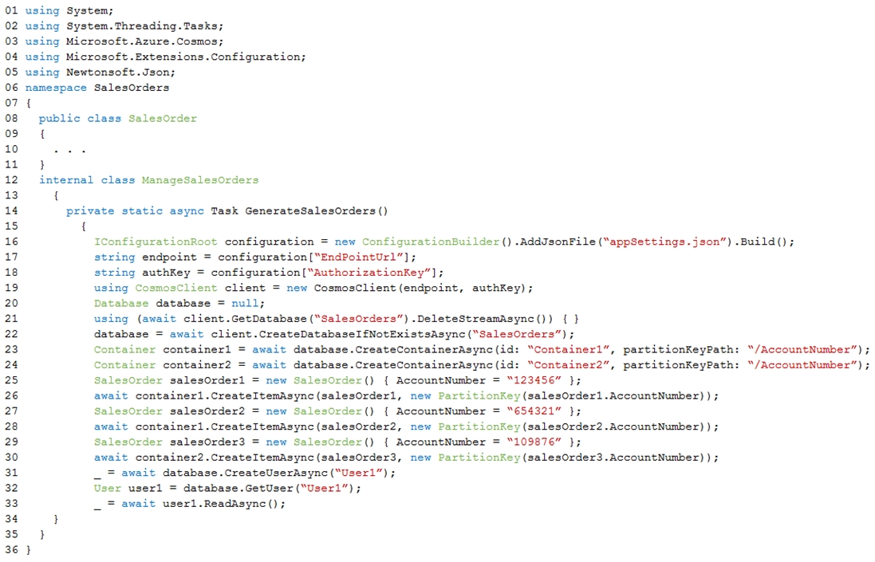  
For each of the following statements, select Yes if the statement is true. Otherwise, select No.  
NOTE: Each correct selection is worth one point.  
Hot Area:  
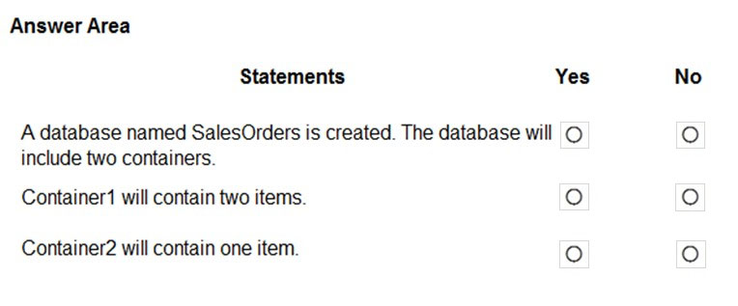

[Hide Solution](https://www.examtopics.com/exams/microsoft/az-204/view/11/) [Discussion   **24**](https://www.examtopics.com/exams/microsoft/az-204/view/11/)

**Correct Answer:** 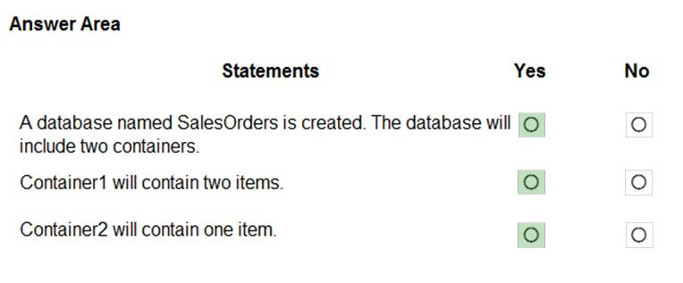  
Box 1: Yes -  
The createDatabaseIfNotExistsAsync method checks if a database exists, and if it doesn't, create it.  
The Database.CreateContainerAsync method creates a container as an asynchronous operation in the Azure Cosmos service.  
  
Box 2: Yes -  
The CosmosContainer.CreateItemAsync method creates an item as an asynchronous operation in the Azure Cosmos service.  
  
Box 3: Yes -  
Reference:  
https://docs.microsoft.com/en-us/dotnet/api/microsoft.azure.cosmos.cosmosclient.createdatabaseifnotexistsasync https://docs.microsoft.com/en-us/dotnet/api/microsoft.azure.cosmos.database.createcontainerasync https://docs.microsoft.com/en-us/dotnet/api/azure.cosmos.cosmoscontainer.createitemasync

Question #20*Topic 3*

DRAG DROP -  
You develop an Azure solution that uses Cosmos DB.  
The current Cosmos DB container must be replicated and must use a partition key that is optimized for queries.  
You need to implement a change feed processor solution.  
Which change feed processor components should you use? To answer, drag the appropriate components to the correct requirements. Each component may be used once, more than once, or not at all. You may need to drag the split bar between panes or scroll to view the content.  
NOTE: Each correct selection is worth one point.  
Select and Place:  
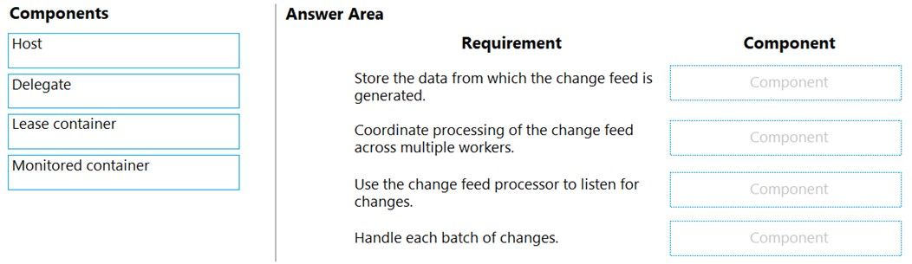

[Hide Solution](https://www.examtopics.com/exams/microsoft/az-204/view/11/) [Discussion   **20**](https://www.examtopics.com/exams/microsoft/az-204/view/11/)

**Correct Answer:** 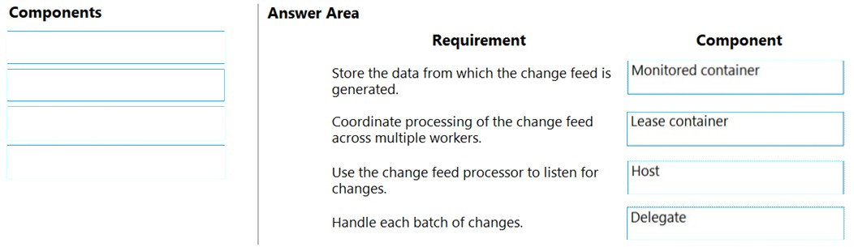  
Box 1: The monitored container -  
The monitored container has the data from which the change feed is generated. Any inserts and updates to the monitored container are reflected in the change feed of the container.  
  
Box 2: The lease container -  
The lease container acts as a state storage and coordinates processing the change feed across multiple workers. The lease container can be stored in the same account as the monitored container or in a separate account.  
Box 3: The host: A host is an application instance that uses the change feed processor to listen for changes. Multiple instances with the same lease configuration can run in parallel, but each instance should have a different instance name.  
  
Box 4: The delegate -  
The delegate is the code that defines what you, the developer, want to do with each batch of changes that the change feed processor reads.  
Reference:  
https://docs.microsoft.com/en-us/azure/cosmos-db/change-feed-processor

Question #21*Topic 3*

HOTSPOT -  
You are developing a web application that will use Azure Storage. Older data will be less frequently used than more recent data.  
You need to configure data storage for the application. You have the following requirements:  
✑ Retain copies of data for five years.  
✑ Minimize costs associated with storing data that is over one year old.  
✑ Implement Zone Redundant Storage for application data.  
What should you do? To answer, select the appropriate options in the answer area.  
NOTE: Each correct selection is worth one point.  
Hot Area:  
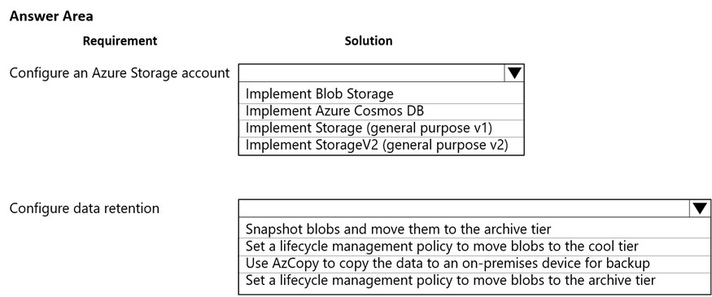

[Hide Solution](https://www.examtopics.com/exams/microsoft/az-204/view/11/) [Discussion   **15**](https://www.examtopics.com/exams/microsoft/az-204/view/11/)

**Correct Answer:** 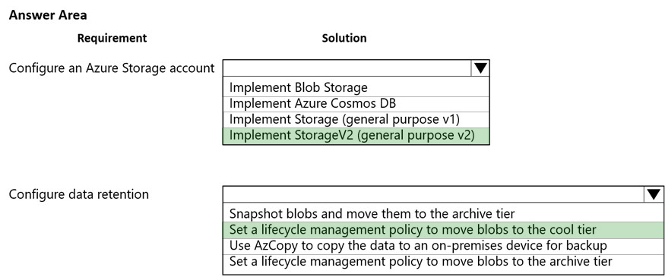  
Reference:  
https://docs.microsoft.com/en-us/azure/storage/blobs/storage-blob-storage-tiers https://docs.microsoft.com/en-us/azure/storage/common/storage-redundancy?toc=/azure/storage/blobs/toc.json

Question #22*Topic 3*

HOTSPOT -  
A company develops a series of mobile games. All games use a single leaderboard service.  
You have the following requirements:  
✑ Code must be scalable and allow for growth.  
✑ Each record must consist of a playerId, gameId, score, and time played.  
✑ When users reach a new high score, the system will save the new score using the SaveScore function below.  
Each game is assigned an Id based on the series title.  
  
You plan to store customer information in Azure Cosmos DB. The following data already exists in the database:  
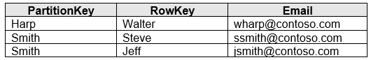  
You develop the following code to save scores in the data store. (Line numbers are included for reference only.)  
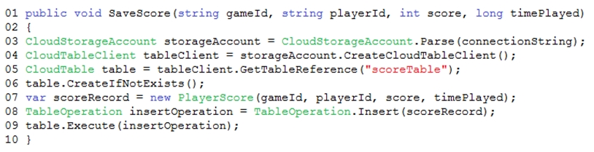  
You develop the following code to query the database. (Line numbers are included for reference only.)  
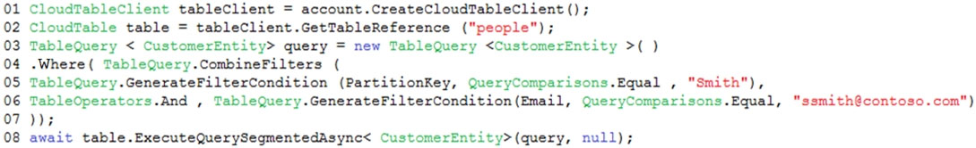  
For each of the following statements, select Yes if the statement is true. Otherwise, select No.  
NOTE: Each correct selection is worth one point.  
Hot Area:  
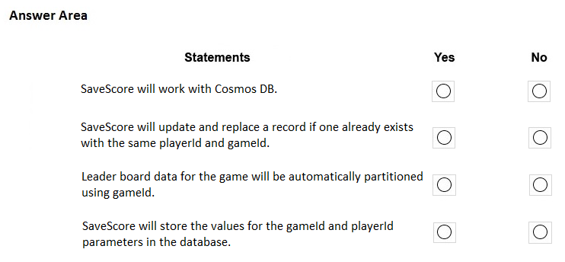

[Hide Solution](https://www.examtopics.com/exams/microsoft/az-204/view/11/) [Discussion   **16**](https://www.examtopics.com/exams/microsoft/az-204/view/11/)

**Correct Answer:** 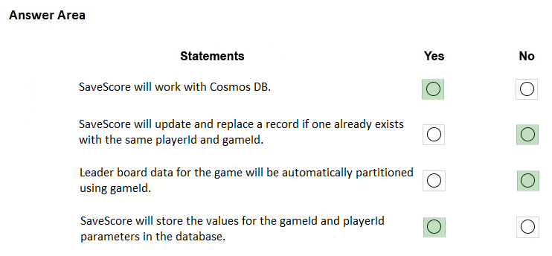  
Box 1: Yes -  
Create a table.  
A CloudTableClient object lets you get reference objects for tables and entities. The following code creates a CloudTableClient object and uses it to create a new  
CloudTable object, which represents a table  
// Retrieve storage account from connection-string.  
CloudStorageAccount storageAccount =  
CloudStorageAccount.parse(storageConnectionString);  
// Create the table client.  
CloudTableClient tableClient = storageAccount.createCloudTableClient();  
// Create the table if it doesn't exist.  
String tableName = "people";  
CloudTable cloudTable = tableClient.getTableReference(tableName); cloudTable.createIfNotExists();  
  
Box 2: No -  
New records are inserted with TableOperation.insert. Old records are not updated.  
To update old records TableOperation.insertOrReplace should be used instead.  
  
Box 3: No -  
  
Box 4: Yes -  
Reference:  
https://docs.microsoft.com/en-us/azure/cosmos-db/table-storage-how-to-use-java

Question #23*Topic 3*

You develop and deploy a web application to Azure App Service. The application accesses data stored in an Azure Storage account. The account contains several containers with several blobs with large amounts of data. You deploy all Azure resources to a single region.  
You need to move the Azure Storage account to the new region. You must copy all data to the new region.  
What should you do first?

* A. Export the Azure Storage account Azure Resource Manager template **Most Voted**
* B. Initiate a storage account failover
* C. Configure object replication for all blobs
* D. Use the AzCopy command line tool
* E. Create a new Azure Storage account in the current region
* F. Create a new subscription in the current region

[Hide Solution](https://www.examtopics.com/exams/microsoft/az-204/view/11/) [Discussion   **6**](https://www.examtopics.com/exams/microsoft/az-204/view/11/)

**Correct Answer:** *A* [🗳️](https://www.examtopics.com/exams/microsoft/az-204/view/11/)  
To move a storage account, create a copy of your storage account in another region. Then, move your data to that account by using AzCopy, or another tool of your choice and finally, delete the resources in the source region.  
To get started, export, and then modify a Resource Manager template.  
Reference:  
https://docs.microsoft.com/en-us/azure/storage/common/storage-account-move?tabs=azure-portal

*Community vote distribution*

A (100%)

Question #24*Topic 3*

HOTSPOT -  
You are developing an application to collect the following telemetry data for delivery drivers: first name, last name, package count, item id, and current location coordinates. The app will store the data in Azure Cosmos DB.  
You need to configure Azure Cosmos DB to query the data.  
Which values should you use? To answer, select the appropriate options in the answer area.  
NOTE: Each correct selection is worth one point.  
Hot Area:  
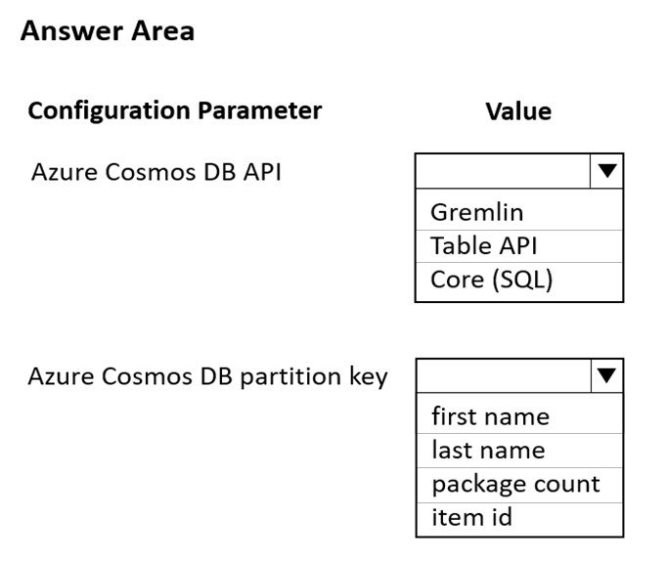

[Hide Solution](https://www.examtopics.com/exams/microsoft/az-204/view/11/) [Discussion   **10**](https://www.examtopics.com/exams/microsoft/az-204/view/11/)

**Correct Answer:** 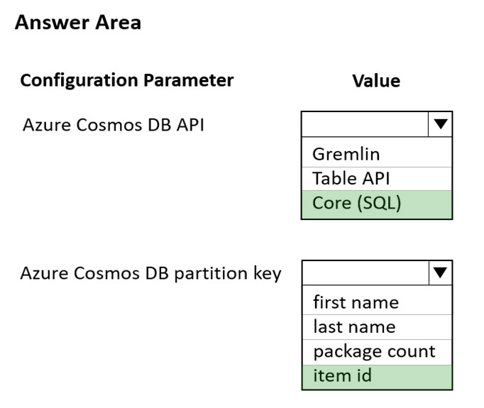  
Box 1: Core (SQL)  
Core(SQL) API stores data in document format. It offers the best end-to-end experience as we have full control over the interface, service, and the SDK client libraries. SQL API supports analytics and offers performance isolation between operational and analytical workloads.  
  
Box 2: item id -  
item id is a unique identifier and is suitable for the partition key.  
Reference:  
https://docs.microsoft.com/en-us/azure/cosmos-db/choose-api  
https://docs.microsoft.com/en-us/azure/cosmos-db/partitioning-overview

Question #25*Topic 3*

DRAG DROP -  
You are implementing an Azure solution that uses Azure Cosmos DB and the latest Azure Cosmos DB SDK. You add a change feed processor to a new container instance.  
You attempt to read a batch of 100 documents. The process fails when reading one of the documents. The solution must monitor the progress of the change feed processor instance on the new container as the change feed is read. You must prevent the change feed processor from retrying the entire batch when one document cannot be read.  
You need to implement the change feed processor to read the documents.  
Which features should you use? To answer, drag the appropriate features to the cored requirements. Each feature may be used once, more than once, or not at all. You may need to drag the split bar between panes or scroll to view content.  
NOTE: Each cored selection is worth one point.  
Select and Place:  
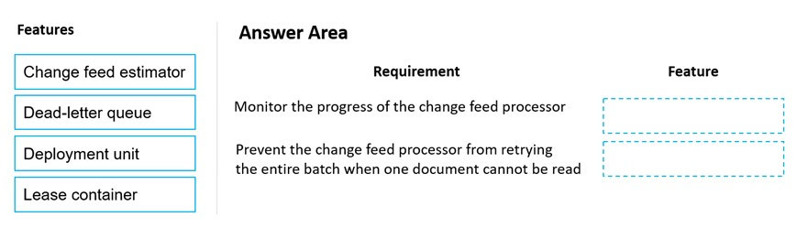

[Hide Solution](https://www.examtopics.com/exams/microsoft/az-204/view/11/) [Discussion   **11**](https://www.examtopics.com/exams/microsoft/az-204/view/11/)

**Correct Answer:** 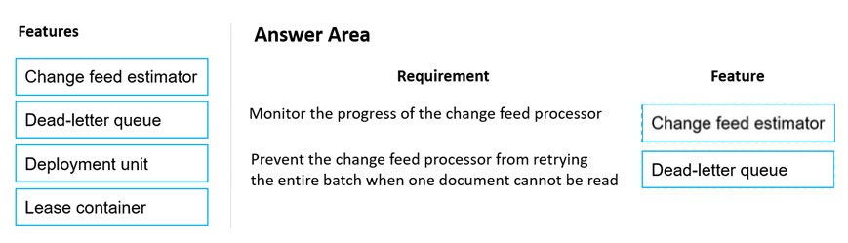  
Box 1: Change feed estimator -  
You can use the change feed estimator to monitor the progress of your change feed processor instances as they read the change feed or use the life cycle notifications to detect underlying failures.  
  
Box 2: Dead-letter queue -  
To prevent your change feed processor from getting "stuck" continuously retrying the same batch of changes, you should add logic in your delegate code to write documents, upon exception, to a dead-letter queue. This design ensures that you can keep track of unprocessed changes while still being able to continue to process future changes. The dead-letter queue might be another Cosmos container. The exact data store does not matter, simply that the unprocessed changes are persisted.  
Reference:  
<https://docs.microsoft.com/en-us/azure/cosmos-db/sql/change-feed-processor>

Question #26*Topic 3*

HOTSPOT -  
You are developing an application that uses a premium block blob storage account. The application will process a large volume of transactions daily. You enable  
Blob storage versioning.  
You are optimizing costs by automating Azure Blob Storage access tiers. You apply the following policy rules to the storage account. (Line numbers are included for reference only.)  
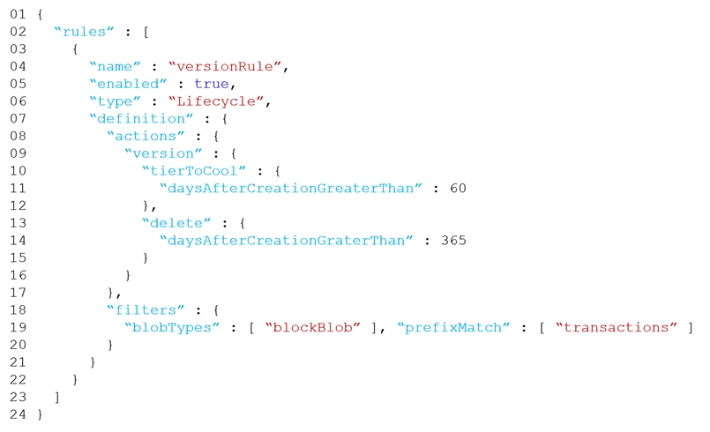  
For each of the following statements, select Yes if the statement is true. Otherwise, select No.  
NOTE: Each correct selection is worth one point.  
Hot Area:  
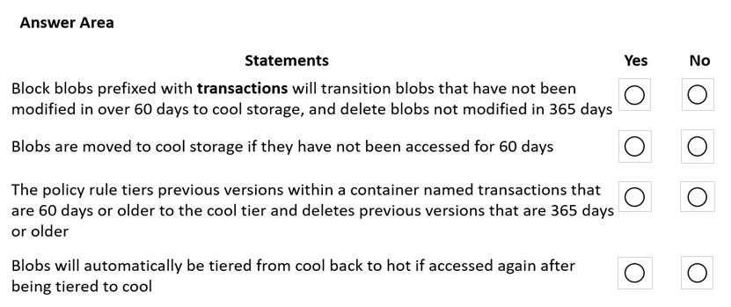

[Hide Solution](https://www.examtopics.com/exams/microsoft/az-204/view/12/) [Discussion   **27**](https://www.examtopics.com/exams/microsoft/az-204/view/12/)

**Correct Answer:** 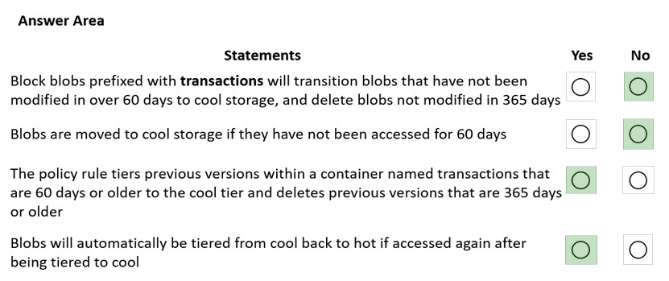  
Box 1: No -  
Would be true if daysAfterModificationGreaterThan was used, but here daysAfterCreationGreaterThan  
  
Box 2: No -  
Would need to use the daysAfterLastAccessTimeGreaterThan predicate.  
  
Box 3: Yes -  
  
Box 4: Yes -  
With the lifecycle management policy, you can:  
Transition blobs from cool to hot immediately when they are accessed, to optimize for performance.  
Reference:  
https://docs.microsoft.com/en-us/azure/storage/blobs/lifecycle-management-overview

Question #27*Topic 3*

An organization deploys Azure Cosmos DB.  
You need to ensure that the index is updated as items are created, updated, or deleted.  
What should you do?

* A. Set the indexing mode to Lazy.
* B. Set the value of the automatic property of the indexing policy to False.
* C. Set the value of the EnableScanInQuery option to True.
* D. Set the indexing mode to Consistent.

[Hide Solution](https://www.examtopics.com/exams/microsoft/az-204/view/12/) [Discussion   **4**](https://www.examtopics.com/exams/microsoft/az-204/view/12/)

**Correct Answer:** *D* [🗳️](https://www.examtopics.com/exams/microsoft/az-204/view/12/)  
Azure Cosmos DB supports two indexing modes:  
Consistent: The index is updated synchronously as you create, update or delete items. This means that the consistency of your read queries will be the consistency configured for the account.  
None: Indexing is disabled on the container.  
Reference:  
https://docs.microsoft.com/en-us/azure/cosmos-db/index-policy

*Community vote distribution*

D (100%)

Question #28*Topic 3*

You are developing a .Net web application that stores data in Azure Cosmos DB. The application must use the Core API and allow millions of reads and writes.  
The Azure Cosmos DB account has been created with multiple write regions enabled. The application has been deployed to the East US2 and Central US regions.  
You need to update the application to support multi-region writes.  
What are two possible ways to achieve this goal? Each correct answer presents part of the solution.  
NOTE: Each correct selection is worth one point.

* A. Update the ConnectionPolicy class for the Cosmos client and populate the PreferredLocations property based on the geo-proximity of the application. **Most Voted**
* B. Update Azure Cosmos DB to use the Strong consistency level. Add indexed properties to the container to indicate region.
* C. Update the ConnectionPolicy class for the Cosmos client and set the UseMultipleWriteLocations property to true. **Most Voted**
* D. Create and deploy a custom conflict resolution policy.
* E. Update Azure Cosmos DB to use the Session consistency level. Send the SessionToken property value from the FeedResponse object of the write action to the end-user by using a cookie.

[Hide Solution](https://www.examtopics.com/exams/microsoft/az-204/view/12/) [Discussion   **16**](https://www.examtopics.com/exams/microsoft/az-204/view/12/)

**Correct Answer:** *CD* [🗳️](https://www.examtopics.com/exams/microsoft/az-204/view/12/)  
C: The UseMultipleWriteLocations of the ConnectionPolicy class gets or sets the flag to enable writes on any locations (regions) for geo-replicated database accounts in the Azure Cosmos DB service.  
Note: Once an account has been created with multiple write regions enabled, you must make two changes in your application to the ConnectionPolicy for the  
Cosmos client to enable the multi-region writes in Azure Cosmos DB. Within the ConnectionPolicy, set UseMultipleWriteLocations to true and pass the name of the region where the application is deployed to ApplicationRegion. This will populate the PreferredLocations property based on the geo-proximity from location passed in. If a new region is later added to the account, the application does not have to be updated or redeployed, it will automatically detect the closer region and will auto-home on to it should a regional event occur.  
Azure core API application " ConnectionPolicy class" cosmos db multiple write regions enabled  
D: With multi-region writes, when multiple clients write to the same item, conflicts may occur. When a conflict occurs, you can resolve the conflict by using different conflict resolution policies.  
Note: Conflict resolution policy can only be specified at container creation time and cannot be modified after container creation.  
Reference:  
https://docs.microsoft.com/en-us/dotnet/api/microsoft.azure.documents.client.connectionpolicy https://docs.microsoft.com/en-us/azure/cosmos-db/sql/how-to-multi-master https://docs.microsoft.com/en-us/azure/cosmos-db/sql/how-to-manage-conflicts

*Community vote distribution*

AC (78%)

CD (22%)

Question #29*Topic 3*

HOTSPOT -  
You are developing a solution to store documents in Azure Blob storage. Customers upload documents to multiple containers. Documents consist of PDF, CSV,  
Microsoft Office format and plain text files.  
The solution must process millions of documents across hundreds of containers. The solution must meet the following requirements:  
✑ Documents must be categorized by a customer identifier as they are uploaded to the storage account.  
✑ Allow filtering by the customer identifier.  
✑ Allow searching of information contained within a document  
✑ Minimize costs.  
You create and configure a standard general-purpose v2 storage account to support the solution.  
You need to implement the solution.  
What should you implement? To answer, select the appropriate options in the answer area.  
NOTE: Each correct selection is worth one point.  
Hot Area:  
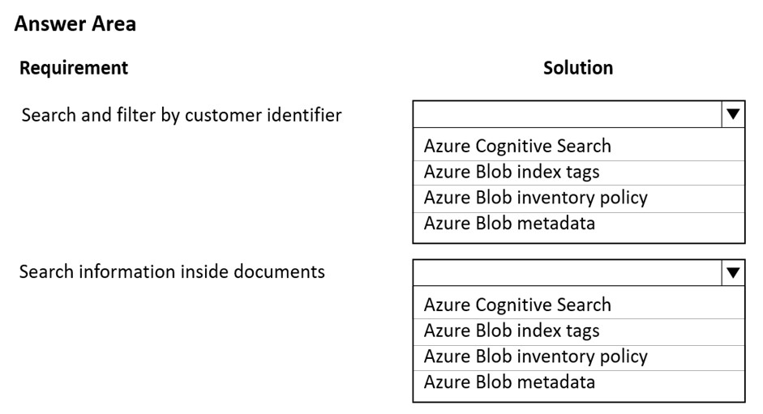

[Hide Solution](https://www.examtopics.com/exams/microsoft/az-204/view/12/) [Discussion   **10**](https://www.examtopics.com/exams/microsoft/az-204/view/12/)

**Correct Answer:** 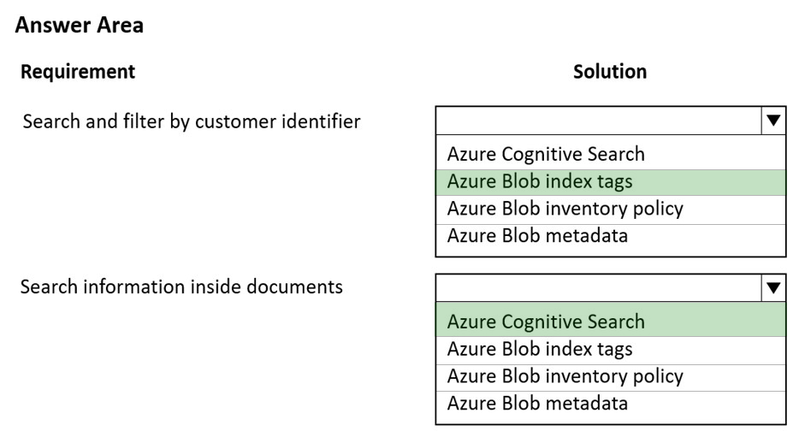  
Box 1: Azure Blob index tags -  
As datasets get larger, finding a specific object in a sea of data can be difficult. Blob index tags provide data management and discovery capabilities by using key- value index tag attributes. You can categorize and find objects within a single container or across all containers in your storage account. As data requirements change, objects can be dynamically categorized by updating their index tags. Objects can remain in-place with their current container organization.  
  
Box 2: Azure Cognitive Search -  
Only index tags are automatically indexed and made searchable by the native Blob Storage service. Metadata can't be natively indexed or searched. You must use a separate service such as Azure Search.  
Azure Cognitive Search is the only cloud search service with built-in AI capabilities that enrich all types of information to help you identify and explore relevant content at scale. Use cognitive skills for vision, language, and speech, or use custom machine learning models to uncover insights from all types of content.  
Reference:  
https://docs.microsoft.com/en-us/azure/storage/blobs/storage-manage-find-blobs https://azure.microsoft.com/en-us/services/search/

Question #30*Topic 3*

HOTSPOT -  
You are developing a web application by using the Azure SDK. The web application accesses data in a zone-redundant BlockBlobStorage storage account.  
The application must determine whether the data has changed since the application last read the data. Update operations must use the latest data changes when writing data to the storage account.  
You need to implement the update operations.  
Which values should you use? To answer, select the appropriate option in the answer area.  
NOTE: Each correct selection is worth one point.  
Hot Area:  
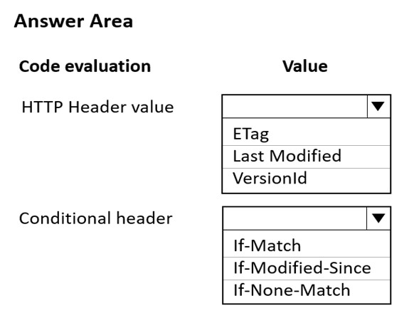

[Hide Solution](https://www.examtopics.com/exams/microsoft/az-204/view/12/) [Discussion   **13**](https://www.examtopics.com/exams/microsoft/az-204/view/12/)

**Correct Answer:** 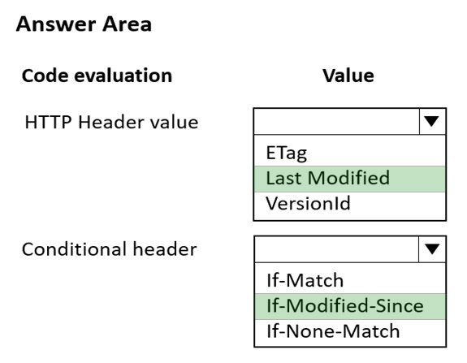  
Box 1: Last Modified -  
The Last-Modified response HTTP header contains a date and time when the origin server believes the resource was last modified. It is used as a validator to determine if the resource is the same as the previously stored one. Less accurate than an ETag header, it is a fallback mechanism.  
  
Box 2: If-Modified-Since -  
Conditional Header If-Modified-Since:  
A DateTime value. Specify this header to perform the operation only if the resource has been modified since the specified time.  
Incorrect:  
  
Not ETag/If-Match -  
Conditional Header If-Match:  
An ETag value. Specify this header to perform the operation only if the resource's ETag matches the value specified. For versions 2011-08-18 and newer, the  
ETag can be specified in quotes.  
Reference:  
https://developer.mozilla.org/en-US/docs/Web/HTTP/Headers/Last-Modified https://docs.microsoft.com/en-us/rest/api/storageservices/specifying-conditional-headers-for-blob-service-operations

Question #31*Topic 3*

HOTSPOT -  
An organization deploys a blob storage account. Users take multiple snapshots of the blob storage account over time.  
You need to delete all snapshots of the blob storage account. You must not delete the blob storage account itself.  
How should you complete the code segment? To answer, select the appropriate options in the answer area.  
NOTE: Each correct selection is worth one point.  
Hot Area:  
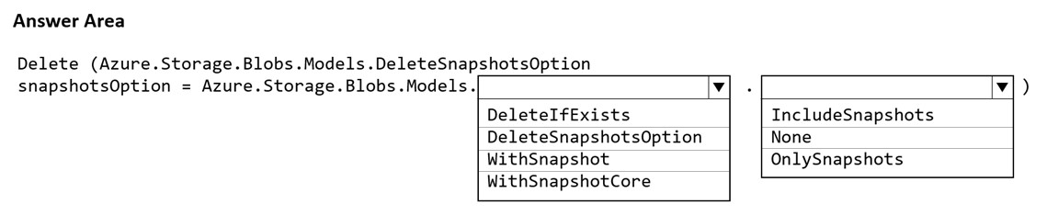

[Hide Solution](https://www.examtopics.com/exams/microsoft/az-204/view/12/) [Discussion   **6**](https://www.examtopics.com/exams/microsoft/az-204/view/12/)

**Correct Answer:** 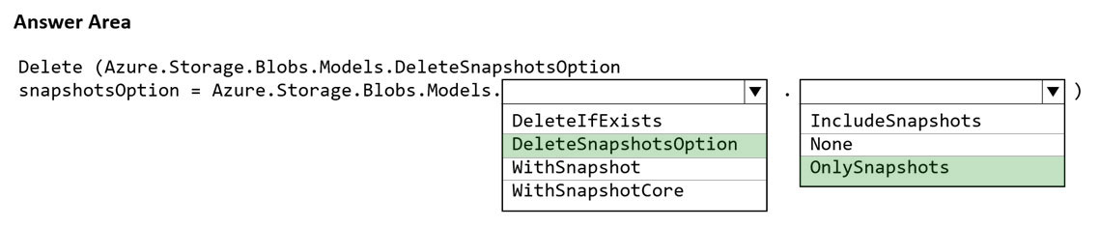  
Box 1: DeleteSnapshotsOption -  
Sample code in powershell:  
//dont forget to add the include snapshots :)  
await batchClient.DeleteBlobsAsync(listofURIforBlobs,  
Azure.Storage.Blobs.Models.DeleteSnapshotsOption.IncludeSnapshots);  
Sample code in .Net:  
// Create a batch with three deletes  
BlobBatchClient batchClient = service.GetBlobBatchClient();  
BlobBatch batch = batchClient.CreateBatch();  
batch.DeleteBlob(foo.Uri, DeleteSnapshotsOption.IncludeSnapshots); batch.DeleteBlob(bar.Uri, DeleteSnapshotsOption.OnlySnapshots); batch.DeleteBlob(baz.Uri);  
// Submit the batch  
batchClient.SubmitBatch(batch);  
  
Box 2: OnlySnapshots -  
Reference:  
https://docs.microsoft.com/en-us/dotnet/api/overview/azure/storage.blobs.batch-readme https://stackoverflow.com/questions/39471212/programmatically-delete-azure-blob-storage-objects-in-bulks

Question #32*Topic 3*

HOTSPOT -  
An organization deploys a blob storage account. Users take multiple snapshots of the blob storage account over time.  
You need to delete all snapshots of the blob storage account. You must not delete the blob storage account itself.  
How should you complete the code segment? To answer, select the appropriate options in the answer area.  
NOTE: Each correct selection is worth one point.  
Hot Area:  
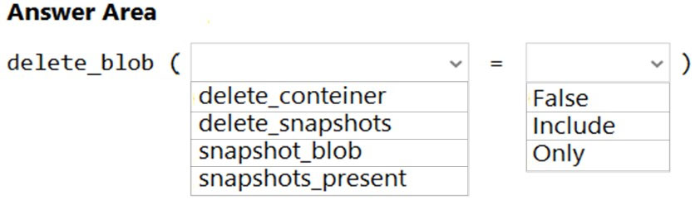

[Hide Solution](https://www.examtopics.com/exams/microsoft/az-204/view/12/) [Discussion   **9**](https://www.examtopics.com/exams/microsoft/az-204/view/12/)

**Correct Answer:** 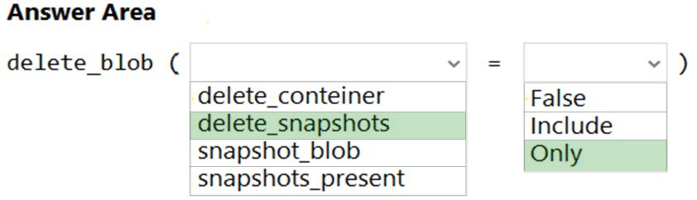  
Box 1: delete_snapshots -  
# Delete only the snapshot (blob itself is retained)  
blob_client.delete_blob(delete_snapshots="only")  
  
Box 2: only -  
Reference:  
https://github.com/Azure/azure-sdk-for-python/blob/main/sdk/storage/azure-storage-blob/samples/blob_samples_common.py

Question #33*Topic 3*

HOTSPOT  
-  
  
You are developing an application that monitors data added to an Azure Blob storage account.  
  
You need to process each change made to the storage account.  
  
How should you complete the code segment? To answer, select the appropriate options in the answer area.  
  
NOTE: Each correct selection is worth one point.  
  
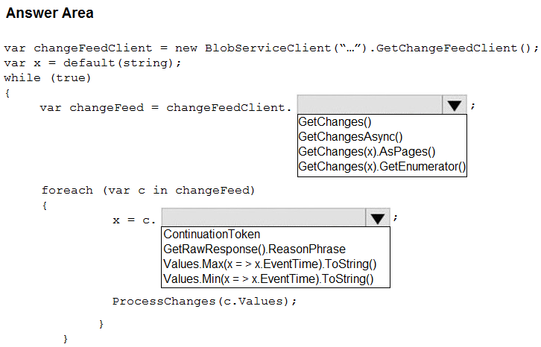

[Hide Solution](https://www.examtopics.com/exams/microsoft/az-204/view/12/) [Discussion   **12**](https://www.examtopics.com/exams/microsoft/az-204/view/12/)

**Correct Answer:** 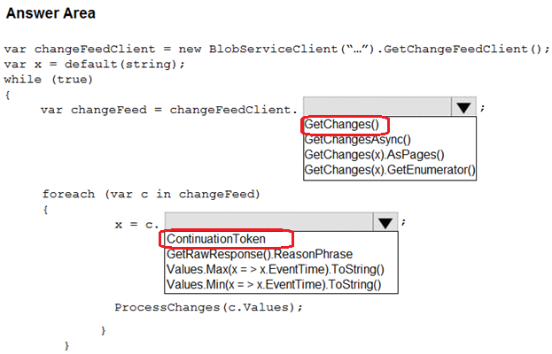

Question #34*Topic 3*

HOTSPOT  
-  
  
You develop an application that sells AI generated images based on user input. You recently started a marketing campaign that displays unique ads every second day.  
  
Sales data is stored in Azure Cosmos DB with the date of each sale being stored in a property named ‘whenFinished’.  
  
The marketing department requires a view that shows the number of sales for each unique ad.  
You need to implement the query for the view.  
  
How should you complete the query? To answer, select the appropriate options in the answer area.  
  
NOTE: Each correct selection is worth one point.  
  
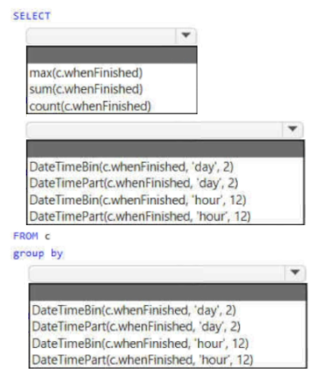

[Hide Solution](https://www.examtopics.com/exams/microsoft/az-204/view/12/) [Discussion   **6**](https://www.examtopics.com/exams/microsoft/az-204/view/12/)

**Correct Answer:** 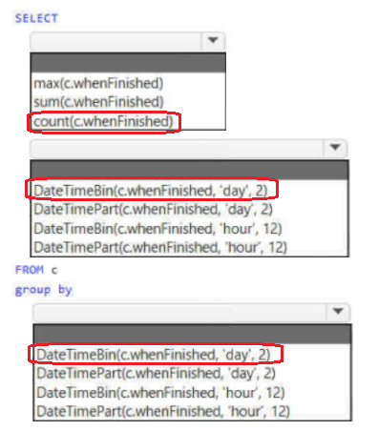

Question #35*Topic 3*

HOTSPOT  
-  
  
You implement an Azure solution to include Azure Cosmos DB, the latest Azure Cosmos DB SDK, and the Core (SQL) API. You also implement a change feed processor on a new container instance by using the Azure Functions trigger for Azure Cosmos DB.  
  
A large batch of documents continues to fail when reading one of the documents in the batch. The same batch of documents is continuously retried by the triggered function and a new batch of documents must be read.  
  
You need to implement the change feed processor to read the documents.  
  
Which feature should you implement? To answer, select the appropriate features in the answer area.  
  
NOTE: Each correct selection is worth one point.  
  
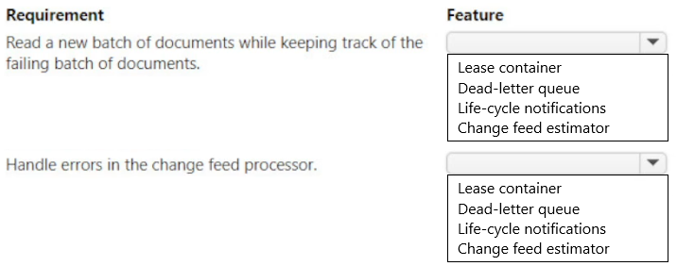

[Hide Solution](https://www.examtopics.com/exams/microsoft/az-204/view/12/) [Discussion   **11**](https://www.examtopics.com/exams/microsoft/az-204/view/12/)

**Correct Answer:** 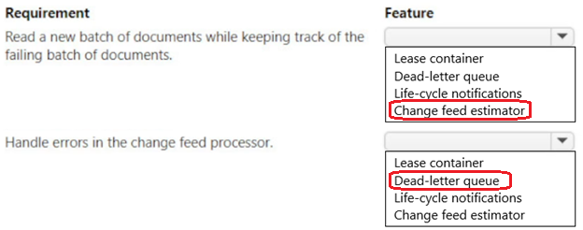

Question #36*Topic 3*

You are developing an application to store business-critical data in Azure Blob storage.  
  
The application must meet the following requirements:  
  
• Data must not be modified or deleted for a user-specified interval.  
• Data must be protected from overwrites and deletes.  
• Data must be written once and allowed to be read many times.  
  
You need to protect the data in the Azure Blob storage account.  
  
Which two actions should you perform? Each correct answer presents part of the solution.  
  
NOTE: Each correct selection is worth one point.

* A. Configure a time-based retention policy for the storage account. **Most Voted**
* B. Create an account shared-access signature (SAS).
* C. Enable the blob change feed for the storage account.
* D. Enable version-level immutability support for the storage account. **Most Voted**
* E. Enable point-in-time restore for containers in the storage account.
* F. Create a service shared-access signature (SAS).

[Hide Solution](https://www.examtopics.com/exams/microsoft/az-204/view/13/) [Discussion   **13**](https://www.examtopics.com/exams/microsoft/az-204/view/13/)

**Correct Answer:** *AF* [🗳️](https://www.examtopics.com/exams/microsoft/az-204/view/13/)

*Community vote distribution*

AD (91%)

9%

Question #37*Topic 3*

You are updating an application that stores data on Azure and uses Azure Cosmos DB for storage. The application stores data in multiple documents associated with a single username.  
  
The application requires the ability to update multiple documents for a username in a single ACID operation.  
  
You need to configure Azure Cosmos DB.  
  
Which two actions should you perform? Each correct answer presents part of the solution.  
  
NOTE: Each correct selection is worth one point.

* A. Create a collection sharded on username to store documents.
* B. Configure Azure Cosmos DB to use the Gremlin API.
* C. Create an unsharded collection to store documents. **Most Voted**
* D. Configure Azure Cosmos DB to use the MongoDB API. **Most Voted**

[Hide Solution](https://www.examtopics.com/exams/microsoft/az-204/view/13/) [Discussion   **6**](https://www.examtopics.com/exams/microsoft/az-204/view/13/)

**Correct Answer:** *CD* [🗳️](https://www.examtopics.com/exams/microsoft/az-204/view/13/)

*Community vote distribution*

CD (100%)

Question #38*Topic 3*

You develop Azure solutions.  
  
You must connect to a No-SQL globally-distributed database by using the .NET API.  
  
You need to create an object to configure and execute requests in the database.  
  
Which code segment should you use?

* A. database_name = 'MyDatabase'  
  database = client.create_database_if_not_exists(id=database_name)
* B. client = CosmosClient(endpoint, key) **Most Voted**
* C. container_name = 'MyContainer'  
  container = database.create_container_if_not_exists(  
  id=container_name, partition_key=PartitionKey(path="/lastName"), offer_throughput=400 )

[Hide Solution](https://www.examtopics.com/exams/microsoft/az-204/view/13/) [Discussion   **11**](https://www.examtopics.com/exams/microsoft/az-204/view/13/)

**Correct Answer:** *C* [🗳️](https://www.examtopics.com/exams/microsoft/az-204/view/13/)

*Community vote distribution*

B (100%)

**Topic 4 - Question Set 4**

Question #1*Topic 4*

You are developing a Java application that uses Cassandra to store key and value data. You plan to use a new Azure Cosmos DB resource and the Cassandra  
API in the application. You create an Azure Active Directory (Azure AD) group named Cosmos DB Creators to enable provisioning of Azure Cosmos accounts, databases, and containers.  
The Azure AD group must not be able to access the keys that are required to access the data.  
You need to restrict access to the Azure AD group.  
Which role-based access control should you use?

* A. DocumentDB Accounts Contributor
* B. Cosmos Backup Operator
* C. Cosmos DB Operator **Most Voted**
* D. Cosmos DB Account Reader

[Hide Solution](https://www.examtopics.com/exams/microsoft/az-204/view/13/) [Discussion   **19**](https://www.examtopics.com/exams/microsoft/az-204/view/13/)

**Correct Answer:** *C* [🗳️](https://www.examtopics.com/exams/microsoft/az-204/view/13/)  
Azure Cosmos DB now provides a new RBAC role, Cosmos DB Operator. This new role lets you provision Azure Cosmos accounts, databases, and containers, but can't access the keys that are required to access the data. This role is intended for use in scenarios where the ability to grant access to Azure Active Directory service principals to manage deployment operations for Cosmos DB is needed, including the account, database, and containers.  
Reference:  
https://azure.microsoft.com/en-us/updates/azure-cosmos-db-operator-role-for-role-based-access-control-rbac-is-now-available/

*Community vote distribution*

C (100%)

Question #2*Topic 4*

Note: This question is part of a series of questions that present the same scenario. Each question in the series contains a unique solution that might meet the stated goals. Some question sets might have more than one correct solution, while others might not have a correct solution.  
After you answer a question in this section, you will NOT be able to return to it. As a result, these questions will not appear in the review screen.  
You are developing a website that will run as an Azure Web App. Users will authenticate by using their Azure Active Directory (Azure AD) credentials.  
You plan to assign users one of the following permission levels for the website: admin, normal, and reader. A user's Azure AD group membership must be used to determine the permission level.  
You need to configure authorization.  
Solution: Configure the Azure Web App for the website to allow only authenticated requests and require Azure AD log on.  
Does the solution meet the goal?

* A. Yes
* B. No

[Hide Solution](https://www.examtopics.com/exams/microsoft/az-204/view/13/) [Discussion   **20**](https://www.examtopics.com/exams/microsoft/az-204/view/13/)

**Correct Answer:** *B* [🗳️](https://www.examtopics.com/exams/microsoft/az-204/view/13/)  
Instead in the Azure AD application's manifest, set value of the groupMembershipClaims option to All.  
Reference:  
https://blogs.msdn.microsoft.com/waws/2017/03/13/azure-app-service-authentication-aad-groups/

*Community vote distribution*

B (75%)

A (25%)

Question #3*Topic 4*

Note: This question is part of a series of questions that present the same scenario. Each question in the series contains a unique solution that might meet the stated goals. Some question sets might have more than one correct solution, while others might not have a correct solution.  
After you answer a question in this section, you will NOT be able to return to it. As a result, these questions will not appear in the review screen.  
You are developing a website that will run as an Azure Web App. Users will authenticate by using their Azure Active Directory (Azure AD) credentials.  
You plan to assign users one of the following permission levels for the website: admin, normal, and reader. A user's Azure AD group membership must be used to determine the permission level.  
You need to configure authorization.  
Solution:  
✑ Create a new Azure AD application. In the application's manifest, set value of the groupMembershipClaims option to All.  
✑ In the website, use the value of the groups claim from the JWT for the user to determine permissions.  
Does the solution meet the goal?

* A. Yes **Most Voted**
* B. No

[Hide Solution](https://www.examtopics.com/exams/microsoft/az-204/view/13/) [Discussion   **15**](https://www.examtopics.com/exams/microsoft/az-204/view/13/)

**Correct Answer:** *A* [🗳️](https://www.examtopics.com/exams/microsoft/az-204/view/13/)  
To configure Manifest to include Group Claims in Auth Token  
1. Go to Azure Active Directory to configure the Manifest. Click on Azure Active Directory, and go to App registrations to find your application:  
2. Click on your application (or search for it if you have a lot of apps) and edit the Manifest by clicking on it.  
3. Locate the ג€groupMembershipClaimsג€ setting. Set its value to either ג€SecurityGroupג€ or ג€Allג€. To help you decide which:  
✑ ג€SecurityGroupג€ - groups claim will contain the identifiers of all security groups of which the user is a member.  
✑ ג€Allג€ - groups claim will contain the identifiers of all security groups and all distribution lists of which the user is a member  
Now your application will include group claims in your manifest and you can use this fact in your code.  
Reference:  
https://blogs.msdn.microsoft.com/waws/2017/03/13/azure-app-service-authentication-aad-groups/

*Community vote distribution*

A (100%)

Question #4*Topic 4*

Note: This question is part of a series of questions that present the same scenario. Each question in the series contains a unique solution that might meet the stated goals. Some question sets might have more than one correct solution, while others might not have a correct solution.  
After you answer a question in this section, you will NOT be able to return to it. As a result, these questions will not appear in the review screen.  
You are developing a website that will run as an Azure Web App. Users will authenticate by using their Azure Active Directory (Azure AD) credentials.  
You plan to assign users one of the following permission levels for the website: admin, normal, and reader. A user's Azure AD group membership must be used to determine the permission level.  
You need to configure authorization.  
Solution:  
✑ Create a new Azure AD application. In the application's manifest, define application roles that match the required permission levels for the application.  
✑ Assign the appropriate Azure AD group to each role. In the website, use the value of the roles claim from the JWT for the user to determine permissions.  
Does the solution meet the goal?

* A. Yes **Most Voted**
* B. No

[Hide Solution](https://www.examtopics.com/exams/microsoft/az-204/view/13/) [Discussion   **32**](https://www.examtopics.com/exams/microsoft/az-204/view/13/)

**Correct Answer:** *B* [🗳️](https://www.examtopics.com/exams/microsoft/az-204/view/13/)  
To configure Manifest to include Group Claims in Auth Token  
1. Go to Azure Active Directory to configure the Manifest. Click on Azure Active Directory, and go to App registrations to find your application:  
2. Click on your application (or search for it if you have a lot of apps) and edit the Manifest by clicking on it.  
3. Locate the ג€groupMembershipClaimsג€ setting. Set its value to either ג€SecurityGroupג€ or ג€Allג€. To help you decide which:  
✑ ג€SecurityGroupג€ - groups claim will contain the identifiers of all security groups of which the user is a member.  
✑ ג€Allג€ - groups claim will contain the identifiers of all security groups and all distribution lists of which the user is a member  
Now your application will include group claims in your manifest and you can use this fact in your code.  
Reference:  
https://blogs.msdn.microsoft.com/waws/2017/03/13/azure-app-service-authentication-aad-groups/

*Community vote distribution*

A (70%)

B (30%)

Question #5*Topic 4*

DRAG DROP -  
You are developing an application to securely transfer data between on-premises file systems and Azure Blob storage. The application stores keys, secrets, and certificates in Azure Key Vault. The application uses the Azure Key Vault APIs.  
The application must allow recovery of an accidental deletion of the key vault or key vault objects. Key vault objects must be retained for 90 days after deletion.  
You need to protect the key vault and key vault objects.  
Which Azure Key Vault feature should you use? To answer, drag the appropriate features to the correct actions. Each feature may be used once, more than once, or not at all. You may need to drag the split bar between panes or scroll to view content.  
NOTE: Each correct selection is worth one point.  
Select and Place:  
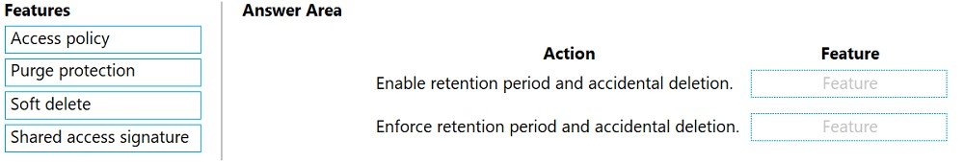

[Hide Solution](https://www.examtopics.com/exams/microsoft/az-204/view/13/) [Discussion   **12**](https://www.examtopics.com/exams/microsoft/az-204/view/13/)

**Correct Answer:** 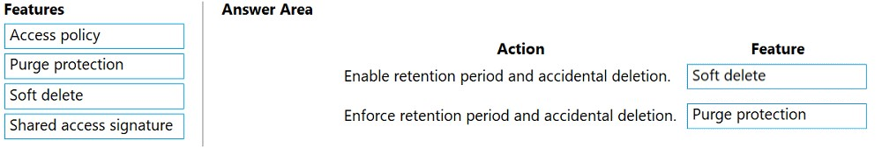  
Box 1: Soft delete -  
When soft-delete is enabled, resources marked as deleted resources are retained for a specified period (90 days by default). The service further provides a mechanism for recovering the deleted object, essentially undoing the deletion.  
  
Box 2: Purge protection -  
Purge protection is an optional Key Vault behavior and is not enabled by default. Purge protection can only be enabled once soft-delete is enabled.  
When purge protection is on, a vault or an object in the deleted state cannot be purged until the retention period has passed. Soft-deleted vaults and objects can still be recovered, ensuring that the retention policy will be followed.  
Reference:  
https://docs.microsoft.com/en-us/azure/key-vault/general/soft-delete-overview

Question #6*Topic 4*

You provide an Azure API Management managed web service to clients. The back-end web service implements HTTP Strict Transport Security (HSTS).  
Every request to the backend service must include a valid HTTP authorization header.  
You need to configure the Azure API Management instance with an authentication policy.  
Which two policies can you use? Each correct answer presents a complete solution.  
NOTE: Each correct selection is worth one point.

* A. Basic Authentication **Most VotedMost Voted**
* B. Digest Authentication
* C. Certificate Authentication **Most Voted**
* D. OAuth Client Credential Grant **Most Voted**

[Hide Solution](https://www.examtopics.com/exams/microsoft/az-204/view/13/) [Discussion   **56**](https://www.examtopics.com/exams/microsoft/az-204/view/13/)

**Correct Answer:** *CD* [🗳️](https://www.examtopics.com/exams/microsoft/az-204/view/13/)

*Community vote distribution*

AC (60%)

AD (40%)

Question #7*Topic 4*

DRAG DROP -  
You are developing an ASP.NET Core website that can be used to manage photographs which are stored in Azure Blob Storage containers.  
Users of the website authenticate by using their Azure Active Directory (Azure AD) credentials.  
You implement role-based access control (RBAC) role permissions on the containers that store photographs. You assign users to RBAC roles.  
You need to configure the website's Azure AD Application so that user's permissions can be used with the Azure Blob containers.  
How should you configure the application? To answer, drag the appropriate setting to the correct location. Each setting can be used once, more than once, or not at all. You may need to drag the split bar between panes or scroll to view content.  
NOTE: Each correct selection is worth one point.  
Select and Place:  
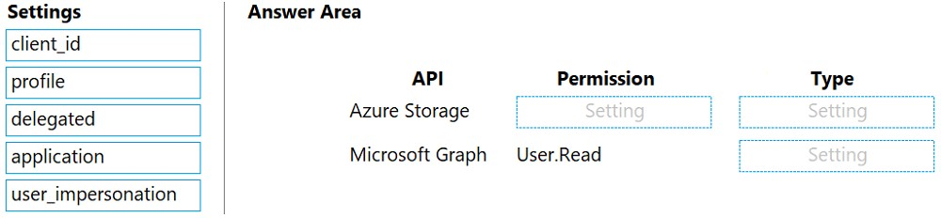

[Hide Solution](https://www.examtopics.com/exams/microsoft/az-204/view/13/) [Discussion   **16**](https://www.examtopics.com/exams/microsoft/az-204/view/13/)

**Correct Answer:** 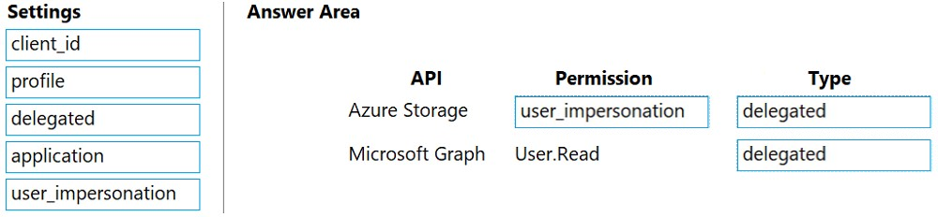  
Box 1: user_impersonation -  
  
Box 2: delegated -  
Example:  
1. Select the API permissions section  
2. Click the Add a permission button and then:  
Ensure that the My APIs tab is selected  
3. In the list of APIs, select the API TodoListService-aspnetcore.  
4. In the Delegated permissions section, ensure that the right permissions are checked: user_impersonation.  
5. Select the Add permissions button.  
  
Box 3: delegated -  
  
Example -  
1. Select the API permissions section  
2. Click the Add a permission button and then,  
Ensure that the Microsoft APIs tab is selected  
3. In the Commonly used Microsoft APIs section, click on Microsoft Graph  
4. In the Delegated permissions section, ensure that the right permissions are checked: User.Read. Use the search box if necessary.  
5. Select the Add permissions button  
Reference:  
https://docs.microsoft.com/en-us/samples/azure-samples/active-directory-dotnet-webapp-webapi-openidconnect-aspnetcore/calling-a-web-api-in-an-aspnet-core- web-application-using-azure-ad/

Question #8*Topic 4*

HOTSPOT -  
You are developing an ASP.NET Core app that includes feature flags which are managed by Azure App Configuration. You create an Azure App Configuration store named AppFeatureFlagStore that contains a feature flag named Export.  
You need to update the app to meet the following requirements:  
✑ Use the Export feature in the app without requiring a restart of the app.  
✑ Validate users before users are allowed access to secure resources.  
✑ Permit users to access secure resources.  
How should you complete the code segment? To answer, select the appropriate options in the answer area.  
NOTE: Each correct selection is worth one point.  
Hot Area:  
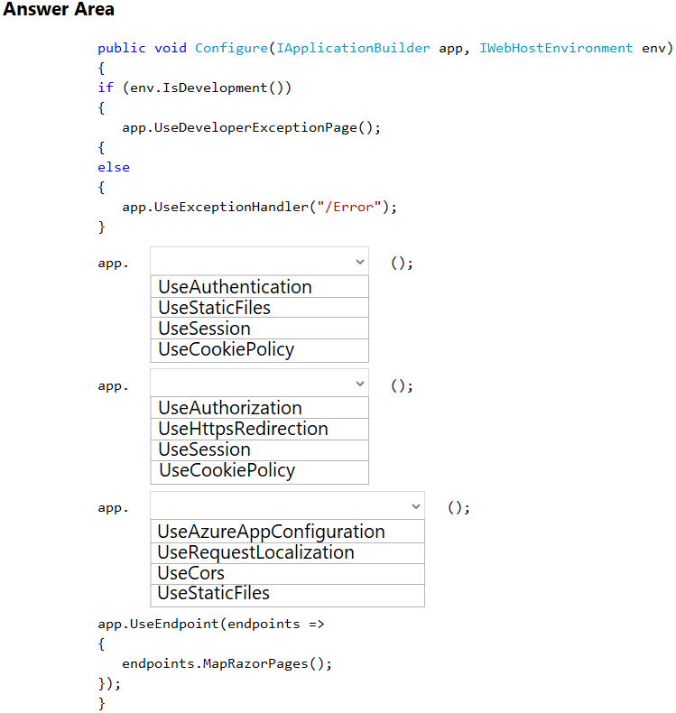

[Hide Solution](https://www.examtopics.com/exams/microsoft/az-204/view/14/) [Discussion   **22**](https://www.examtopics.com/exams/microsoft/az-204/view/14/)

**Correct Answer:** 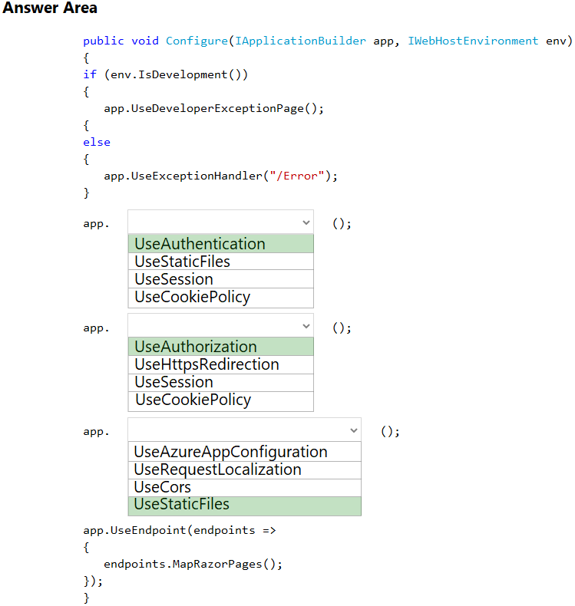  
Box 1: UseAuthentication -  
Need to validate users before users are allowed access to secure resources.  
UseAuthentication adds the AuthenticationMiddleware to the specified IApplicationBuilder, which enables authentication capabilities.  
  
Box 2: UseAuthorization -  
Need to permit users to access secure resources.  
UseAuthorization adds the AuthorizationMiddleware to the specified IApplicationBuilder, which enables authorization capabilities.  
  
Box 3: UseStaticFiles -  
Need to use the Export feature in the app without requiring a restart of the app.  
UseStaticFiles enables static file serving for the current request path  
Reference:  
https://docs.microsoft.com/en-us/dotnet/api/microsoft.aspnetcore.builder.iapplicationbuilder?view=aspnetcore-5.0

Question #9*Topic 4*

You have an application that includes an Azure Web app and several Azure Function apps. Application secrets including connection strings and certificates are stored in Azure Key Vault.  
Secrets must not be stored in the application or application runtime environment. Changes to Azure Active Directory (Azure AD) must be minimized.  
You need to design the approach to loading application secrets.  
What should you do?

* A. Create a single user-assigned Managed Identity with permission to access Key Vault and configure each App Service to use that Managed Identity. **Most Voted**
* B. Create a single Azure AD Service Principal with permission to access Key Vault and use a client secret from within the App Services to access Key Vault.
* C. Create a system assigned Managed Identity in each App Service with permission to access Key Vault.
* D. Create an Azure AD Service Principal with Permissions to access Key Vault for each App Service and use a certificate from within the App Services to access Key Vault.

[Hide Solution](https://www.examtopics.com/exams/microsoft/az-204/view/14/) [Discussion   **72**](https://www.examtopics.com/exams/microsoft/az-204/view/14/)

**Correct Answer:** *C* [🗳️](https://www.examtopics.com/exams/microsoft/az-204/view/14/)  
Use Key Vault references for App Service and Azure Functions.  
Key Vault references currently only support system-assigned managed identities. User-assigned identities cannot be used.  
Reference:  
https://docs.microsoft.com/en-us/azure/app-service/app-service-key-vault-references

*Community vote distribution*

A (78%)

C (22%)

Question #10*Topic 4*

Note: This question is part of a series of questions that present the same scenario. Each question in the series contains a unique solution that might meet the stated goals. Some question sets might have more than one correct solution, while others might not have a correct solution.  
After you answer a question in this section, you will NOT be able to return to it. As a result, these questions will not appear in the review screen.  
You are developing a medical records document management website. The website is used to store scanned copies of patient intake forms.  
If the stored intake forms are downloaded from storage by a third party, the contents of the forms must not be compromised.  
You need to store the intake forms according to the requirements.  
Solution:  
1. Create an Azure Key Vault key named skey.  
2. Encrypt the intake forms using the public key portion of skey.  
3. Store the encrypted data in Azure Blob storage.  
Does the solution meet the goal?

* A. Yes **Most Voted**
* B. No

[Hide Solution](https://www.examtopics.com/exams/microsoft/az-204/view/14/) [Discussion   **26**](https://www.examtopics.com/exams/microsoft/az-204/view/14/)

**Correct Answer:** *A* [🗳️](https://www.examtopics.com/exams/microsoft/az-204/view/14/)

*Community vote distribution*

A (92%)

8%

Question #11*Topic 4*

Note: This question is part of a series of questions that present the same scenario. Each question in the series contains a unique solution that might meet the stated goals. Some question sets might have more than one correct solution, while others might not have a correct solution.  
After you answer a question in this section, you will NOT be able to return to it. As a result, these questions will not appear in the review screen.  
You are developing a medical records document management website. The website is used to store scanned copies of patient intake forms.  
If the stored intake forms are downloaded from storage by a third party, the contents of the forms must not be compromised.  
You need to store the intake forms according to the requirements.  
Solution:  
1. Create an Azure Cosmos DB database with Storage Service Encryption enabled.  
2. Store the intake forms in the Azure Cosmos DB database.  
Does the solution meet the goal?

* A. Yes
* B. No **Most Voted**

[Hide Solution](https://www.examtopics.com/exams/microsoft/az-204/view/14/) [Discussion   **31**](https://www.examtopics.com/exams/microsoft/az-204/view/14/)

**Correct Answer:** *B* [🗳️](https://www.examtopics.com/exams/microsoft/az-204/view/14/)  
Instead use an Azure Key vault and public key encryption. Store the encrypted from in Azure Storage Blob storage.

*Community vote distribution*

B (75%)

A (25%)

Question #12*Topic 4*

Note: This question is part of a series of questions that present the same scenario. Each question in the series contains a unique solution that might meet the stated goals. Some question sets might have more than one correct solution, while others might not have a correct solution.  
After you answer a question in this section, you will NOT be able to return to it. As a result, these questions will not appear in the review screen.  
You are developing a medical records document management website. The website is used to store scanned copies of patient intake forms.  
If the stored intake forms are downloaded from storage by a third party, the contents of the forms must not be compromised.  
You need to store the intake forms according to the requirements.  
Solution: Store the intake forms as Azure Key Vault secrets.  
Does the solution meet the goal?

* A. Yes
* B. No **Most Voted**

[Hide Solution](https://www.examtopics.com/exams/microsoft/az-204/view/14/) [Discussion   **11**](https://www.examtopics.com/exams/microsoft/az-204/view/14/)

**Correct Answer:** *B* [🗳️](https://www.examtopics.com/exams/microsoft/az-204/view/14/)  
Instead use an Azure Key vault and public key encryption. Store the encrypted from in Azure Storage Blob storage.

*Community vote distribution*

B (100%)

Question #13*Topic 4*

HOTSPOT -  
You plan to deploy a new application to a Linux virtual machine (VM) that is hosted in Azure.  
The entire VM must be secured at rest by using industry-standard encryption technology to address organizational security and compliance requirements.  
You need to configure Azure Disk Encryption for the VM.  
How should you complete the Azure CLI commands? To answer, select the appropriate options in the answer area.  
NOTE: Each correct selection is worth one point.  
Hot Area:  
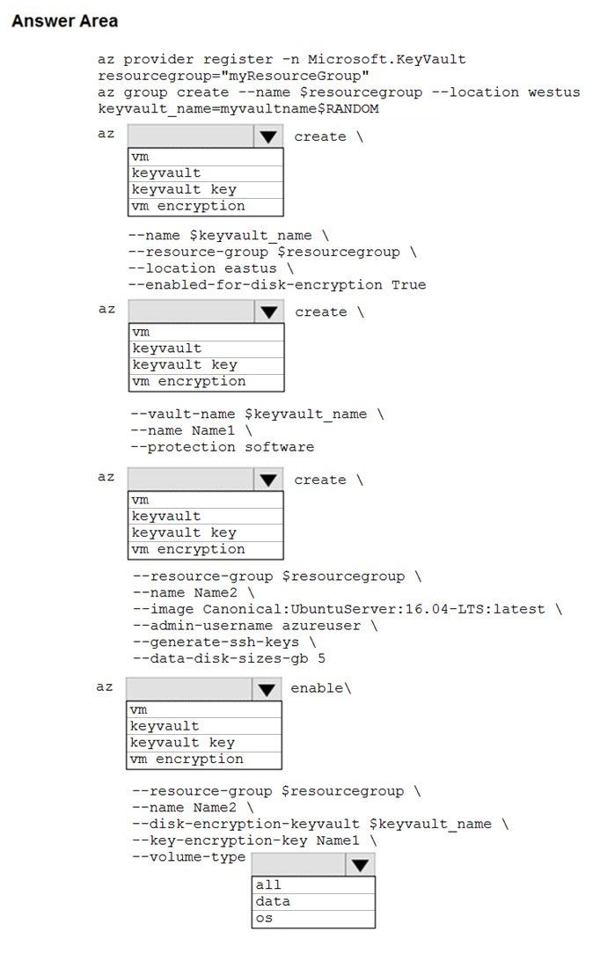

[Hide Solution](https://www.examtopics.com/exams/microsoft/az-204/view/14/) [Discussion   **18**](https://www.examtopics.com/exams/microsoft/az-204/view/14/)

**Correct Answer:** 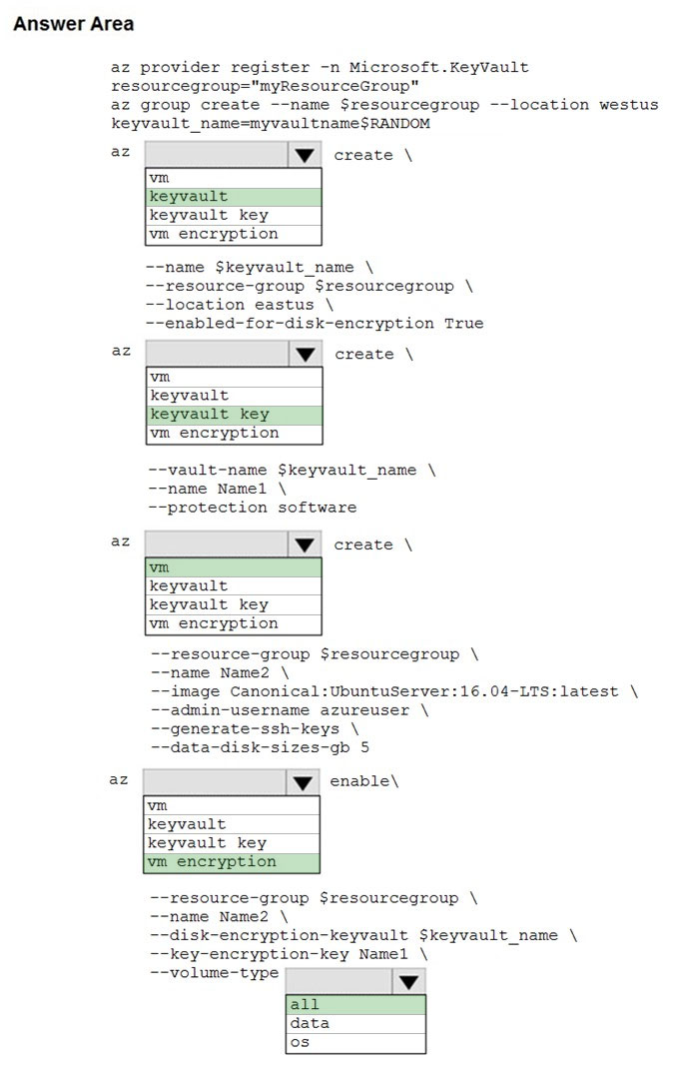  
Box 1: keyvault -  
Create an Azure Key Vault with az keyvault create and enable the Key Vault for use with disk encryption. Specify a unique Key Vault name for keyvault_name as follows: keyvault_name=myvaultname$RANDOM az keyvault create \  
--name $keyvault_name \  
--resource-group $resourcegroup \  
--location eastus \  
--enabled-for-disk-encryption True  
  
Box 2: keyvault key -  
The Azure platform needs to be granted access to request the cryptographic keys when the VM boots to decrypt the virtual disks. Create a cryptographic key in your Key Vault with az keyvault key create. The following example creates a key named myKey: az keyvault key create \  
--vault-name $keyvault_name \  
--name myKey \  
--protection software  
  
Box 3: vm -  
Create a VM with az vm create. Only certain marketplace images support disk encryption. The following example creates a VM named myVM using an Ubuntu  
16.04 LTS image:  
az vm create \  
--resource-group $resourcegroup \  
--name myVM \  
--image Canonical:UbuntuServer:16.04-LTS:latest \  
--admin-username azureuser \  
--generate-ssh-keys \  
  
Box 4: vm encryption -  
Encrypt your VM with az vm encryption enable:  
az vm encryption enable \  
--resource-group $resourcegroup \  
--name myVM \  
--disk-encryption-keyvault $keyvault_name \  
--key-encryption-key myKey \  
--volume-type all  
Note: seems to an error in the question. Should have enable instead of create.  
  
Box 5: all -  
Encrypt both data and operating system.  
Reference:  
https://docs.microsoft.com/en-us/azure/virtual-machines/linux/disk-encryption-cli-quickstart

Question #14*Topic 4*

Your company is developing an Azure API hosted in Azure.  
You need to implement authentication for the Azure API to access other Azure resources. You have the following requirements:  
✑ All API calls must be authenticated.  
✑ Callers to the API must not send credentials to the API.  
Which authentication mechanism should you use?

* A. Basic
* B. Anonymous
* C. Managed identity
* D. Client certificate

[Hide Solution](https://www.examtopics.com/exams/microsoft/az-204/view/14/) [Discussion   **17**](https://www.examtopics.com/exams/microsoft/az-204/view/14/)

**Correct Answer:** *C* [🗳️](https://www.examtopics.com/exams/microsoft/az-204/view/14/)  
Azure Active Directory Managed Service Identity (MSI) gives your code an automatically managed identity for authenticating to Azure services, so that you can keep credentials out of your code.  
Note: Use the authentication-managed-identity policy to authenticate with a backend service using the managed identity. This policy essentially uses the managed identity to obtain an access token from Azure Active Directory for accessing the specified resource. After successfully obtaining the token, the policy will set the value of the token in the Authorization header using the Bearer scheme.  
Incorrect Answers:  
A: Use the authentication-basic policy to authenticate with a backend service using Basic authentication. This policy effectively sets the HTTP Authorization header to the value corresponding to the credentials provided in the policy.  
B: Anonymous is no authentication at all.  
D: Your code needs credentials to authenticate to cloud services, but you want to limit the visibility of those credentials as much as possible. Ideally, they never appear on a developer's workstation or get checked-in to source control. Azure Key Vault can store credentials securely so they aren't in your code, but to retrieve them you need to authenticate to Azure Key Vault. To authenticate to Key Vault, you need a credential! A classic bootstrap problem.  
Reference:  
https://azure.microsoft.com/en-us/blog/keep-credentials-out-of-code-introducing-azure-ad-managed-service-identity/ https://docs.microsoft.com/en-us/azure/api-management/api-management-authentication-policies

*Community vote distribution*

C (100%)

Question #15*Topic 4*

DRAG DROP -  
You are developing an application. You have an Azure user account that has access to two subscriptions.  
You need to retrieve a storage account key secret from Azure Key Vault.  
In which order should you arrange the PowerShell commands to develop the solution? To answer, move all commands from the list of commands to the answer area and arrange them in the correct order.  
Select and Place:  
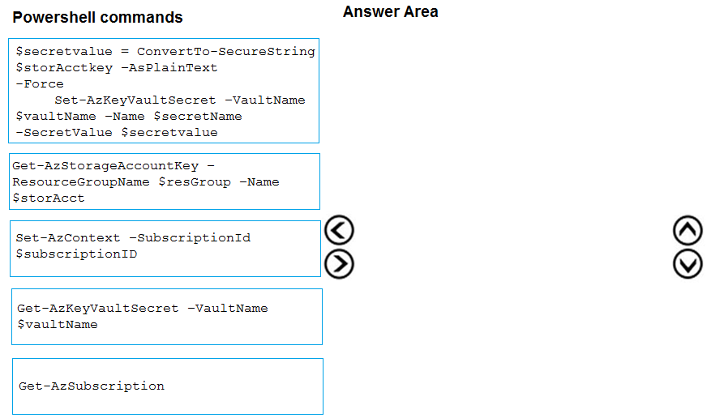

[Hide Solution](https://www.examtopics.com/exams/microsoft/az-204/view/14/) [Discussion   **14**](https://www.examtopics.com/exams/microsoft/az-204/view/14/)

**Correct Answer:** 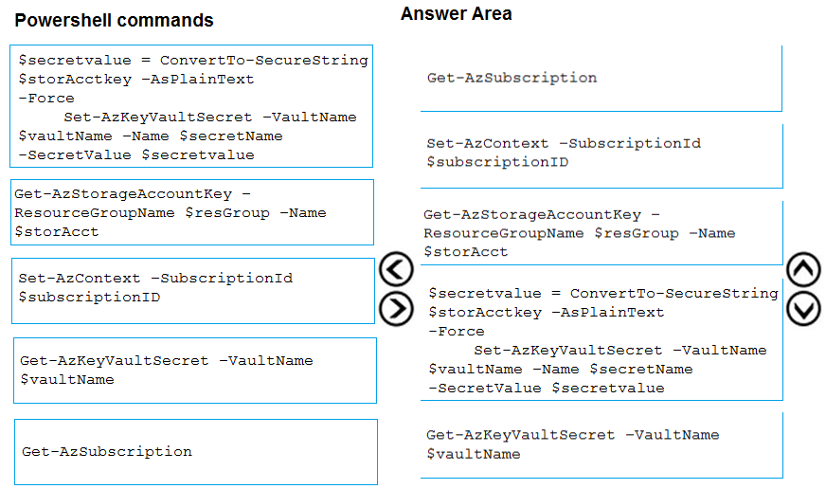  
Step 1: Get-AzSubscription -  
If you have multiple subscriptions, you might have to specify the one that was used to create your key vault. Enter the following to see the subscriptions for your account:  
  
Get-AzSubscription -  
Step 2: Set-AzContext -SubscriptionId  
To specify the subscription that's associated with the key vault you'll be logging, enter:  
Set-AzContext -SubscriptionId <subscriptionID>  
  
Step 3: Get-AzStorageAccountKey -  
You must get that storage account key.  
Step 4: $secretvalue = ConvertTo-SecureString <storageAccountKey> -AsPlainText -Force  
Set-AzKeyVaultSecret -VaultName <vaultName> -Name <secretName> -SecretValue $secretvalue  
After retrieving your secret (in this case, your storage account key), you must convert that key to a secure string, and then create a secret with that value in your key vault.  
  
Step 5: Get-AzKeyVaultSecret -  
Next, get the URI for the secret you created. You'll need this URI in a later step to call the key vault and retrieve your secret. Run the following PowerShell command and make note of the ID value, which is the secret's URI:  
Get-AzKeyVaultSecret ג€"VaultName <vaultName>  
Reference:  
https://docs.microsoft.com/bs-latn-ba/Azure/key-vault/key-vault-key-rotation-log-monitoring

Question #16*Topic 4*

Note: This question is part of a series of questions that present the same scenario. Each question in the series contains a unique solution that might meet the stated goals. Some question sets might have more than one correct solution, while others might not have a correct solution.  
After you answer a question in this section, you will NOT be able to return to it. As a result, these questions will not appear in the review screen.  
You develop Azure solutions.  
You must grant a virtual machine (VM) access to specific resource groups in Azure Resource Manager.  
You need to obtain an Azure Resource Manager access token.  
Solution: Use an X.509 certificate to authenticate the VM with Azure Resource Manager.  
Does the solution meet the goal?

* A. Yes
* B. No

[Hide Solution](https://www.examtopics.com/exams/microsoft/az-204/view/14/) [Discussion   **12**](https://www.examtopics.com/exams/microsoft/az-204/view/14/)

**Correct Answer:** *B* [🗳️](https://www.examtopics.com/exams/microsoft/az-204/view/14/)  
Instead run the Invoke-RestMethod cmdlet to make a request to the local managed identity for Azure resources endpoint.  
Reference:  
https://docs.microsoft.com/en-us/azure/active-directory/managed-identities-azure-resources/tutorial-windows-vm-access-arm

*Community vote distribution*

B (100%)

Question #17*Topic 4*

Note: This question is part of a series of questions that present the same scenario. Each question in the series contains a unique solution that might meet the stated goals. Some question sets might have more than one correct solution, while others might not have a correct solution.  
After you answer a question in this section, you will NOT be able to return to it. As a result, these questions will not appear in the review screen.  
You develop Azure solutions.  
You must grant a virtual machine (VM) access to specific resource groups in Azure Resource Manager.  
You need to obtain an Azure Resource Manager access token.  
Solution: Use the Reader role-based access control (RBAC) role to authenticate the VM with Azure Resource Manager.  
Does the solution meet the goal?

* A. Yes
* B. No

[Hide Solution](https://www.examtopics.com/exams/microsoft/az-204/view/14/) [Discussion   **18**](https://www.examtopics.com/exams/microsoft/az-204/view/14/)

**Correct Answer:** *B* [🗳️](https://www.examtopics.com/exams/microsoft/az-204/view/14/)  
Instead run the Invoke-RestMethod cmdlet to make a request to the local managed identity for Azure resources endpoint.  
Reference:  
https://docs.microsoft.com/en-us/azure/active-directory/managed-identities-azure-resources/tutorial-windows-vm-access-arm

*Community vote distribution*

B (80%)

A (20%)

Question #18*Topic 4*

HOTSPOT -  
You are building a website that is used to review restaurants. The website will use an Azure CDN to improve performance and add functionality to requests.  
You build and deploy a mobile app for Apple iPhones. Whenever a user accesses the website from an iPhone, the user must be redirected to the app store.  
You need to implement an Azure CDN rule that ensures that iPhone users are redirected to the app store.  
How should you complete the Azure Resource Manager template? To answer, select the appropriate options in the answer area.  
NOTE: Each correct selection is worth one point.  
Hot Area:  
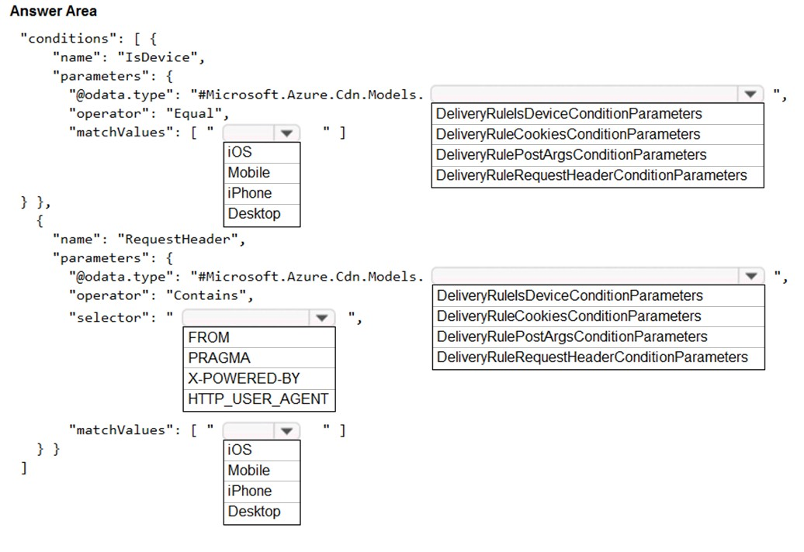

[Hide Solution](https://www.examtopics.com/exams/microsoft/az-204/view/15/) [Discussion   **46**](https://www.examtopics.com/exams/microsoft/az-204/view/15/)

**Correct Answer:** 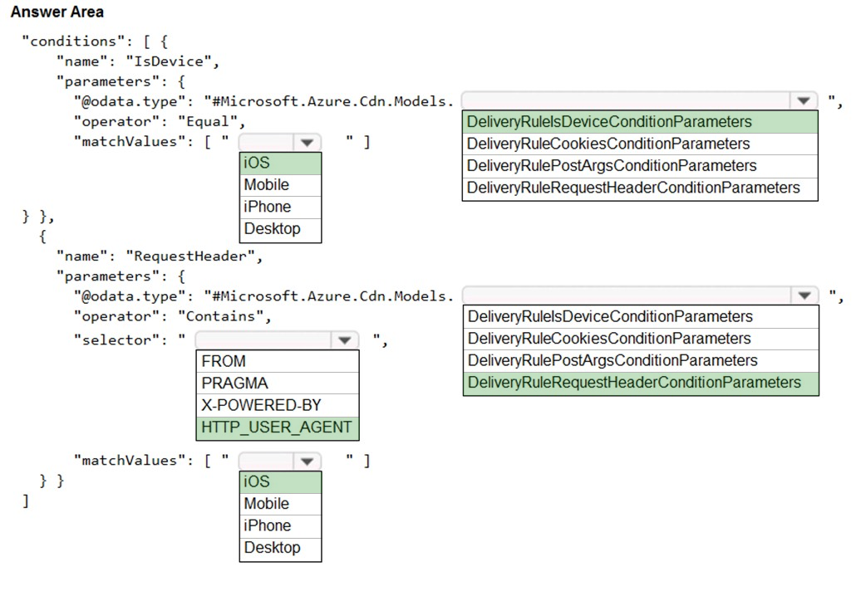  
Box 1: iOS -  
Azure AD Conditional Access supports the following device platforms:  
✑ Android  
✑ iOS  
✑ Windows Phone  
✑ Windows  
macOS  
  
Box 2: DeliveryRuleIsDeviceConditionParameters  
The DeliveryRuleIsDeviceCondition defines the IsDevice condition for the delivery rule. parameters defines the parameters for the condition.  
  
Box 3: HTTP_USER_AGENT -  
Incorrect Answers:  
✑ The Pragma HTTP/1.0 general header is an implementation-specific header that may have various effects along the request-response chain. It is used for backwards compatibility with HTTP/1.0 caches.  
✑ "X-Powered-By" is a common non-standard HTTP response header (most headers prefixed with an 'X-' are non-standard).  
Box 4: DeliveryRuleRequestHeaderConditionParameters  
DeliveryRuleRequestHeaderCondition defines the RequestHeader condition for the delivery rule. parameters defines the parameters for the condition.  
  
Box 5: iOS -  
The Require approved client app requirement only supports the iOS and Android for device platform condition.  
Reference:  
https://docs.microsoft.com/en-us/azure/active-directory/conditional-access/concept-conditional-access-conditions https://docs.microsoft.com/en-us/azure/active-directory/conditional-access/concept-conditional-access-grant

Question #19*Topic 4*

Note: This question is part of a series of questions that present the same scenario. Each question in the series contains a unique solution that might meet the stated goals. Some question sets might have more than one correct solution, while others might not have a correct solution.  
After you answer a question in this section, you will NOT be able to return to it. As a result, these questions will not appear in the review screen.  
You are developing a website that will run as an Azure Web App. Users will authenticate by using their Azure Active Directory (Azure AD) credentials.  
You plan to assign users one of the following permission levels for the website: admin, normal, and reader. A user's Azure AD group membership must be used to determine the permission level.  
You need to configure authorization.  
Solution:  
✑ Configure and use Integrated Windows Authentication in the website.  
✑ In the website, query Microsoft Graph API to load the groups to which the user is a member.  
Does the solution meet the goal?

* A. Yes
* B. No **Most Voted**

[Hide Solution](https://www.examtopics.com/exams/microsoft/az-204/view/15/) [Discussion   **32**](https://www.examtopics.com/exams/microsoft/az-204/view/15/)

**Correct Answer:** *B* [🗳️](https://www.examtopics.com/exams/microsoft/az-204/view/15/)  
Microsoft Graph is a RESTful web API that enables you to access Microsoft Cloud service resources.  
Instead in the Azure AD application's manifest, set value of the groupMembershipClaims option to All. In the website, use the value of the groups claim from the  
JWT for the user to determine permissions.  
Reference:  
https://blogs.msdn.microsoft.com/waws/2017/03/13/azure-app-service-authentication-aad-groups/

*Community vote distribution*

B (78%)

A (22%)

Question #20*Topic 4*

Note: This question is part of a series of questions that present the same scenario. Each question in the series contains a unique solution that might meet the stated goals. Some question sets might have more than one correct solution, while others might not have a correct solution.  
After you answer a question in this section, you will NOT be able to return to it. As a result, these questions will not appear in the review screen.  
You develop Azure solutions.  
You must grant a virtual machine (VM) access to specific resource groups in Azure Resource Manager.  
You need to obtain an Azure Resource Manager access token.  
Solution: Run the Invoke-RestMethod cmdlet to make a request to the local managed identity for Azure resources endpoint.  
Does the solution meet the goal?

* A. Yes **Most Voted**
* B. No

[Hide Solution](https://www.examtopics.com/exams/microsoft/az-204/view/15/) [Discussion   **23**](https://www.examtopics.com/exams/microsoft/az-204/view/15/)

**Correct Answer:** *A* [🗳️](https://www.examtopics.com/exams/microsoft/az-204/view/15/)  
Get an access token using the VM's system-assigned managed identity and use it to call Azure Resource Manager  
You will need to use PowerShell in this portion.  
1. In the portal, navigate to Virtual Machines and go to your Windows virtual machine and in the Overview, click Connect.  
2. Enter in your Username and Password for which you added when you created the Windows VM.  
3. Now that you have created a Remote Desktop Connection with the virtual machine, open PowerShell in the remote session.  
4. Using the Invoke-WebRequest cmdlet, make a request to the local managed identity for Azure resources endpoint to get an access token for Azure Resource  
Manager.  
Example:  
$response = Invoke-WebRequest -Uri 'http://169.254.169.254/metadata/identity/oauth2/token?api-version=2018-02-01&resource=https:// management.azure.com/' -Method GET -Headers @{Metadata="true"}  
Reference:  
https://docs.microsoft.com/en-us/azure/active-directory/managed-identities-azure-resources/tutorial-windows-vm-access-arm

*Community vote distribution*

A (90%)

10%

Question #21*Topic 4*

HOTSPOT -  
You are building a website to access project data related to teams within your organization. The website does not allow anonymous access. Authentication is performed using an Azure Active Directory (Azure AD) app named internal.  
The website has the following authentication requirements:  
✑ Azure AD users must be able to login to the website.  
✑ Personalization of the website must be based on membership in Active Directory groups.  
You need to configure the application's manifest to meet the authentication requirements.  
How should you configure the manifest? To answer, select the appropriate configuration in the answer area.  
NOTE: Each correct selection is worth one point.  
Hot Area:  
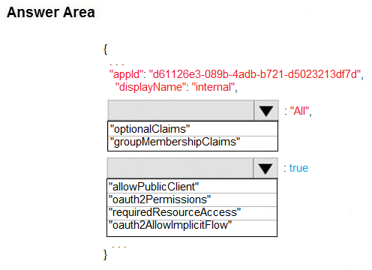

[Hide Solution](https://www.examtopics.com/exams/microsoft/az-204/view/15/) [Discussion   **33**](https://www.examtopics.com/exams/microsoft/az-204/view/15/)

**Correct Answer:** 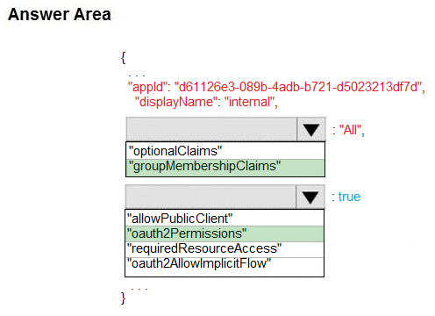  
Box 1: groupMembershipClaims -  
Scenario: Personalization of the website must be based on membership in Active Directory groups.  
Group claims can also be configured in the Optional Claims section of the Application Manifest.  
Enable group membership claims by changing the groupMembershipClaim  
The valid values are:  
"All"  
"SecurityGroup"  
"DistributionList"  
"DirectoryRole"  
  
Box 2: oauth2Permissions -  
Scenario: Azure AD users must be able to login to the website. oauth2Permissions specifies the collection of OAuth 2.0 permission scopes that the web API (resource) app exposes to client apps. These permission scopes may be granted to client apps during consent.  
Incorrect Answers:  
oauth2AllowImplicitFlow. oauth2AllowImplicitFlow specifies whether this web app can request OAuth2.0 implicit flow access tokens. The default is false. This flag is used for browser-based apps, like Javascript single-page apps.  
Reference:  
https://docs.microsoft.com/en-us/azure/active-directory/hybrid/how-to-connect-fed-group-claims

Question #22*Topic 4*

You develop an app that allows users to upload photos and videos to Azure storage. The app uses a storage REST API call to upload the media to a blob storage account named Account1. You have blob storage containers named Container1 and Container2.  
Uploading of videos occurs on an irregular basis.  
You need to copy specific blobs from Container1 to Container2 when a new video is uploaded.  
What should you do?

* A. Copy blobs to Container2 by using the Put Blob operation of the Blob Service REST API
* B. Create an Event Grid topic that uses the Start-AzureStorageBlobCopy cmdlet **Most Voted**
* C. Use AzCopy with the Snapshot switch to copy blobs to Container2
* D. Download the blob to a virtual machine and then upload the blob to Container2

[Hide Solution](https://www.examtopics.com/exams/microsoft/az-204/view/15/) [Discussion   **33**](https://www.examtopics.com/exams/microsoft/az-204/view/15/)

**Correct Answer:** *B* [🗳️](https://www.examtopics.com/exams/microsoft/az-204/view/15/)  
The Start-AzureStorageBlobCopy cmdlet starts to copy a blob.  
  
Example 1: Copy a named blob -  
C:\PS>Start-AzureStorageBlobCopy -SrcBlob "ContosoPlanning2015" -DestContainer "ContosoArchives" -SrcContainer "ContosoUploads"  
This command starts the copy operation of the blob named ContosoPlanning2015 from the container named ContosoUploads to the container named  
ContosoArchives.  
Reference:  
https://docs.microsoft.com/en-us/powershell/module/azure.storage/start-azurestorageblobcopy?view=azurermps-6.13.0

*Community vote distribution*

B (100%)

Question #23*Topic 4*

You are developing an ASP.NET Core website that uses Azure FrontDoor. The website is used to build custom weather data sets for researchers. Data sets are downloaded by users as Comma Separated Value (CSV) files. The data is refreshed every 10 hours.  
Specific files must be purged from the FrontDoor cache based upon Response Header values.  
You need to purge individual assets from the Front Door cache.  
Which type of cache purge should you use?

* A. single path **Most Voted**
* B. wildcard
* C. root domain

[Hide Solution](https://www.examtopics.com/exams/microsoft/az-204/view/15/) [Discussion   **21**](https://www.examtopics.com/exams/microsoft/az-204/view/15/)

**Correct Answer:** *A* [🗳️](https://www.examtopics.com/exams/microsoft/az-204/view/15/)  
These formats are supported in the lists of paths to purge:  
✑ Single path purge: Purge individual assets by specifying the full path of the asset (without the protocol and domain), with the file extension, for example, /  
[1]  
✑ Wildcard purge: Asterisk (*) may be used as a wildcard. Purge all folders, subfolders, and files under an endpoint with /* in the path or purge all subfolders and files under a specific folder by specifying the folder followed by /*, for example, /pictures/*.  
✑ Root domain purge: Purge the root of the endpoint with "/" in the path.  
Reference:  
https://docs.microsoft.com/en-us/azure/frontdoor/front-door-caching

*Community vote distribution*

A (100%)

Question #24*Topic 4*

Your company is developing an Azure API.  
You need to implement authentication for the Azure API. You have the following requirements:  
All API calls must be secure.  
  
✑ Callers to the API must not send credentials to the API.  
Which authentication mechanism should you use?

* A. Basic
* B. Anonymous
* C. Managed identity **Most Voted**
* D. Client certificate

[Hide Solution](https://www.examtopics.com/exams/microsoft/az-204/view/15/) [Discussion   **42**](https://www.examtopics.com/exams/microsoft/az-204/view/15/)

**Correct Answer:** *C* [🗳️](https://www.examtopics.com/exams/microsoft/az-204/view/15/)  
Use the authentication-managed-identity policy to authenticate with a backend service using the managed identity of the API Management service. This policy essentially uses the managed identity to obtain an access token from Azure Active Directory for accessing the specified resource. After successfully obtaining the token, the policy will set the value of the token in the Authorization header using the Bearer scheme.  
Reference:  
https://docs.microsoft.com/bs-cyrl-ba/azure/api-management/api-management-authentication-policies

*Community vote distribution*

C (70%)

D (30%)

Question #25*Topic 4*

You are a developer for a SaaS company that offers many web services.  
All web services for the company must meet the following requirements:  
✑ Use API Management to access the services  
✑ Use OpenID Connect for authentication  
✑ Prevent anonymous usage  
A recent security audit found that several web services can be called without any authentication.  
Which API Management policy should you implement?

* A. jsonp
* B. authentication-certificate
* C. check-header
* D. validate-jwt **Most Voted**

[Hide Solution](https://www.examtopics.com/exams/microsoft/az-204/view/15/) [Discussion   **20**](https://www.examtopics.com/exams/microsoft/az-204/view/15/)

**Correct Answer:** *D* [🗳️](https://www.examtopics.com/exams/microsoft/az-204/view/15/)  
Add the validate-jwt policy to validate the OAuth token for every incoming request.  
Incorrect Answers:  
A: The jsonp policy adds JSON with padding (JSONP) support to an operation or an API to allow cross-domain calls from JavaScript browser-based clients.  
JSONP is a method used in JavaScript programs to request data from a server in a different domain. JSONP bypasses the limitation enforced by most web browsers where access to web pages must be in the same domain.  
JSONP - Adds JSON with padding (JSONP) support to an operation or an API to allow cross-domain calls from JavaScript browser-based clients.  
Reference:  
https://docs.microsoft.com/en-us/azure/api-management/api-management-howto-protect-backend-with-aad

*Community vote distribution*

D (100%)

Question #26*Topic 4*

DRAG DROP -  
Contoso, Ltd. provides an API to customers by using Azure API Management (APIM). The API authorizes users with a JWT token.  
You must implement response caching for the APIM gateway. The caching mechanism must detect the user ID of the client that accesses data for a given location and cache the response for that user ID.  
You need to add the following policies to the policies file:  
✑ a set-variable policy to store the detected user identity  
✑ a cache-lookup-value policy  
✑ a cache-store-value policy  
✑ a find-and-replace policy to update the response body with the user profile information  
To which policy section should you add the policies? To answer, drag the appropriate sections to the correct policies. Each section may be used once, more than once, or not at all. You may need to drag the split bar between panes or scroll to view content.  
NOTE: Each correct selection is worth one point.  
Select and Place:  
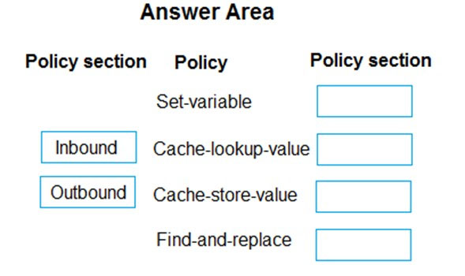

[Hide Solution](https://www.examtopics.com/exams/microsoft/az-204/view/15/) [Discussion   **65**](https://www.examtopics.com/exams/microsoft/az-204/view/15/)

**Correct Answer:** 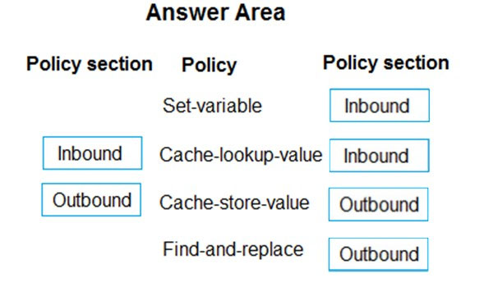  
Box 1: Inbound.  
A set-variable policy to store the detected user identity.  
Example:  
<policies>  
<inbound>  
<!-- How you determine user identity is application dependent -->  
<set-variable  
name="enduserid"  
value="@(context.Request.Headers.GetValueOrDefault("Authorization","").Split(' ')[1].AsJwt()?.Subject)" />  
  
Box 2: Inbound -  
  
A cache-lookup-value policy -  
Example:  
<inbound>  
<base />  
<cache-lookup vary-by-developer="true | false" vary-by-developer-groups="true | false" downstream-caching-type="none | private | public" must- revalidate="true | false">  
<vary-by-query-parameter>parameter name</vary-by-query-parameter> <!-- optional, can repeated several times -->  
</cache-lookup>  
</inbound>  
  
Box 3: Outbound -  
A cache-store-value policy.  
Example:  
<outbound>  
<base />  
<cache-store duration="3600" />  
</outbound>  
  
Box 4: Outbound -  
A find-and-replace policy to update the response body with the user profile information.  
Example:  
<outbound>  
<!-- Update response body with user profile-->  
<find-and-replace  
from='"$userprofile$"'  
to="@((string)context.Variables["userprofile"])" />  
<base />  
</outbound>  
Reference:  
https://docs.microsoft.com/en-us/azure/api-management/api-management-caching-policies https://docs.microsoft.com/en-us/azure/api-management/api-management-sample-cache-by-key

Question #27*Topic 4*

DRAG DROP -  
You are developing an Azure solution.  
You need to develop code to access a secret stored in Azure Key Vault.  
How should you complete the code segment? To answer, drag the appropriate code segments to the correct location. Each code segment may be used once, more than once, or not at all. You may need to drag the split bar between panes or scroll to view content.  
NOTE: Each correct selection is worth one point.  
Select and Place:  
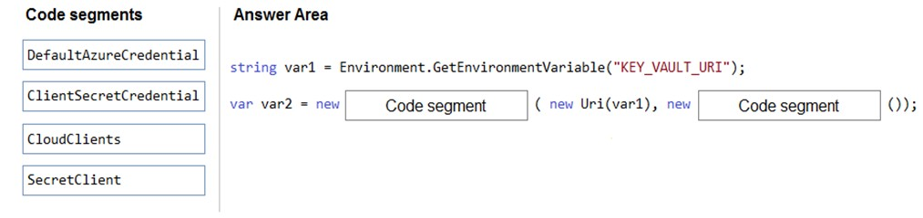

[Hide Solution](https://www.examtopics.com/exams/microsoft/az-204/view/15/) [Discussion   **11**](https://www.examtopics.com/exams/microsoft/az-204/view/15/)

**Correct Answer:** 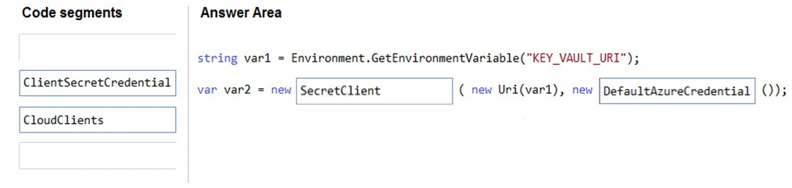  
Box 1: SecretClient -  
  
Box 2: DefaultAzureCredential -  
In below example, the name of your key vault is expanded to the key vault URI, in the format "https://<your-key-vault-name>.vault.azure.net". This example is using 'DefaultAzureCredential()' class from Azure Identity Library, which allows to use the same code across different environments with different options to provide identity. string keyVaultName = Environment.GetEnvironmentVariable("KEY_VAULT_NAME"); var kvUri = "https://" + keyVaultName + ".vault.azure.net"; var client = new SecretClient(new Uri(kvUri), new DefaultAzureCredential());  
Reference:  
https://docs.microsoft.com/en-us/azure/key-vault/secrets/quick-create-net

Question #28*Topic 4*

You are developing an Azure App Service REST API.  
The API must be called by an Azure App Service web app. The API must retrieve and update user profile information stored in Azure Active Directory (Azure AD).  
You need to configure the API to make the updates.  
Which two tools should you use? Each correct answer presents part of the solution.  
NOTE: Each correct selection is worth one point.

* A. Microsoft Graph API **Most Voted**
* B. Microsoft Authentication Library (MSAL) **Most Voted**
* C. Azure API Management
* D. Microsoft Azure Security Center
* E. Microsoft Azure Key Vault SDK

[Hide Solution](https://www.examtopics.com/exams/microsoft/az-204/view/16/) [Discussion   **26**](https://www.examtopics.com/exams/microsoft/az-204/view/16/)

**Correct Answer:** *AC* [🗳️](https://www.examtopics.com/exams/microsoft/az-204/view/16/)  
A: You can use the Azure AD REST APIs in Microsoft Graph to create unique workflows between Azure AD resources and third-party services.  
Enterprise developers use Microsoft Graph to integrate Azure AD identity management and other services to automate administrative workflows, such as employee onboarding (and termination), profile maintenance, license deployment, and more.  
C: API Management (APIM) is a way to create consistent and modern API gateways for existing back-end services.  
API Management helps organizations publish APIs to external, partner, and internal developers to unlock the potential of their data and services.  
Reference:  
https://docs.microsoft.com/en-us/graph/azuread-identity-access-management-concept-overview

*Community vote distribution*

AB (100%)

Question #29*Topic 4*

You develop a REST API. You implement a user delegation SAS token to communicate with Azure Blob storage.  
The token is compromised.  
You need to revoke the token.  
What are two possible ways to achieve this goal? Each correct answer presents a complete solution.  
NOTE: Each correct selection is worth one point.

* A. Revoke the delegation key. **Most Voted**
* B. Delete the stored access policy.
* C. Regenerate the account key.
* D. Remove the role assignment for the security principle. **Most Voted**

[Hide Solution](https://www.examtopics.com/exams/microsoft/az-204/view/16/) [Discussion   **30**](https://www.examtopics.com/exams/microsoft/az-204/view/16/)

**Correct Answer:** *AB* [🗳️](https://www.examtopics.com/exams/microsoft/az-204/view/16/)  
A: Revoke a user delegation SAS -  
To revoke a user delegation SAS from the Azure CLI, call the az storage account revoke-delegation-keys command. This command revokes all of the user delegation keys associated with the specified storage account. Any shared access signatures associated with those keys are invalidated.  
B: To revoke a stored access policy, you can either delete it, or rename it by changing the signed identifier. Changing the signed identifier breaks the associations between any existing signatures and the stored access policy. Deleting or renaming the stored access policy immediately effects all of the shared access signatures associated with it.  
Reference:  
https://github.com/MicrosoftDocs/azure-docs/blob/master/articles/storage/blobs/storage-blob-user-delegation-sas-create-cli.md https://docs.microsoft.com/en-us/rest/api/storageservices/define-stored-access-policy#modifying-or-revoking-a-stored-access-policy

*Community vote distribution*

AD (100%)

Question #30*Topic 4*

DRAG DROP -  
You are developing an Azure-hosted application that must use an on-premises hardware security module (HSM) key.  
The key must be transferred to your existing Azure Key Vault by using the Bring Your Own Key (BYOK) process.  
You need to securely transfer the key to Azure Key Vault.  
Which four actions should you perform in sequence? To answer, move the appropriate actions from the list of actions to the answer area and arrange them in the correct order.  
Select and Place:  
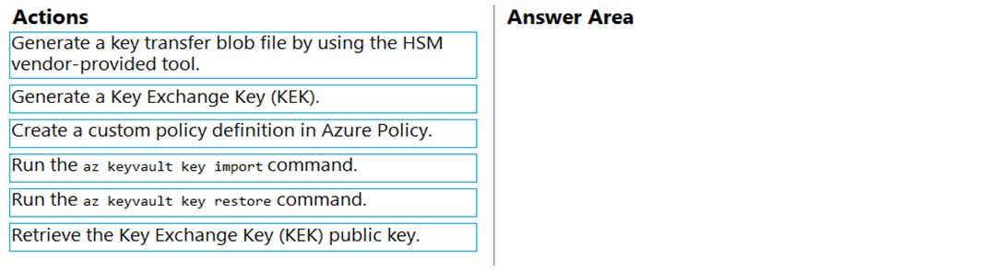

[Hide Solution](https://www.examtopics.com/exams/microsoft/az-204/view/16/) [Discussion   **14**](https://www.examtopics.com/exams/microsoft/az-204/view/16/)

**Correct Answer:** 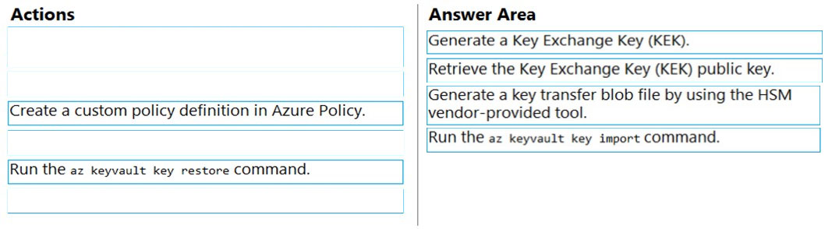  
To perform a key transfer, a user performs following steps:  
✑ Generate KEK.  
✑ Retrieve the public key of the KEK.  
✑ Using HSM vendor provided BYOK tool - Import the KEK into the target HSM and exports the Target Key protected by the KEK.  
✑ Import the protected Target Key to Azure Key Vault.  
Step 1: Generate a Key Exchange Key (KEK).  
Step 2: Retrieve the Key Exchange Key (KEK) public key.  
Step 3: Generate a key transfer blob file by using the HSM vendor-provided tool.  
Generate key transfer blob using HSM vendor provided BYOK tool  
Step 4: Run the az keyvault key import command  
Upload key transfer blob to import HSM-key.  
Customer will transfer the Key Transfer Blob (".byok" file) to an online workstation and then run a az keyvault key import command to import this blob as a new  
HSM-backed key into Key Vault.  
To import an RSA key use this command:  
az keyvault key import  
Reference:  
https://docs.microsoft.com/en-us/azure/key-vault/keys/byok-specification

Question #31*Topic 4*

You develop and deploy an Azure Logic app that calls an Azure Function app. The Azure Function app includes an OpenAPI (Swagger) definition and uses an  
Azure Blob storage account. All resources are secured by using Azure Active Directory (Azure AD).  
The Azure Logic app must securely access the Azure Blob storage account. Azure AD resources must remain if the Azure Logic app is deleted.  
You need to secure the Azure Logic app.  
What should you do?

* A. Create a user-assigned managed identity and assign role-based access controls.
* B. Create an Azure AD custom role and assign the role to the Azure Blob storage account.
* C. Create an Azure Key Vault and issue a client certificate.
* D. Create a system-assigned managed identity and issue a client certificate.
* E. Create an Azure AD custom role and assign role-based access controls.

[Hide Solution](https://www.examtopics.com/exams/microsoft/az-204/view/16/) [Discussion   **12**](https://www.examtopics.com/exams/microsoft/az-204/view/16/)

**Correct Answer:** *A* [🗳️](https://www.examtopics.com/exams/microsoft/az-204/view/16/)  
To give a managed identity access to an Azure resource, you need to add a role to the target resource for that identity.  
Note: To easily authenticate access to other resources that are protected by Azure Active Directory (Azure AD) without having to sign in and provide credentials or secrets, your logic app can use a managed identity (formerly known as Managed Service Identity or MSI). Azure manages this identity for you and helps secure your credentials because you don't have to provide or rotate secrets.  
If you set up your logic app to use the system-assigned identity or a manually created, user-assigned identity, the function in your logic app can also use that same identity for authentication.  
Reference:  
https://docs.microsoft.com/en-us/azure/logic-apps/create-managed-service-identity https://docs.microsoft.com/en-us/azure/api-management/api-management-howto-mutual-certificates-for-clients

*Community vote distribution*

A (100%)

Question #32*Topic 4*

HOTSPOT -  
You are developing an application that uses a premium block blob storage account. You are optimizing costs by automating Azure Blob Storage access tiers.  
You apply the following policy rules to the storage account. You must determine the implications of applying the rules to the data. (Line numbers are included for reference only.)  
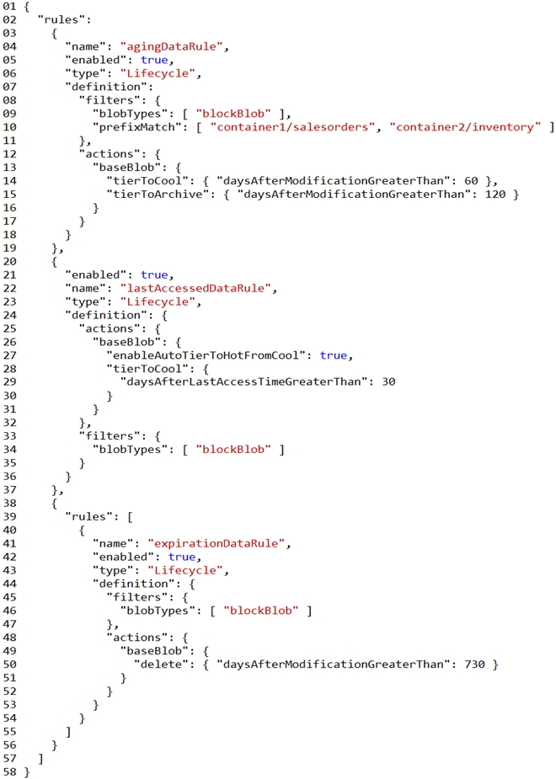  
For each of the following statements, select Yes if the statement is true. Otherwise, select No.  
NOTE: Each correct selection is worth one point.  
Hot Area:  
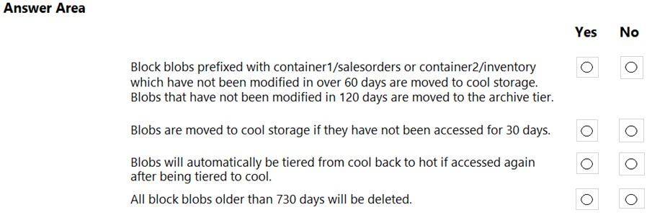

[Hide Solution](https://www.examtopics.com/exams/microsoft/az-204/view/16/) [Discussion   **81**](https://www.examtopics.com/exams/microsoft/az-204/view/16/)

**Correct Answer:** 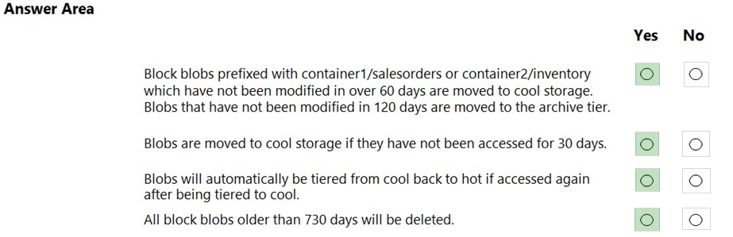  
Box 1: Yes -  
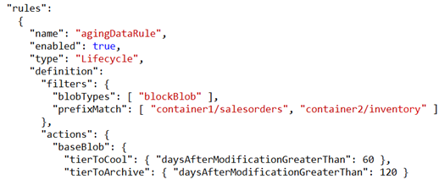  
  
Box 2: Yes -  
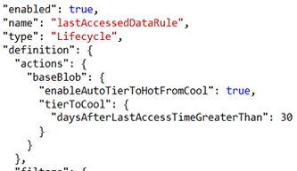  
  
Box 3: Yes -  
  
Box 4: Yes -  
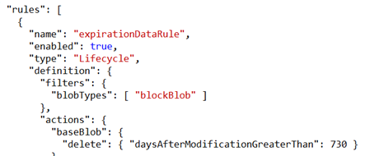

Question #33*Topic 4*

You are developing a solution that will use a multi-partitioned Azure Cosmos DB database. You plan to use the latest Azure Cosmos DB SDK for development.  
The solution must meet the following requirements:  
✑ Send insert and update operations to an Azure Blob storage account.  
✑ Process changes to all partitions immediately.  
✑ Allow parallelization of change processing.  
You need to process the Azure Cosmos DB operations.  
What are two possible ways to achieve this goal? Each correct answer presents a complete solution.  
NOTE: Each correct selection is worth one point.

* A. Create an Azure App Service API and implement the change feed estimator of the SDK. Scale the API by using multiple Azure App Service instances.
* B. Create a background job in an Azure Kubernetes Service and implement the change feed feature of the SDK.
* C. Create an Azure Function to use a trigger for Azure Cosmos DB. Configure the trigger to connect to the container. **Most Voted**
* D. Create an Azure Function that uses a FeedIterator object that processes the change feed by using the pull model on the container. Use a FeedRange object to parallelize the processing of the change feed across multiple functions. **Most Voted**

[Hide Solution](https://www.examtopics.com/exams/microsoft/az-204/view/16/) [Discussion   **29**](https://www.examtopics.com/exams/microsoft/az-204/view/16/)

**Correct Answer:** *AC* [🗳️](https://www.examtopics.com/exams/microsoft/az-204/view/16/)  
Azure Functions is the simplest option if you are just getting started using the change feed. Due to its simplicity, it is also the recommended option for most change feed use cases. When you create an Azure Functions trigger for Azure Cosmos DB, you select the container to connect, and the Azure Function gets triggered whenever there is a change in the container. Because Azure Functions uses the change feed processor behind the scenes, it automatically parallelizes change processing across your container's partitions.  
Note: You can work with change feed using the following options:  
✑ Using change feed with Azure Functions  
✑ Using change feed with change feed processor  
Reference:  
https://docs.microsoft.com/en-us/azure/cosmos-db/read-change-feed

*Community vote distribution*

CD (40%)

D (20%)

A (20%)

Other

Question #34*Topic 4*

HOTSPOT -  
You have an Azure Web app that uses Cosmos DB as a data store. You create a CosmosDB container by running the following PowerShell script:  
$resourceGroupName = "testResourceGroup"  
$accountName = "testCosmosAccount"  
$databaseName = "testDatabase"  
$containerName = "testContainer"  
$partitionKeyPath = "/EmployeeId"  
$autoscaleMaxThroughput = 5000  
  
New-AzCosmosDBSqlContainer -  
-ResourceGroupName $resourceGroupName  
-AccountName $accountName  
-DatabaseName $databaseName  
-Name $containerName  
-PartitionKeyKind Hash  
-PartitionKeyPath $partitionKeyPath  
-AutoscaleMaxThroughput $autoscaleMaxThroughput  
You create the following queries that target the container:  
SELECT * FROM c WHERE c.EmployeeId > '12345'  
SELECT * FROM c WHERE c.UserID = '12345'  
For each of the following statements, select Yes if the statement is true. Otherwise, select No.  
NOTE: Each correct selection is worth one point.  
Hot Area:  
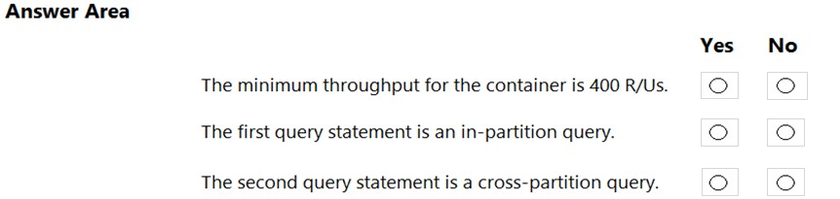

[Hide Solution](https://www.examtopics.com/exams/microsoft/az-204/view/16/) [Discussion   **27**](https://www.examtopics.com/exams/microsoft/az-204/view/16/)

**Correct Answer:** 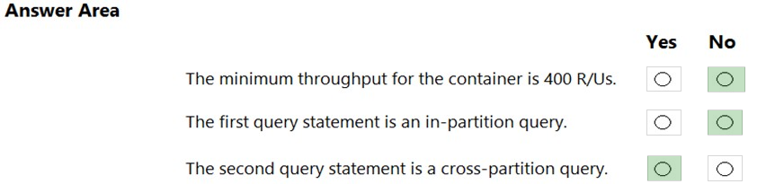  
Box 1: No -  
You set the highest, or maximum RU/s Tmax you don't want the system to exceed. The system automatically scales the throughput T such that 0.1* Tmax <= T <=  
Tmax.  
In this example we have autoscaleMaxThroughput = 5000, so the minimum throughput for the container is 500 R/Us.  
  
Box 2: No -  
First query: SELECT * FROM c WHERE c.EmployeeId > '12345'  
Here's a query that has a range filter on the partition key and won't be scoped to a single physical partition. In order to be an in-partition query, the query must have an equality filter that includes the partition key:  
SELECT * FROM c WHERE c.DeviceId > 'XMS-0001'  
  
Box 3: Yes -  
Example of In-partition query:  
Consider the below query with an equality filter on DeviceId. If we run this query on a container partitioned on DeviceId, this query will filter to a single physical partition.  
SELECT * FROM c WHERE c.DeviceId = 'XMS-0001'  
Reference:  
https://docs.microsoft.com/en-us/azure/cosmos-db/how-to-choose-offer https://docs.microsoft.com/en-us/azure/cosmos-db/how-to-query-container

Question #35*Topic 4*

HOTSPOT -  
You are developing a web application that makes calls to the Microsoft Graph API. You register the application in the Azure portal and upload a valid X509 certificate.  
You create an appsettings.json file containing the certificate name, client identifier for the application, and the tenant identifier of the Azure Active Directory (Azure  
AD). You create a method named ReadCertificate to return the X509 certificate by name.  
You need to implement code that acquires a token by using the certificate.  
How should you complete the code segment? To answer, select the appropriate options in the answer area.  
NOTE: Each correct selection is worth one point.  
Hot Area:  
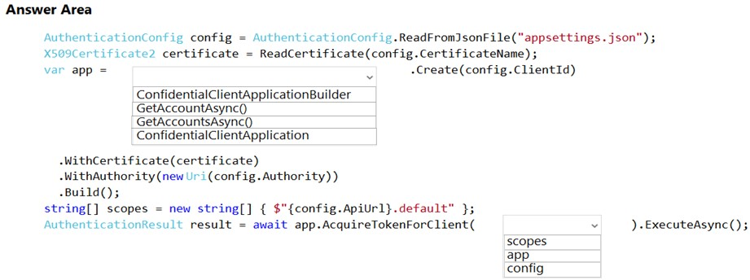

[Hide Solution](https://www.examtopics.com/exams/microsoft/az-204/view/16/) [Discussion   **7**](https://www.examtopics.com/exams/microsoft/az-204/view/16/)

**Correct Answer:** 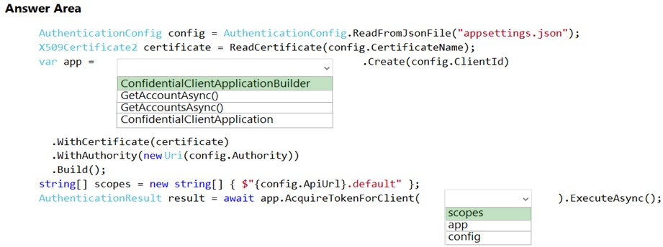  
Box 1: ConfidentialClientApplicationBuilder  
Here's the code to instantiate the confidential client application with a client secret: app = ConfidentialClientApplicationBuilder.Create(config.ClientId)  
.WithClientSecret(config.ClientSecret)  
.WithAuthority(new Uri(config.Authority))  
.Build();  
  
Box 2: scopes -  
After you've constructed a confidential client application, you can acquire a token for the app by calling AcquireTokenForClient, passing the scope, and optionally forcing a refresh of the token.  
Sample code: result = await app.AcquireTokenForClient(scopes)  
.ExecuteAsync();  
Reference:  
https://docs.microsoft.com/en-us/azure/active-directory/develop/scenario-daemon-app-configuration https://docs.microsoft.com/en-us/azure/active-directory/develop/scenario-daemon-acquire-token

Question #36*Topic 4*

HOTSPOT -  
You develop a containerized application. You plan to deploy the application to a new Azure Container instance by using a third-party continuous integration and continuous delivery (CI/CD) utility.  
The deployment must be unattended and include all application assets. The third-party utility must only be able to push and pull images from the registry. The authentication must be managed by Azure Active Directory (Azure AD). The solution must use the principle of least privilege.  
You need to ensure that the third-party utility can access the registry.  
Which authentication options should you use? To answer, select the appropriate options in the answer area.  
NOTE: Each correct selection is worth one point.  
Hot Area:  
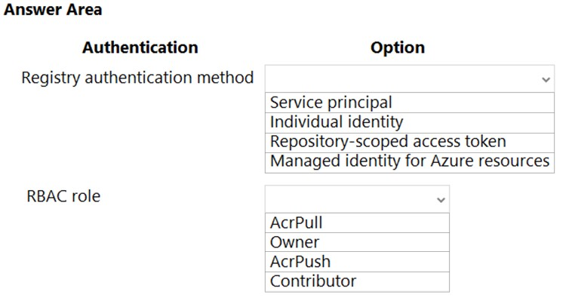

[Hide Solution](https://www.examtopics.com/exams/microsoft/az-204/view/16/) [Discussion   **12**](https://www.examtopics.com/exams/microsoft/az-204/view/16/)

**Correct Answer:** 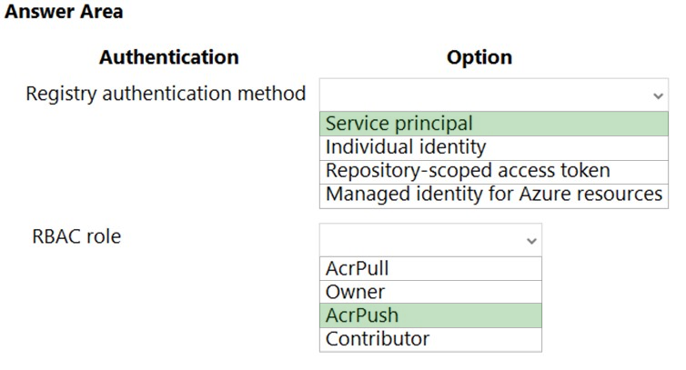  
Box 1: Service principal -  
Applications and container orchestrators can perform unattended, or "headless," authentication by using an Azure Active Directory (Azure AD) service principal.  
Incorrect Answers:  
✑ Individual AD identity does not support unattended push/pull  
✑ Repository-scoped access token is not integrated with AD identity  
✑ Managed identity for Azure resources is used to authenticate to an Azure container registry from another Azure resource.  
  
Box 2: AcrPush -  
AcrPush provides pull/push permissions only and meets the principle of least privilege.  
Incorrect Answers:  
AcrPull only allows pull permissions it does not allow push permissions.  
  
✑ Owner and Contributor allow pull/push permissions but does not meet the principle of least privilege.  
Reference:  
https://docs.microsoft.com/en-us/azure/container-registry/container-registry-authentication?tabs=azure-cli https://docs.microsoft.com/en-us/azure/container-registry/container-registry-roles?tabs=azure-cli

Question #37*Topic 4*

You deploy an Azure App Service web app. You create an app registration for the app in Azure Active Directory (Azure AD) and Twitter.  
The app must authenticate users and must use SSL for all communications. The app must use Twitter as the identity provider.  
You need to validate the Azure AD request in the app code.  
What should you validate?

* A. ID token header
* B. ID token signature **Most Voted**
* C. HTTP response code
* D. Tenant ID

[Hide Solution](https://www.examtopics.com/exams/microsoft/az-204/view/16/) [Discussion   **16**](https://www.examtopics.com/exams/microsoft/az-204/view/16/)

**Correct Answer:** *A* [🗳️](https://www.examtopics.com/exams/microsoft/az-204/view/16/)  
Reference:  
https://docs.microsoft.com/en-us/azure/storage/common/storage-auth-aad-app?tabs=dotnet

*Community vote distribution*

B (85%)

A (15%)